Online Result Computation System

User Manual

# Contents

Contents 2

1.0 About Online Result Computation System (RCS) 2

2.0 User Access Levels 3

3.0 Configuration 3

3.2 Create database 3

3.3 SQL Statement. 5

4.0 Getting started 6

4.1 Login 6

4.1.1 Admin Login Access. 6

4.2 User Dashboard 6

4.3 The Users’ Navigation Menu 6

4.4 The “profile dropdown” Menu 7

4.5 Settings 7

5.0 System Manager Role 9

5.1 Generate Template menu: 9

5.2 Manage backups menu: 9

5.3 Manage courses menu 10

5.4 Manage Programme 13

5.5 Manage Student 15

5.6 User access control 16

6.0 Coordinator Role 17

6.1 Allocation menu 18

6.2 Generate Templet 18

6.3 Manage Result 18

6.4 Manage Score 20

6.5 Result Analysis 24

7.0 Teacher / Lecture Role 26

8.0 Exams and Record Role 26

9.0 Student Role 26

# 1.0 About Online Result Computation System (RCS)

RCS is a web based application that allows teachers to submit/input/import students’ examination scores, the system compute the scores, generate a broadsheet and provide a graphical/visual analysis of the results on a semester basis. The students would be able to view their result through their profiles. It also keeps backups of record in case of loss.

# 2.0 User Access Levels

There are five (5) type of users. The user (System Manager) have the authority to upload view and edit courses and students records, control all user access and navigation and view activity logs. The user (Coordinator) is the departmental examination officer, can view analysis of results, and upload, edit and view the exam score of students in the department. The user (Teacher/Lecturer), can view the courses he/she is allocated to, and upload and view exam score of the student he thought. The user (Exams and Record), can view courses, results, analysis of results, and students record. The user (Student), can view their semester results.

All the user can change their passwords.

# 3.0 Configuration

To run the web application, it is required to host it on a server, the server could be a local server or cloud server.

A cloud is a type of server that can be access through the internet, by renting the server space rather than owning it. While a local server is regular server that can be own physically as well as have with you on site.

To run the online result computation system on a local server, it is required to have a Local Server (e.g. WAMP Server) installed on user PC. To install Wamp Server, click the link below:

<https://www.developerdrive.com/installing-and-configuring-a-wamp-server-on-your-computer/>

After the installation of Wamp Server, the web base application should be copied to C://Wamp/www directory on user PC, then set up a database.

## 3.2 Create database

To set up the database

* Launch the server by searching for WampServer in the Start Menu, see the figure below.

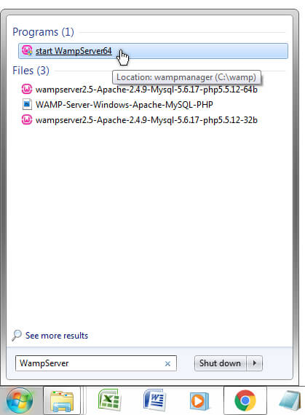

Figure 3. 1: Searching for Wamp Server

* Launch a browser, in the address bar type the URL: ([http://localhost/](http://localhost/The_RMS/SEET/)) and press the entre key. The index page of Wamp is dialysed as shown below:

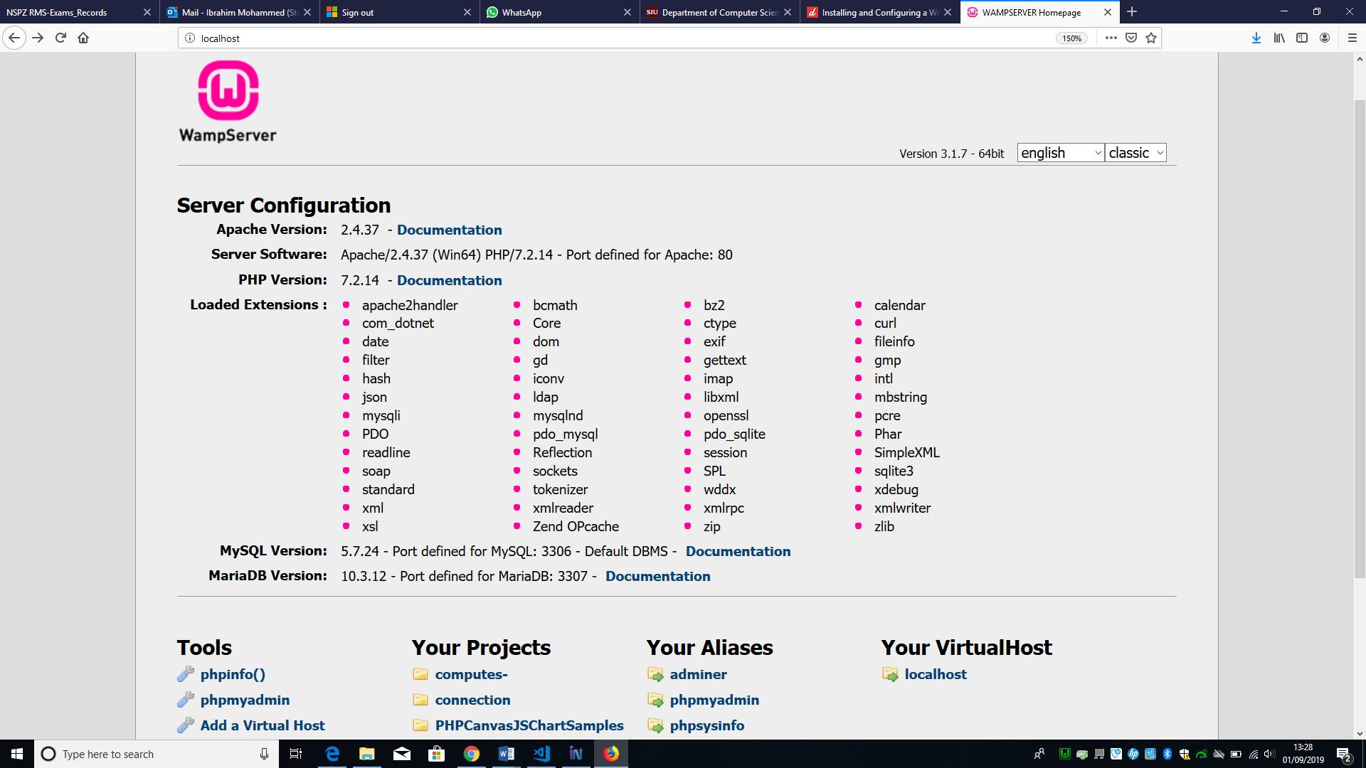

Figure 3. 2: Wamp Server Index Page

* Click on the link (phpmyadmin) on the index page (see the figure above).
* Click on the Databases menu tab (see the figure below).

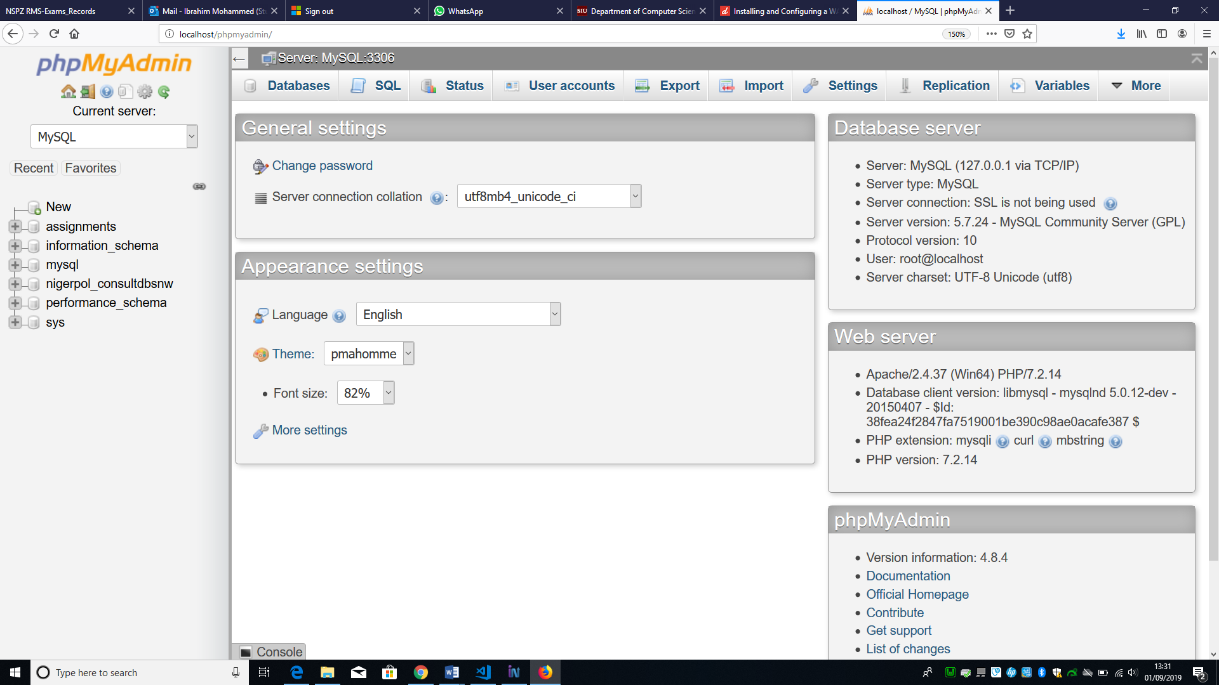

Figure 3. 3: PHPMYADMIN, Databases menu TAB

* Type the database name (nigerpol_consultdbsnw) and click on create (see the figure below).

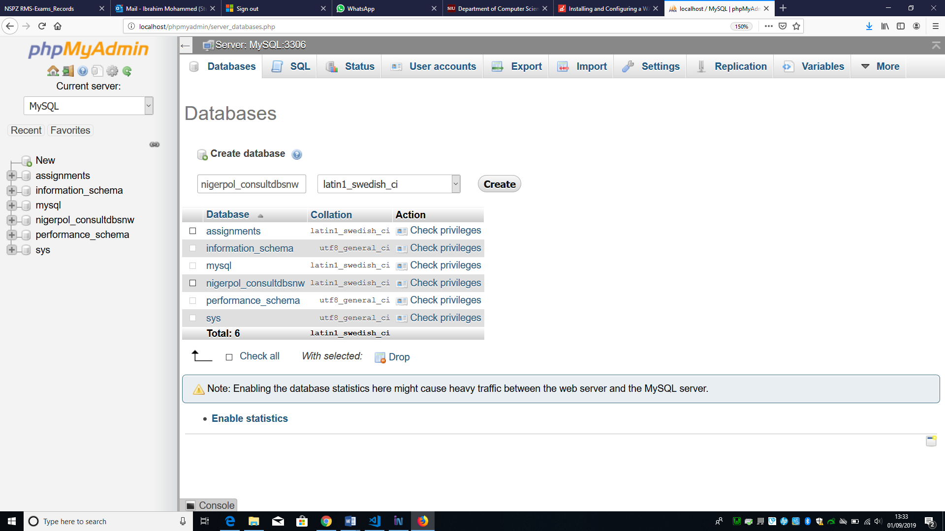

Figure 3. 4: Creating Database

* Click on the database name (nigerpol_consultdbsnw) at the right panel, then click on import at the top menu bar then click on browse to select the SQL file containing the statements for creating tables. (see figure below)

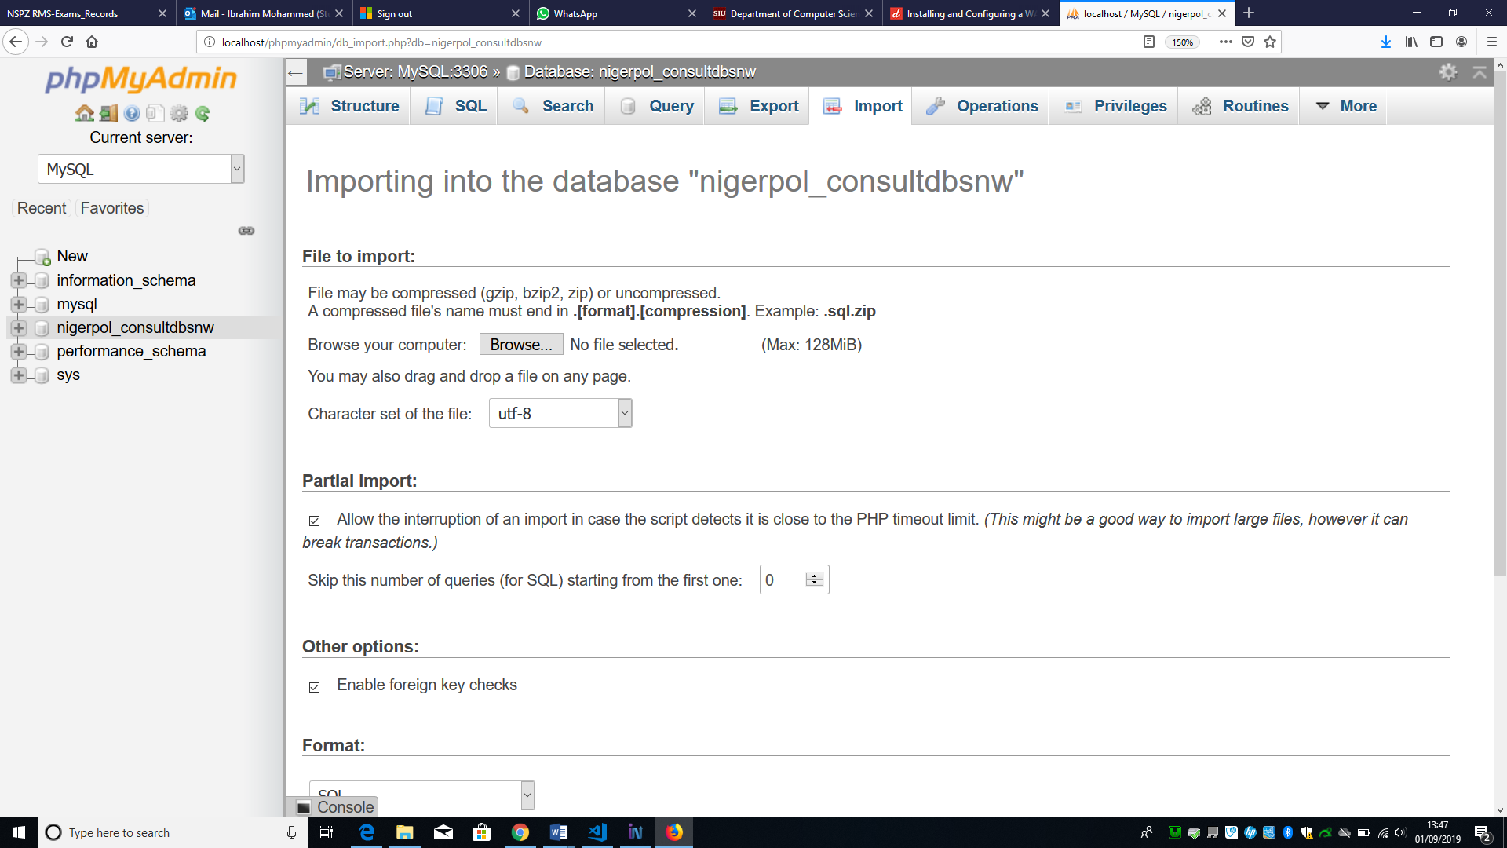

Figure 3. 5: Importing Database

## 3.3 SQL Statement.

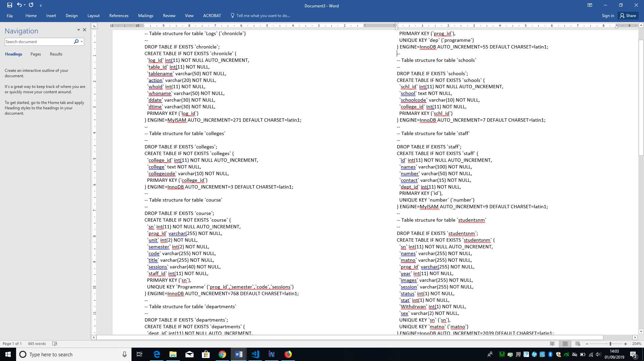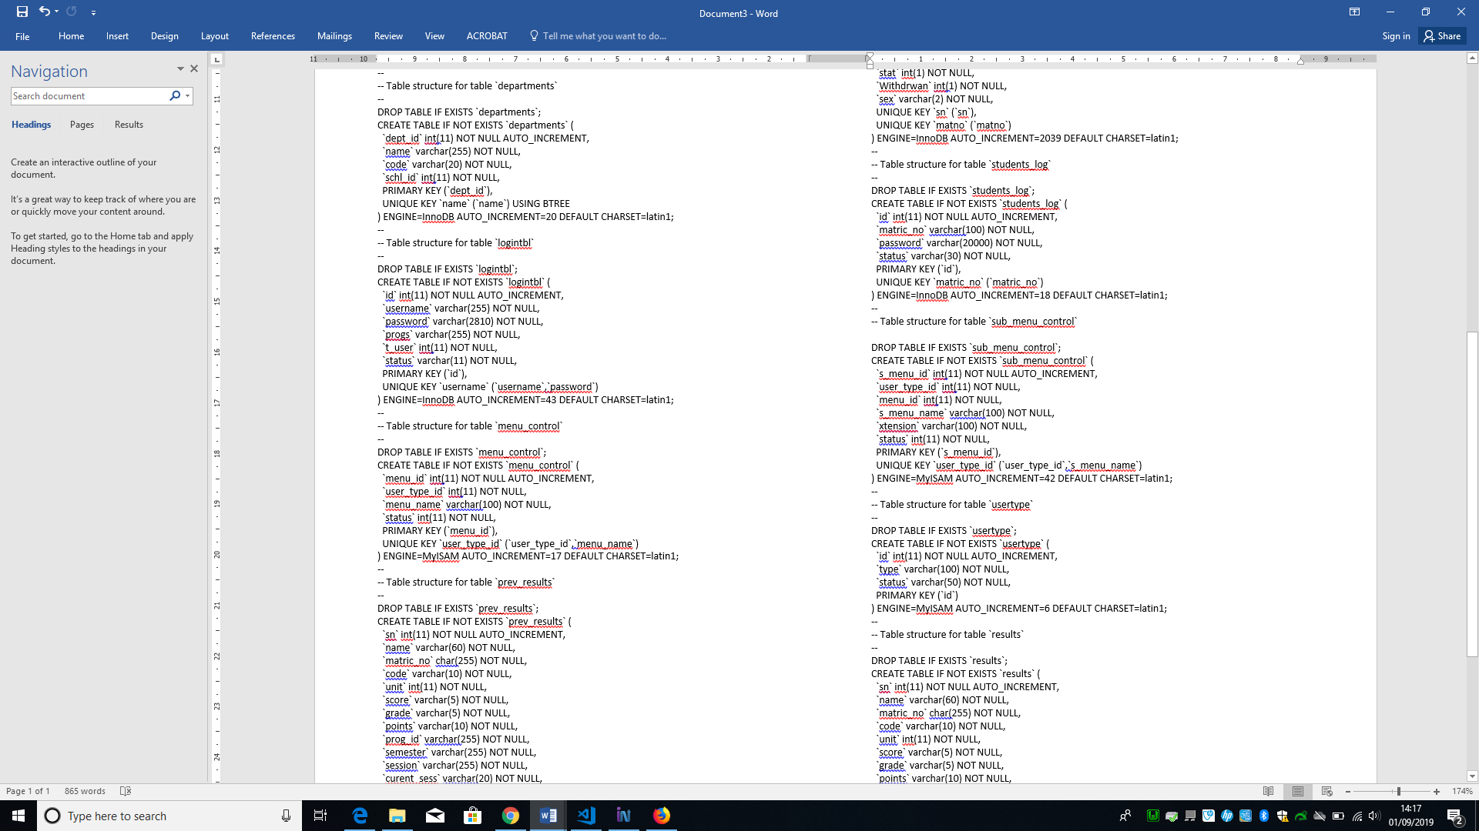

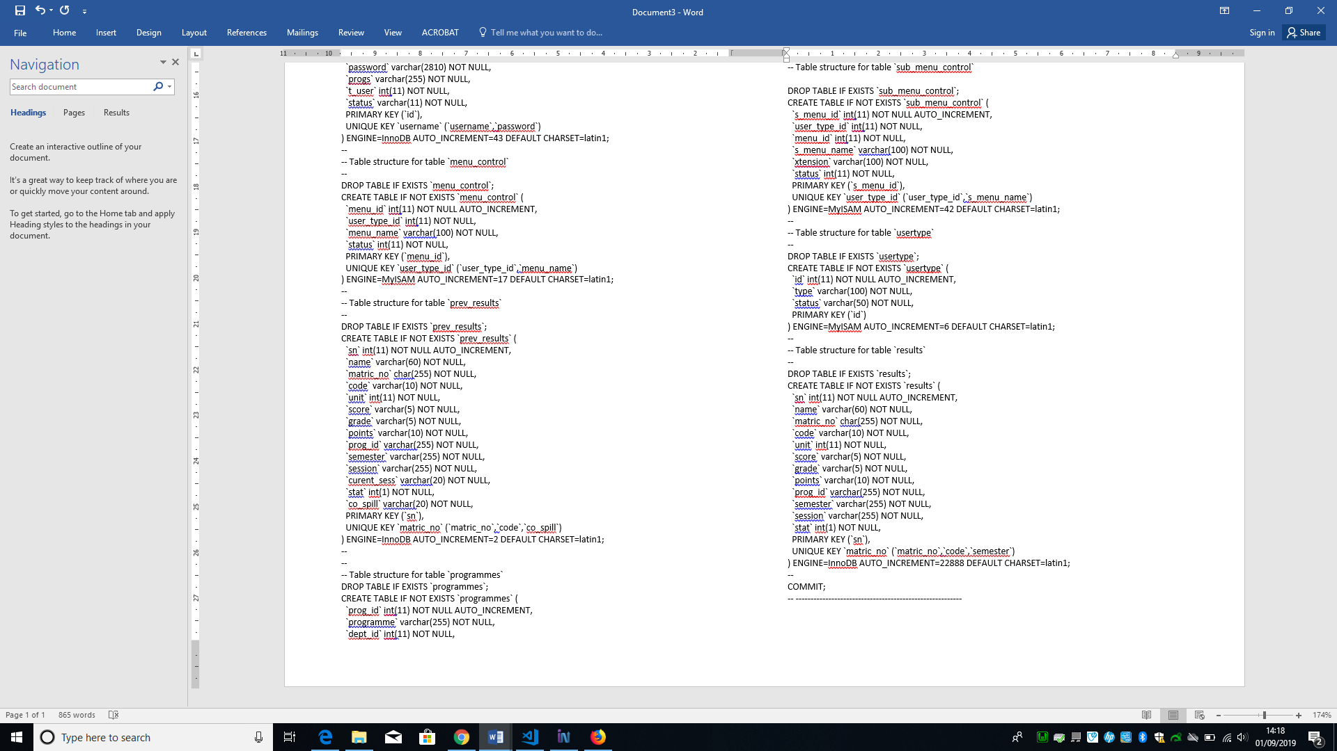

# 4.0 Getting started

To access the system Launch the server, then launch a browser and type in the address bar: (<http://localhost/The_RMS/SEET/>). A login page is displayed as shown in figure 2 below.

Currently the Online Result Computation System is hosted on the Students server (ZENO) and can be accessed through the URL:

<https://zeno.computing.dundee.ac.uk/2018-msc/ibrahimmohammed/The_RMS/SEET/>

### 4.1 Login

All user of the system are required to enter their login details on the login page to access their dashboard and navigation menus. When the users enter their login detail the system authenticate and verify user detail, if the details are correct then user is given access to the system, otherwise the user is prompted “incorrect login details” and denied access. See the login page in figure 4.1 below.

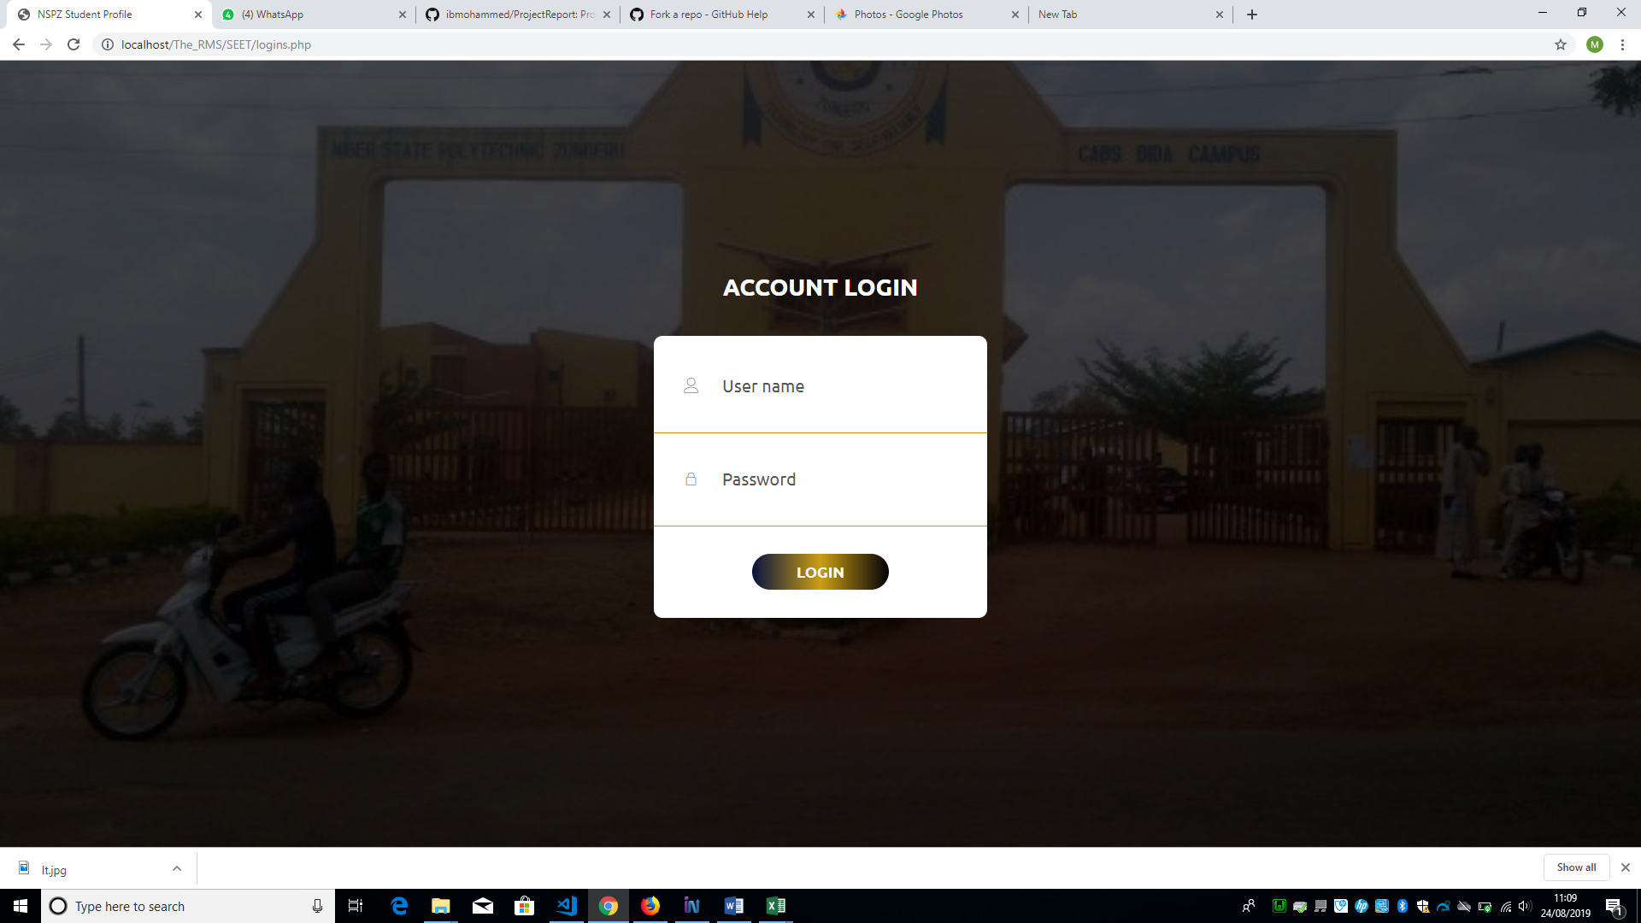

Figure 4. 1:User Login Page

### 4.1.1 Admin Login Access.

The System Managers (Admin) user access is (Username: Admin, Password: 000000). Access to other user can be created through the System manager. See section 5.6: (User access control) below. This password is the default and can be changed as well (see section 5.6(User access control)). The users (Student and Teacher) have default passwords as; Easy0123 and Simply012345 and as user logged in the passwords can be changed from the menu “settings”.

For user (student), if they logged in with the default password, it ask for confirmation of identity (see the figure 4.1.1, 4.1.2, 4.1.3 & 4.1.4 below) and provide a link to change their password.

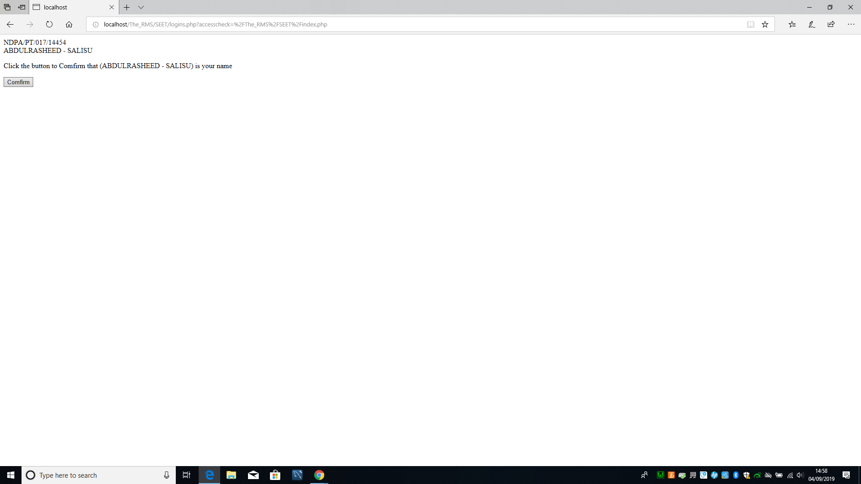

Figure 4.1.1: confirmation statement

If the user clicks on the button “confirm” in the figure above it popup the dialogue box below.

If the user clicks on cancel, it redirect the user to the login page, otherwise if the user clicks on OK it direct the user to figure 4.1.3 below.

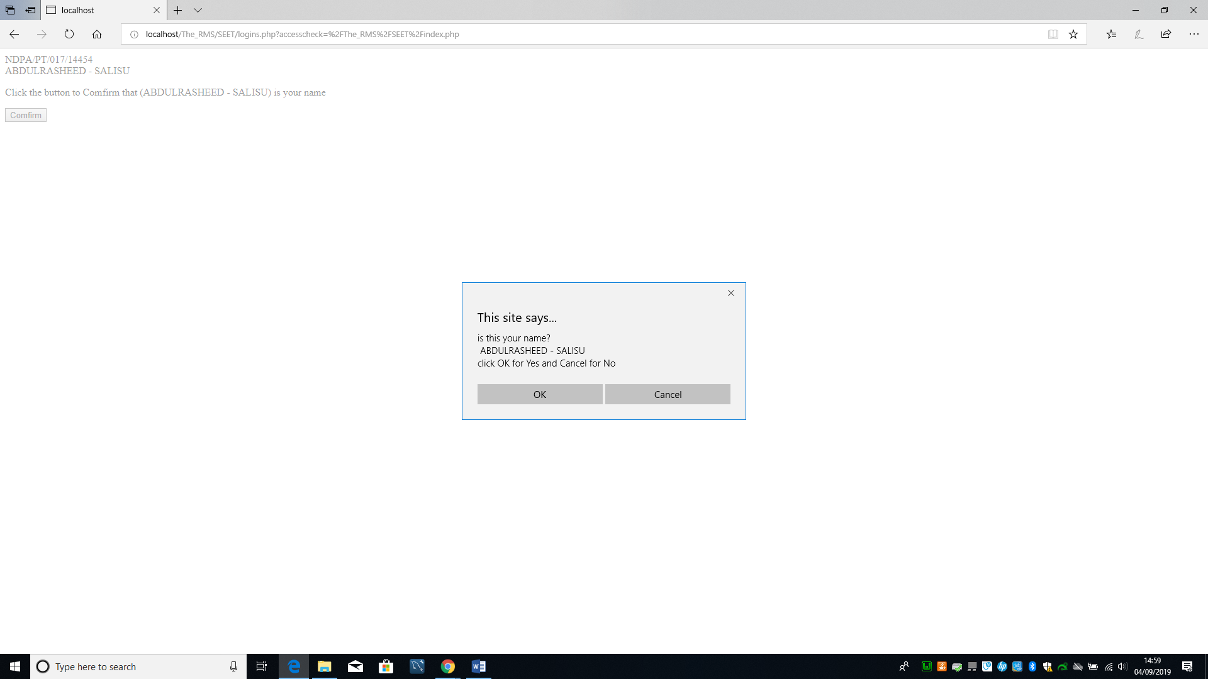

Figure 4.1.2: Confirmation Dialogue box

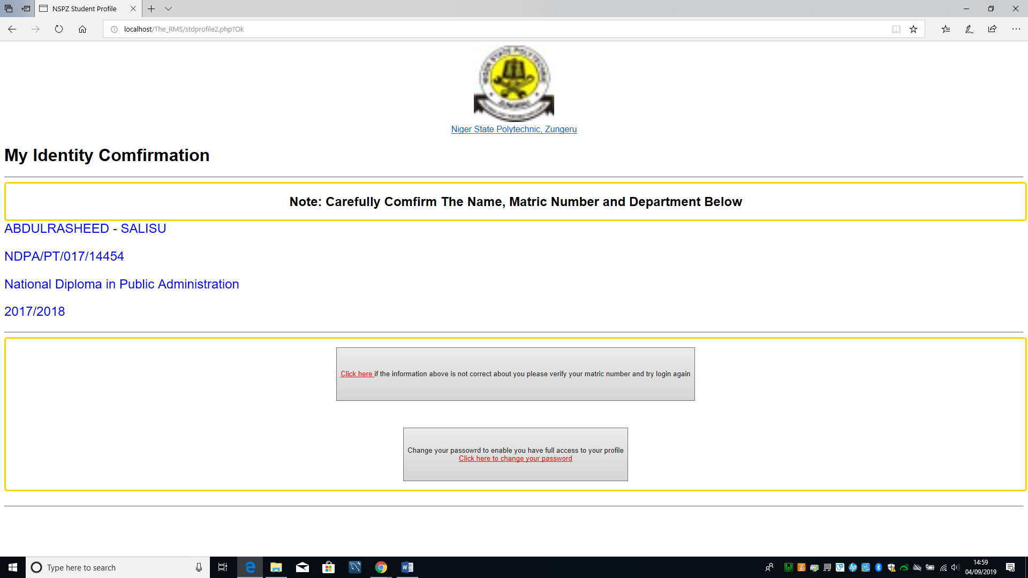

Figure 4.1.3: My Identity Confirmation Page

If the user clicks to change password, it popup the window in figure 4.1.4 below to enable the user change password. Immediately the user enters the password and click on confirm. It redirect the user to login page. If the user login with the new login credentials, the system opens the users profile page (Dashboard and navigation menu) see figure 4.12: below.

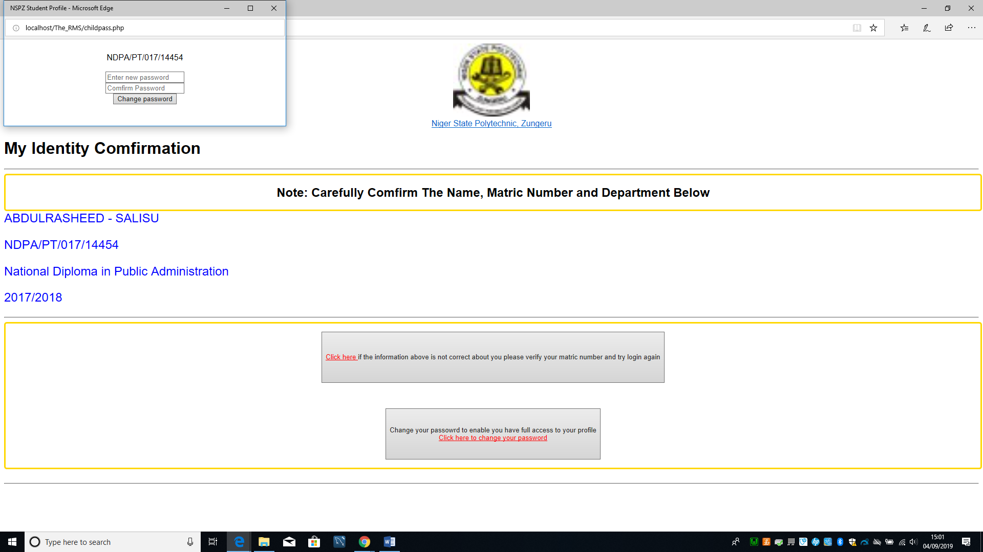

Figure 4.1.4: Change Password

### 4.2 User Dashboard

Every user when logged in successfully, will be presented a dashboard, logout icon, profile drop down, menu at the top right-hand corner of the page and navigation menus, every user is presented with different dashboard, and navigation menu.

The dashboard of the users (system manger, and exams & records) shows a link for viewing colleges, schools and departments. For user (coordinator) the dashboard shows the name of the college, school and department in which the coordinator belongs, and a link to view the programmes in the department. The dashboard of user (student) shows the course unit offered by the student, the cumulative grade point (CGP), the cumulative grade point average (CGPA) and the courses offered and result of each course. The dashboard of user (teacher/lecturer) shows the name of the college, school, department to which a teacher / lecturer belongs, and the courses allocated to user (teacher). See all the users’ dashboards below in figure 4.10, 4.11, 4.12 & 4.13

### 4.3 The Users’ Navigation Menu

The navigation menu of the user (System Manger) comprises of the menus; generate templates, manage backup, manage courses, manage programme, manage student and user access control (see figure 4.2).

The navigation menu of the user (Teacher) comprises of Exam score, generate template and setting (see figure 4.5).

The navigation menu of the user (Coordinator) consist of the menus; Allocation, Generate Template, Manage Result, Manage Score, Result Analysis and Settings (see figure 4.3).

The navigation menu of the user (Exams and Records) consist of the menus; Courses, Result, Student data and Settings (see figure 4.6).

The navigation menu of the user (Student) consist of menus; Semester Results, and Settings (see figure 4.4).

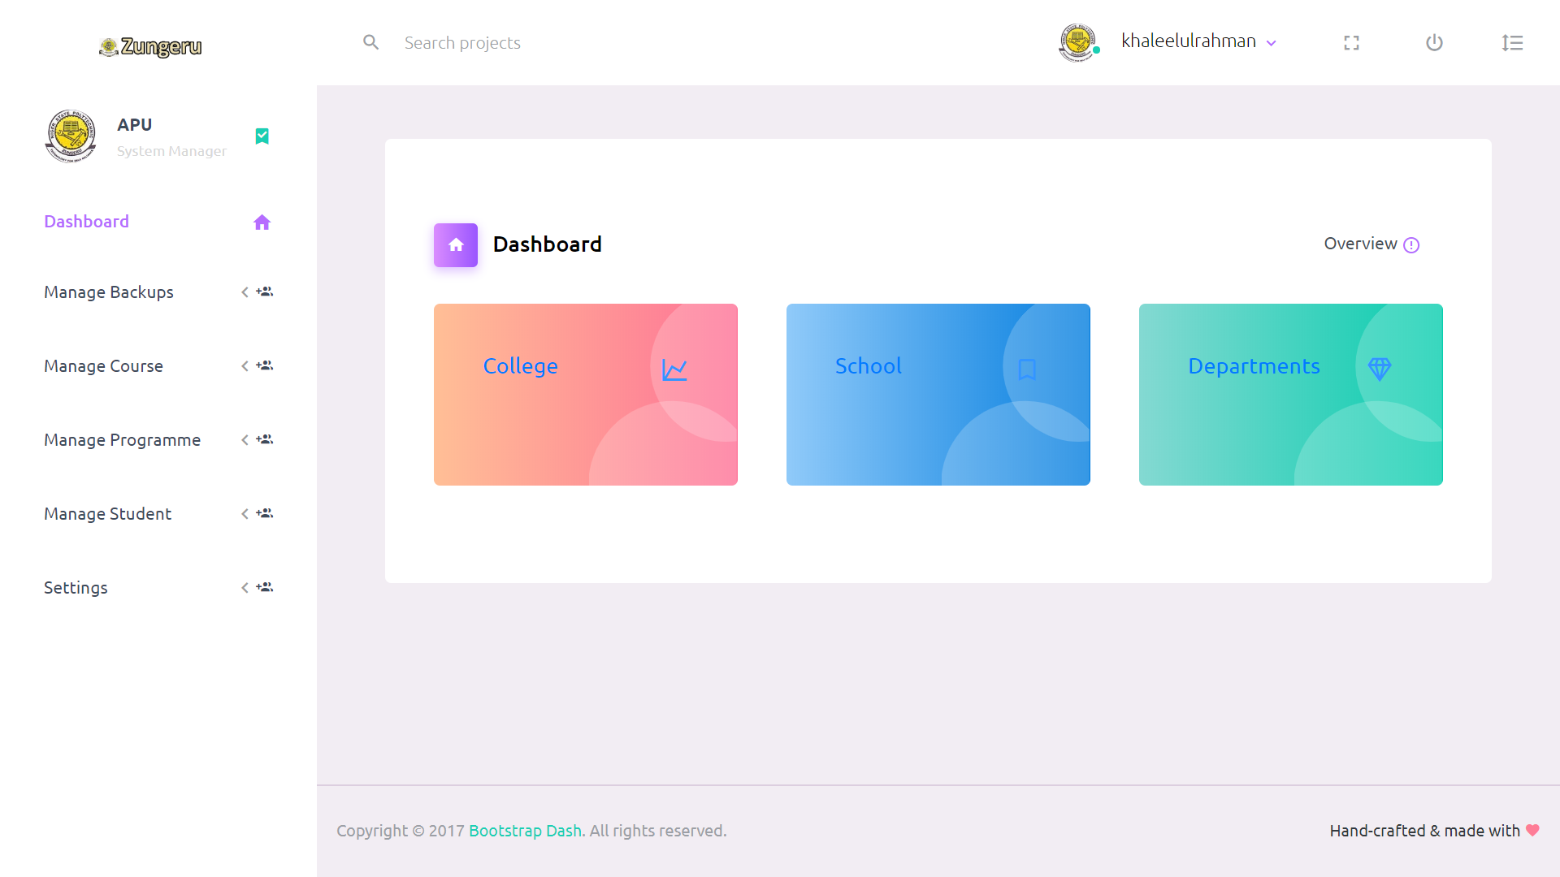

Figure 4. 2: System Manager Menu

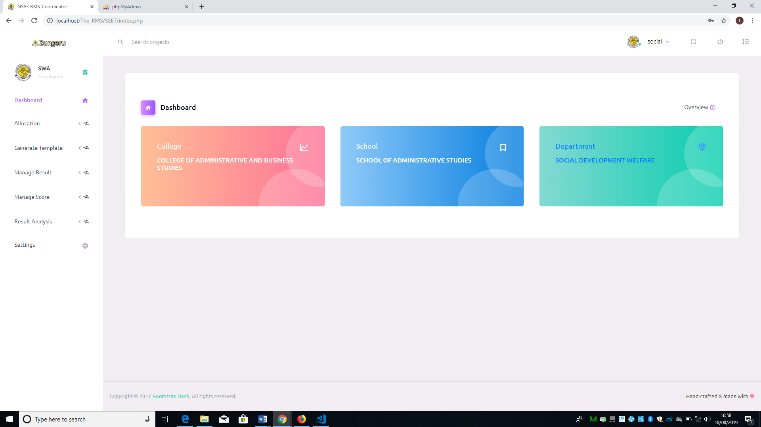

Figure 4. 3: Coordinator Menu

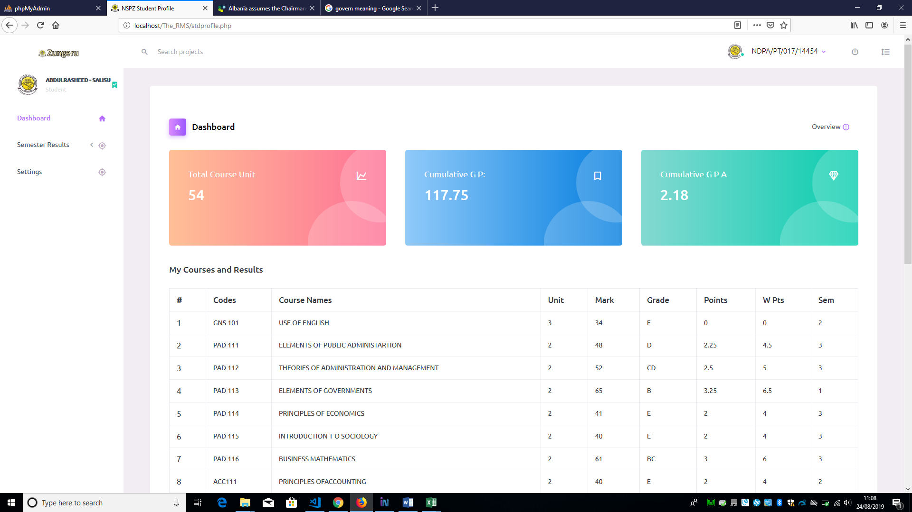

Figure 4. 4Student Menu

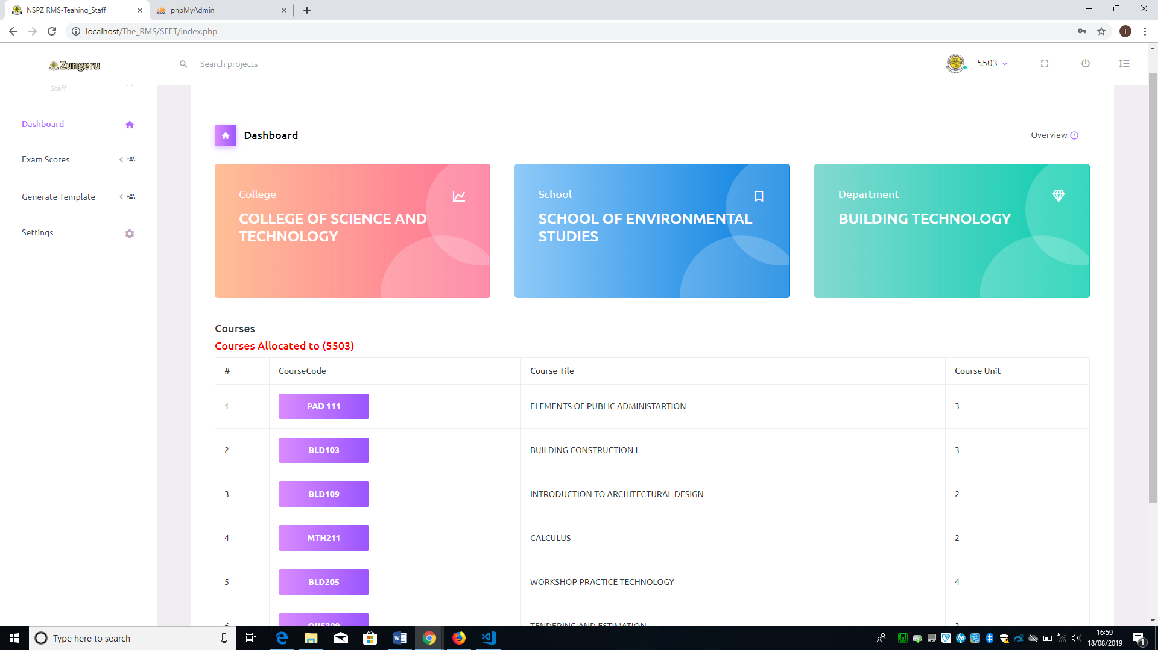

Figure 4. 5: Teacher Menu

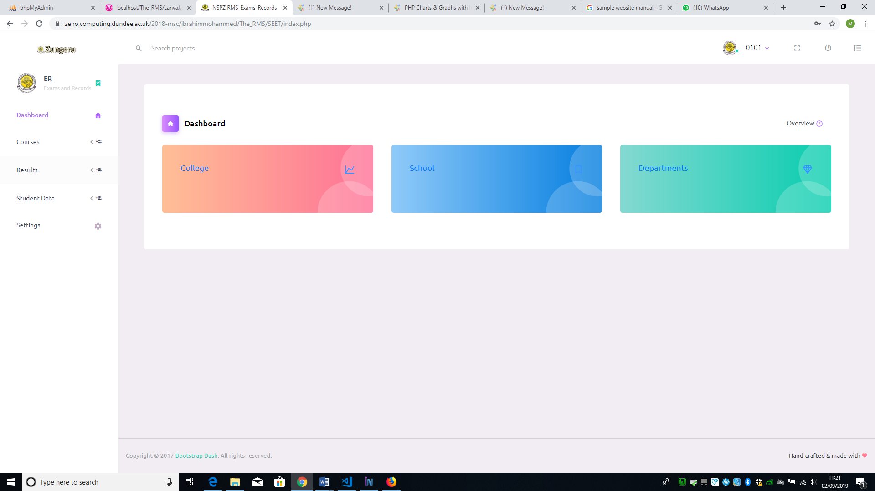

Figure 4. 6: Exam & Records Menu

### 4.4 The “profile dropdown” Menu

The “profile dropdown” menu shows the username/id of user and when click, it gives a submenu in dropdown, the users (Student, Teacher, exams & records) have the same submenu (Signout) on the dropdown while the system manger have the submenu as Activity Log and Signout. The “Activity Log” sub menu enables the system manager to view user logs and the Signout is to exit the user out of the system. Figure 4.7, & 4.8 shows the “profile dropdown”.

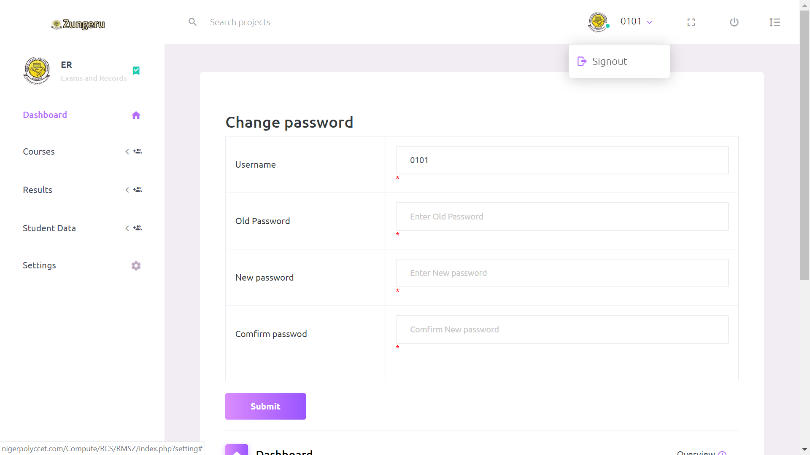 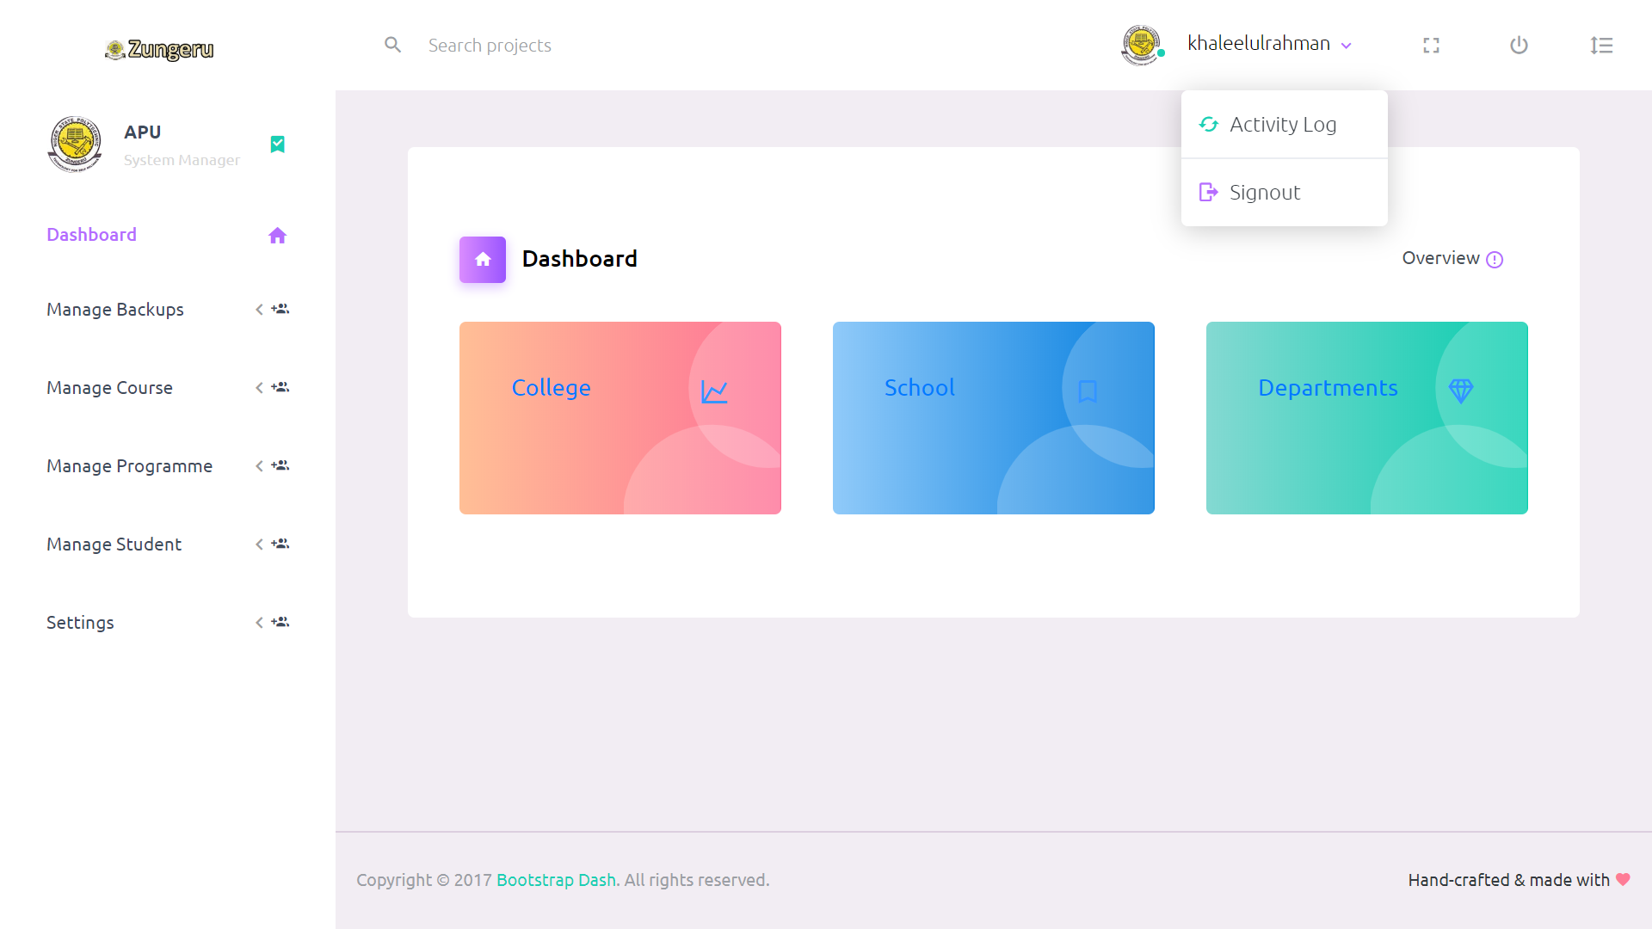

Figure 4. 7: Other Users Profile Dropdown Menu Figure 4. 8: Users (System Manager) Profile Dropdown Menu

### 4.5 Settings

Setting is a menu common to the users (coordinator, Teacher, Student and exam & record), when the menu is clicked on, it displays form to enable the users change their password, the user fills in their username/id, their old password, a new password, and a confirmation password in the fields provided. Figure 4.8 shows the form for changing user logging details.

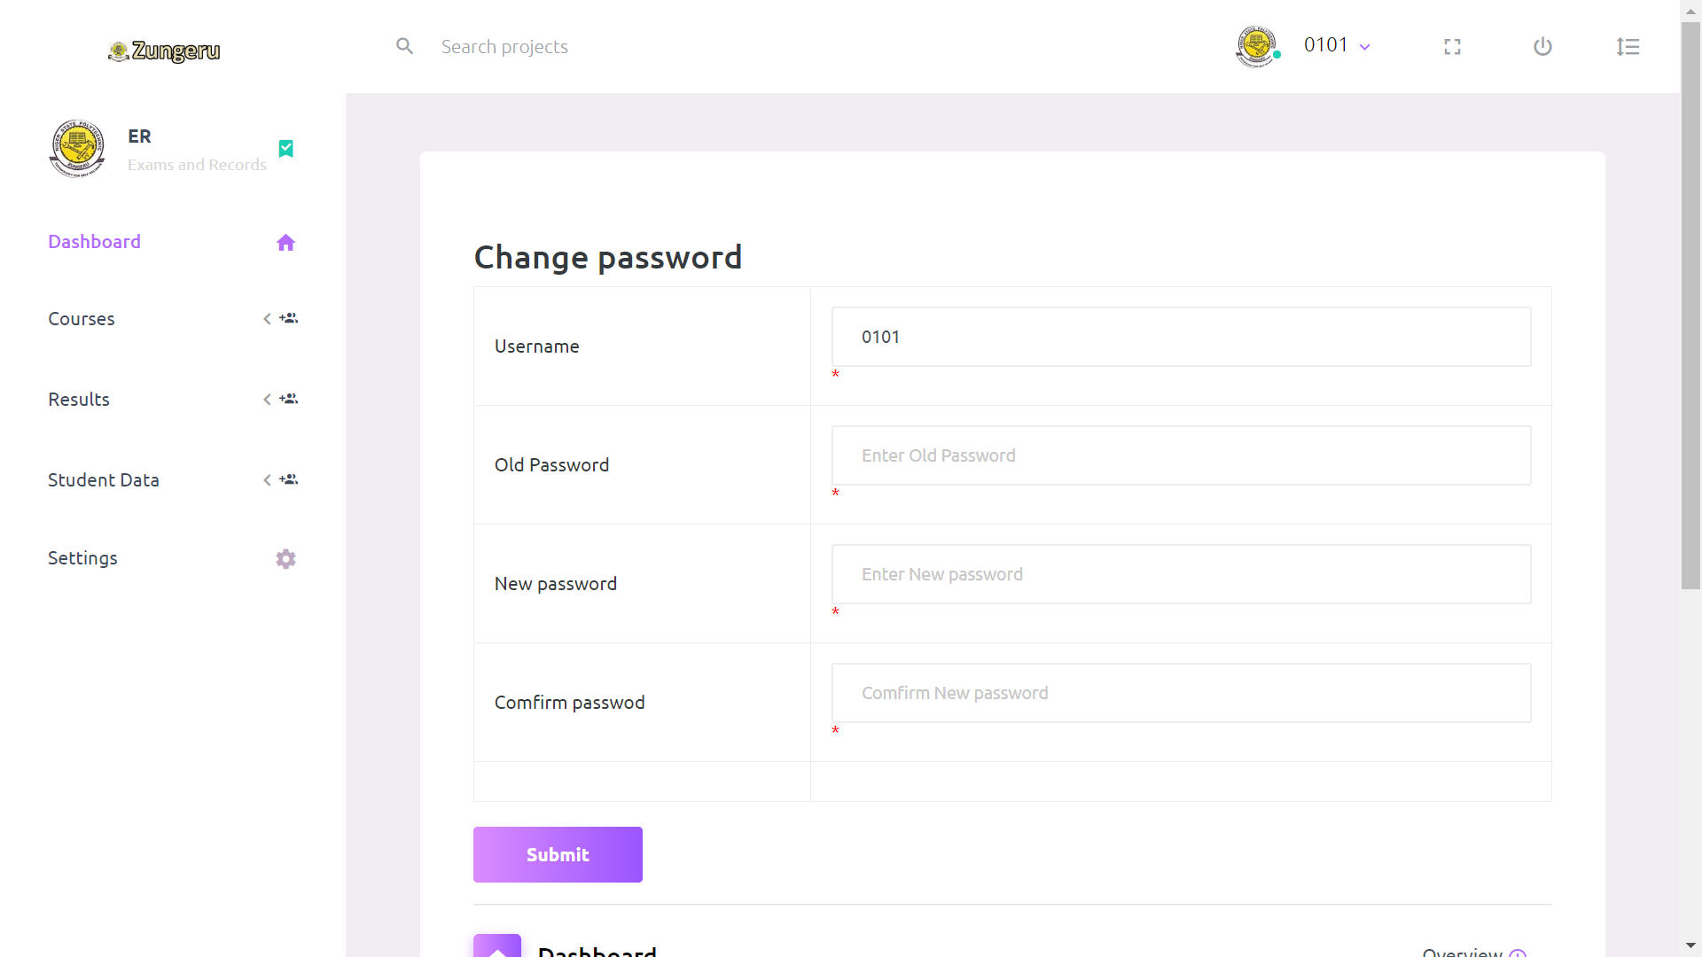

Figure 4. 9: Change Password Form



Figure 4. 10: System Manager Dashboard



Figure 4. 11: Coordinator Dashboard



Figure 4. 12: Student dashboard



Figure 4. 13: Teacher/Lecture dashboard

# 5.0 System Manager Role

The user (system manager) after a successful login can have access the dashboard and navigation menus as described below. Figure 4.10 show the system manager dashboard and menu.

### 5.1 Generate Template menu:

This menu comprises of sub menus (student data and course data template). If a user clicks on student data and course data template it generates a “.csv” file format for entering student data and course data respectively (See figure 5.1).

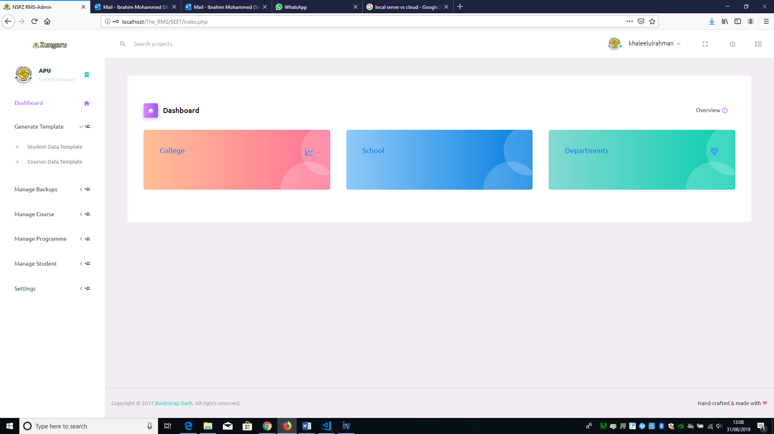

Figure 5. 1: Generate Template Menu and Submenus

### 5.2 Manage backups menu:

This menu comprises of two submenus namely; create backup and import backup. Figure 5.2 shows the “manage backup” menu and it submenus.

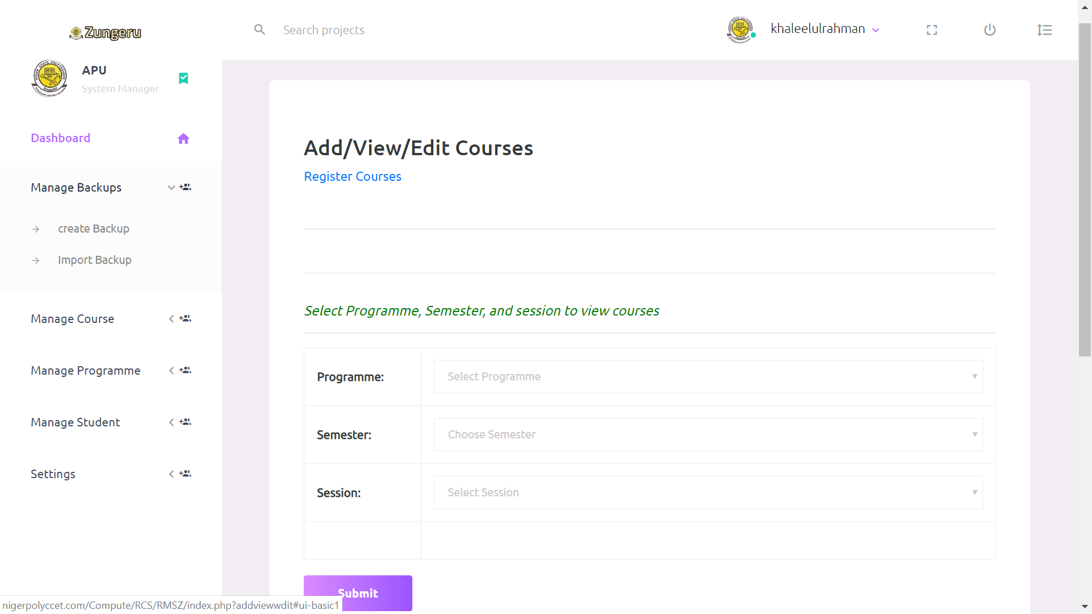

Figure 5. 2: Manage Backup Menu and Submenus

When a user click on the create backup submenu all the records in the database is backed up in .sql file format with the name “db-backup” followed by a time stamp saved in the root folder on the server. , and if user click on the import backup, the system automatically create backup and prompt the user that a backup has been created, then prompt the user that “You are about to import a backup file, Note this will overwrite the existing records, Do you wish to continue?”. Figure 5.3 shows the prompt.

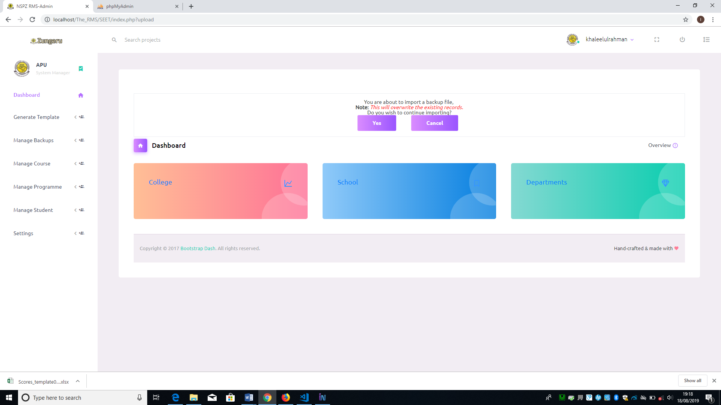

Figure 5. 3: A Prompt for Impotring Backups

### 5.3 Manage courses menu

This menu have four sub menus; import courses, input courses, view courses and edit courses. See the menu and sub menu in figure 5.4 below

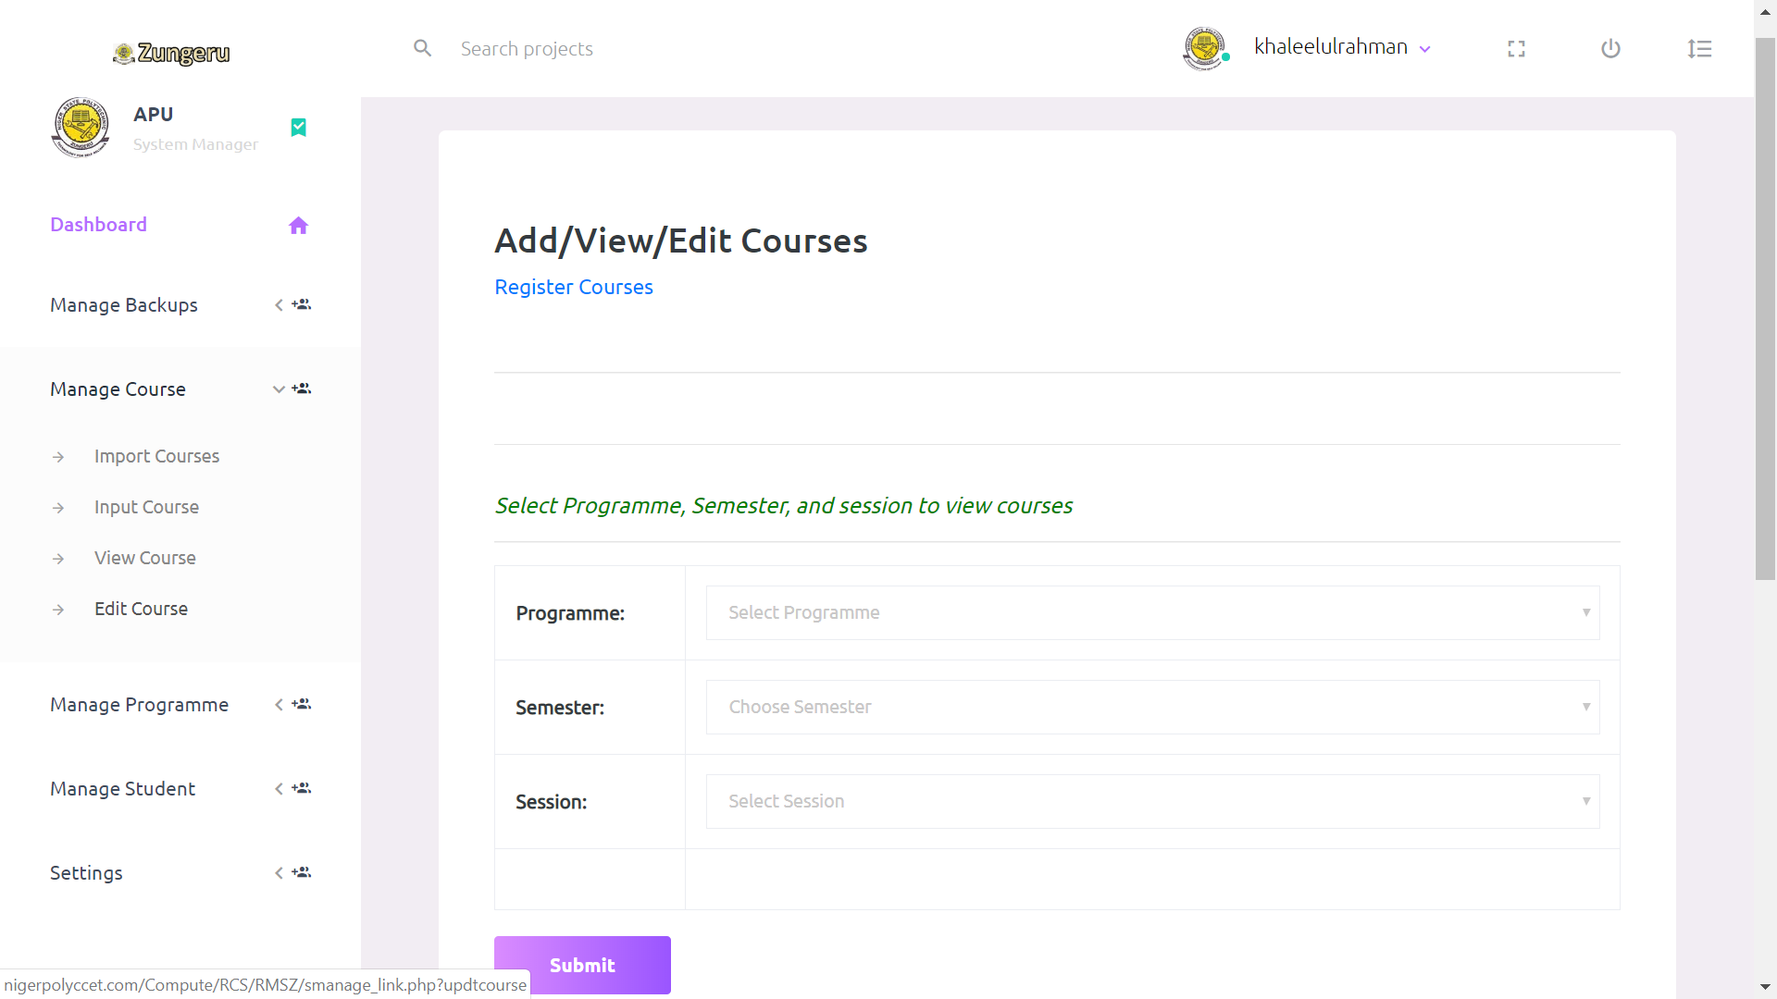

Figure 5. 4: Manage Course Menu and Submenus

As the user click on “import course” sub menu, the system displays a form requiring user to select programme (e.g. National Diploma in Computer Science), session (e.g. 2018/2019), semester (e.g. First Semester), click on choose file to choose file containing the courses to import for the selected programme, semester and session and then Click on the “Submit button” and the content of the file is entered into the database figure 5.5 shows the import courses form.

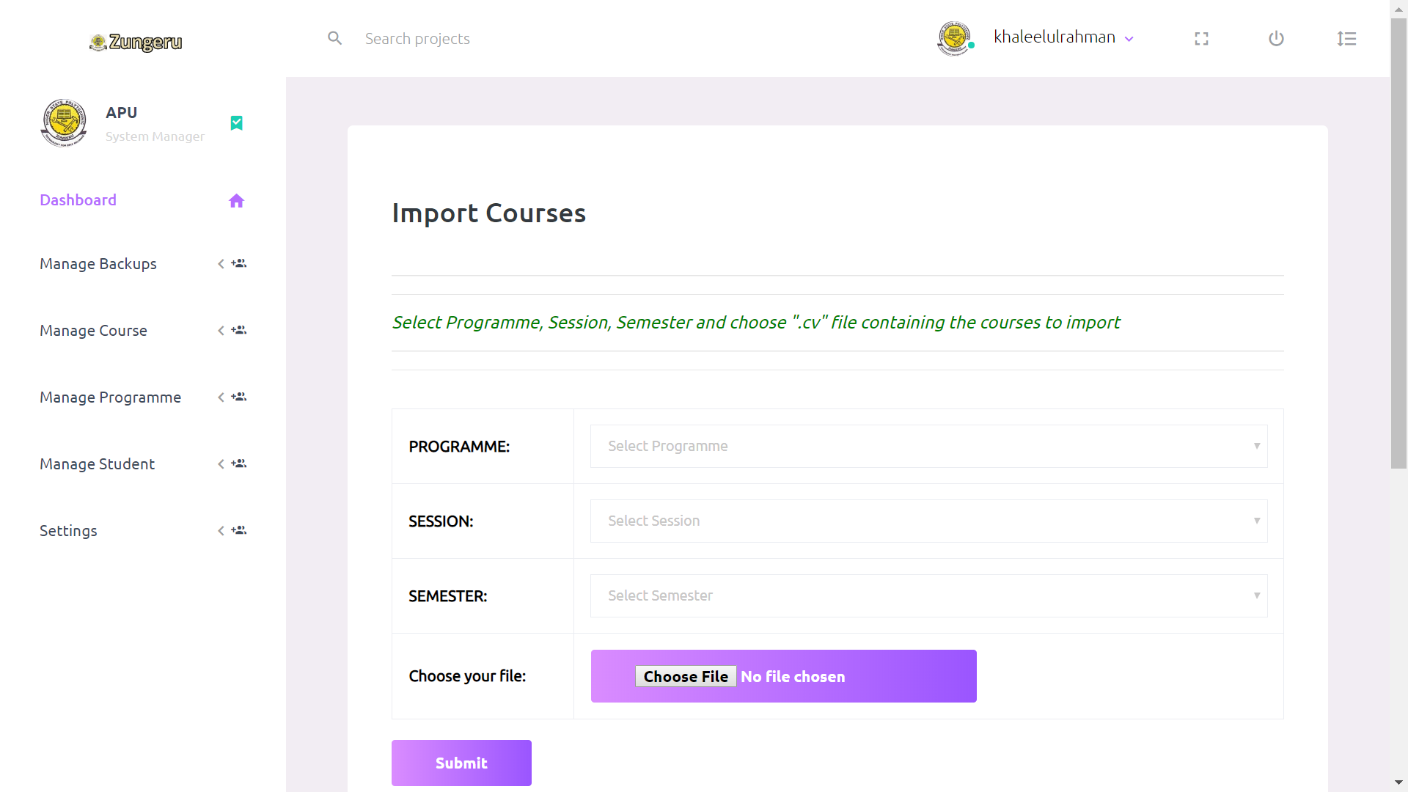

Figure 5. 5: Import Courses.

If user fail to select all/any of the option or choose a file to import, the system prompts the user that “Empty fields are not allowed” then return to the import courses form. Also, if user select the wrong file format or file with wrong column entry, the system prompts the user that “incorrect file format” or “wrong column entry” respectively then return to the import courses form.

If user click on the “input courses” sub menu, the system displays the input courses form, this allow user to fill in the form trough the keyboard with required fields to select programme, enter course title, course code, choose course unit, semester and session, then click on submit, all the entered and select data is entered in the database. See the input courses form in figure 5.6 below

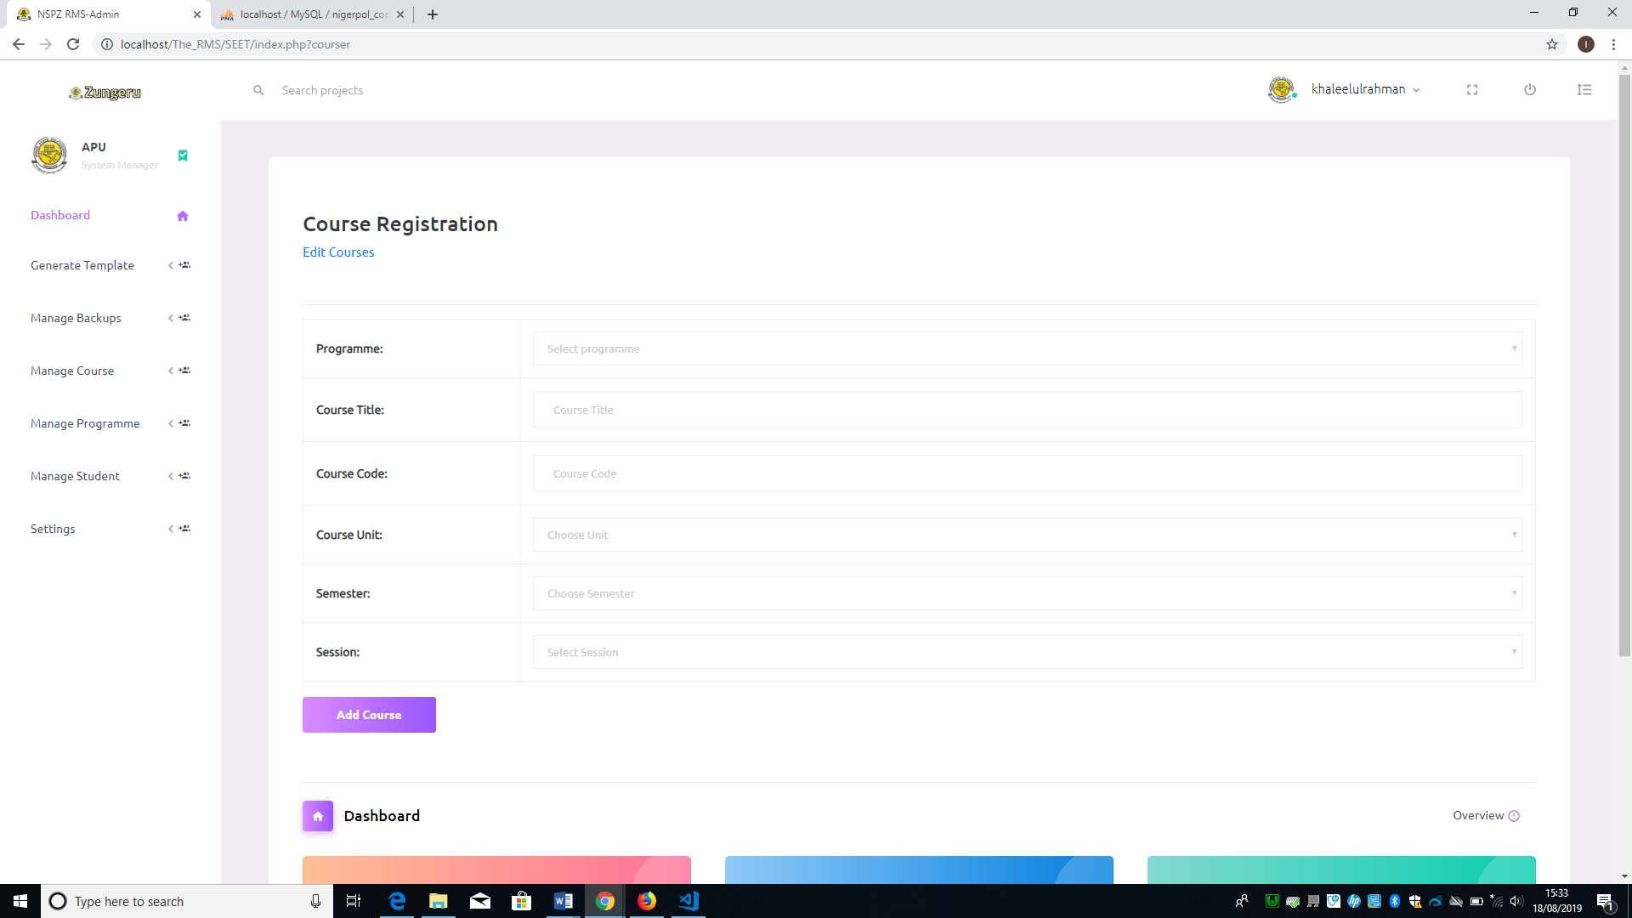

Figure 5. 6: Input Course From

If the user fails to select or enter any of the fields on the form it prompts “Empty fields are not allowed”, then return to the input courses form.

Click on the View courses menu, the system displays a form to select the programme, semester and session of the courses to display. Figure 5.7 shows below

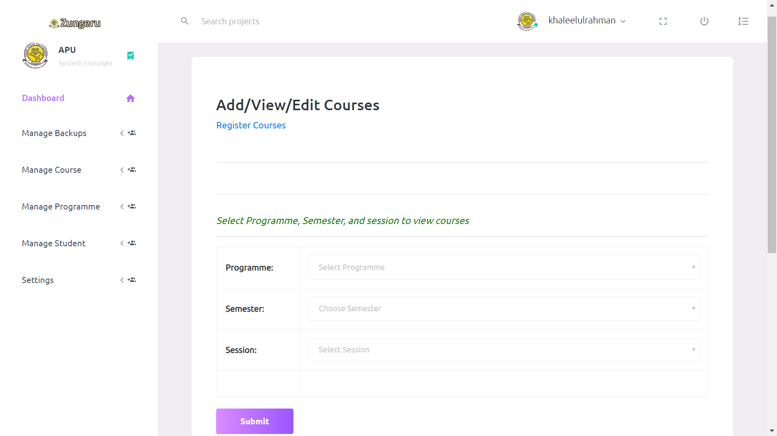

Figure 5. 7: View Courses Form

If all the required fields on the form are selected and the user click on submit, the courses are displayed. Figure 5.8 shows the list of displayed courses.

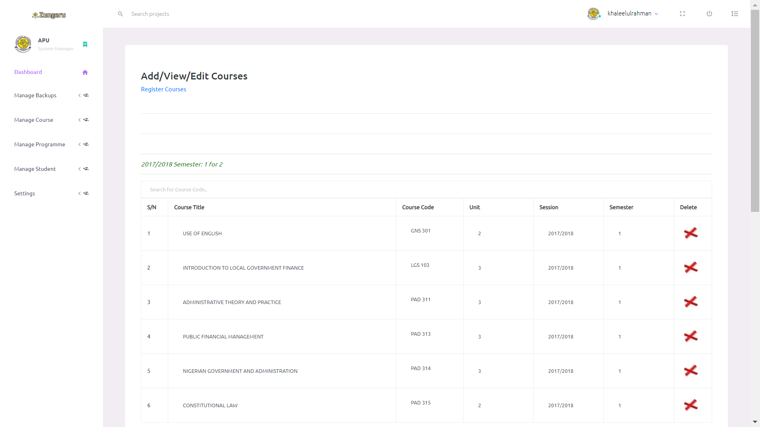

Figure 5. 8: List of Courses

All the list of courses displayed have a corresponding delete icon that enable user delete any of the course record on the list as shown in figure 5.26 above.

Clicking on the “edit courses” submenu the system displays a form to enable the user to select the programme, semester and session of the courses to be edit and it displays a form with list of courses (see figure 5. 27), it allow user to directly make changes to the records then save the changes by clicking on the button “Edit Records”. Figure 5.9 shows the edit course form.

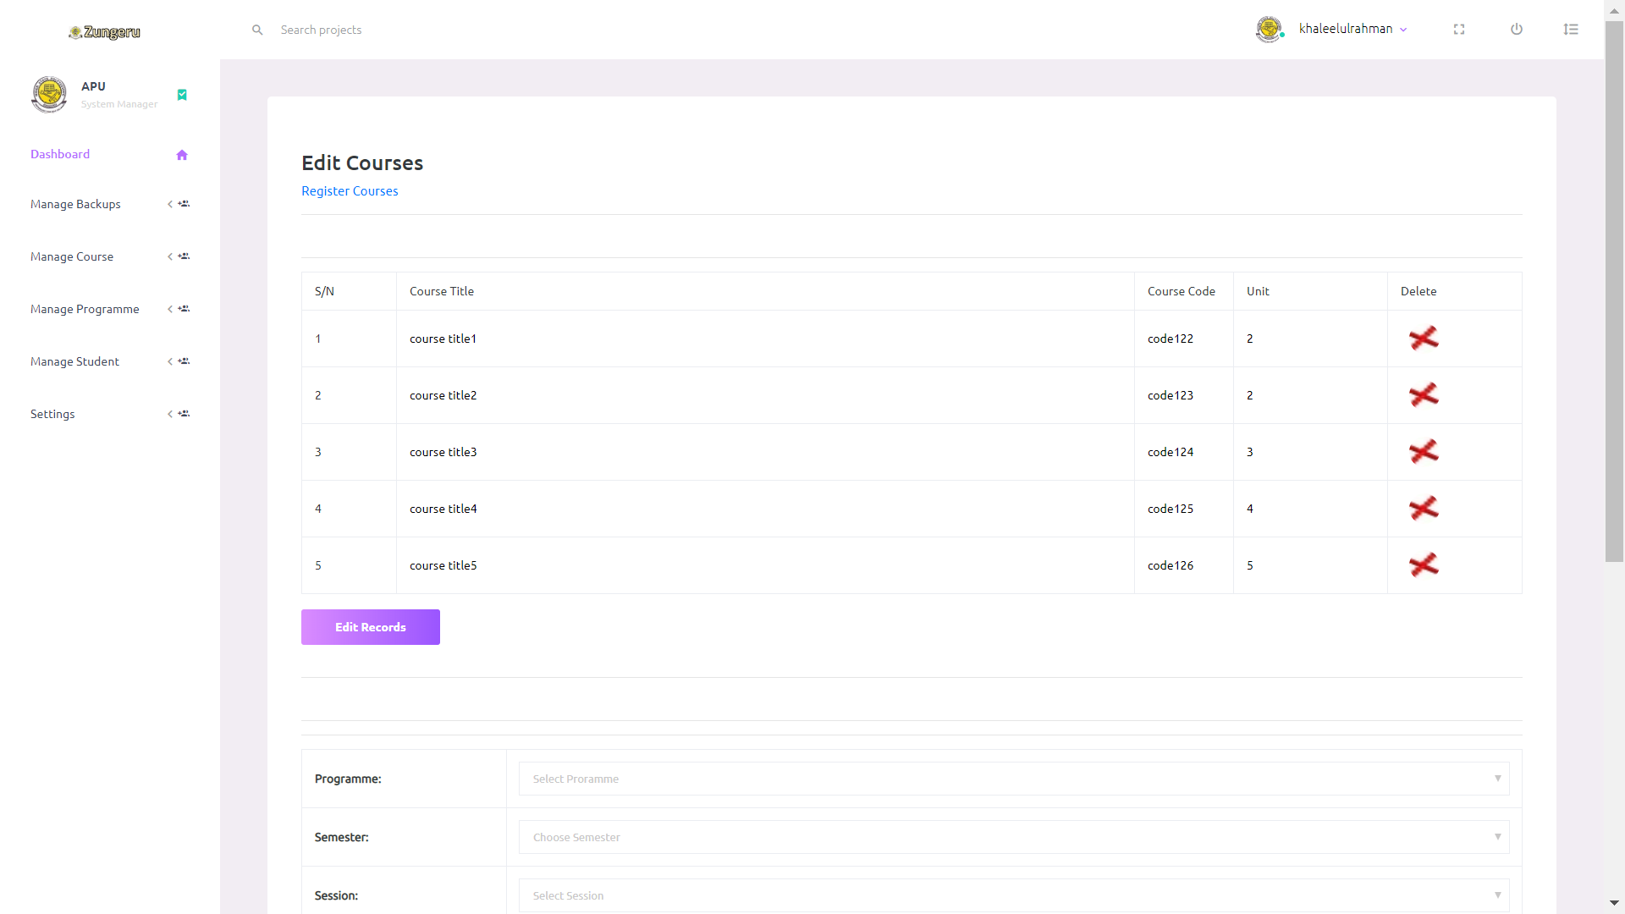

Figure 5. 9: Edit Course Form

### 5.4 Manage Programme

This menu comprises of eight sub menus; Import /input programmes, Input /import department, Edit/View programme, and Edit/View Department. Figure 5.10 shows the menu and the submenus.

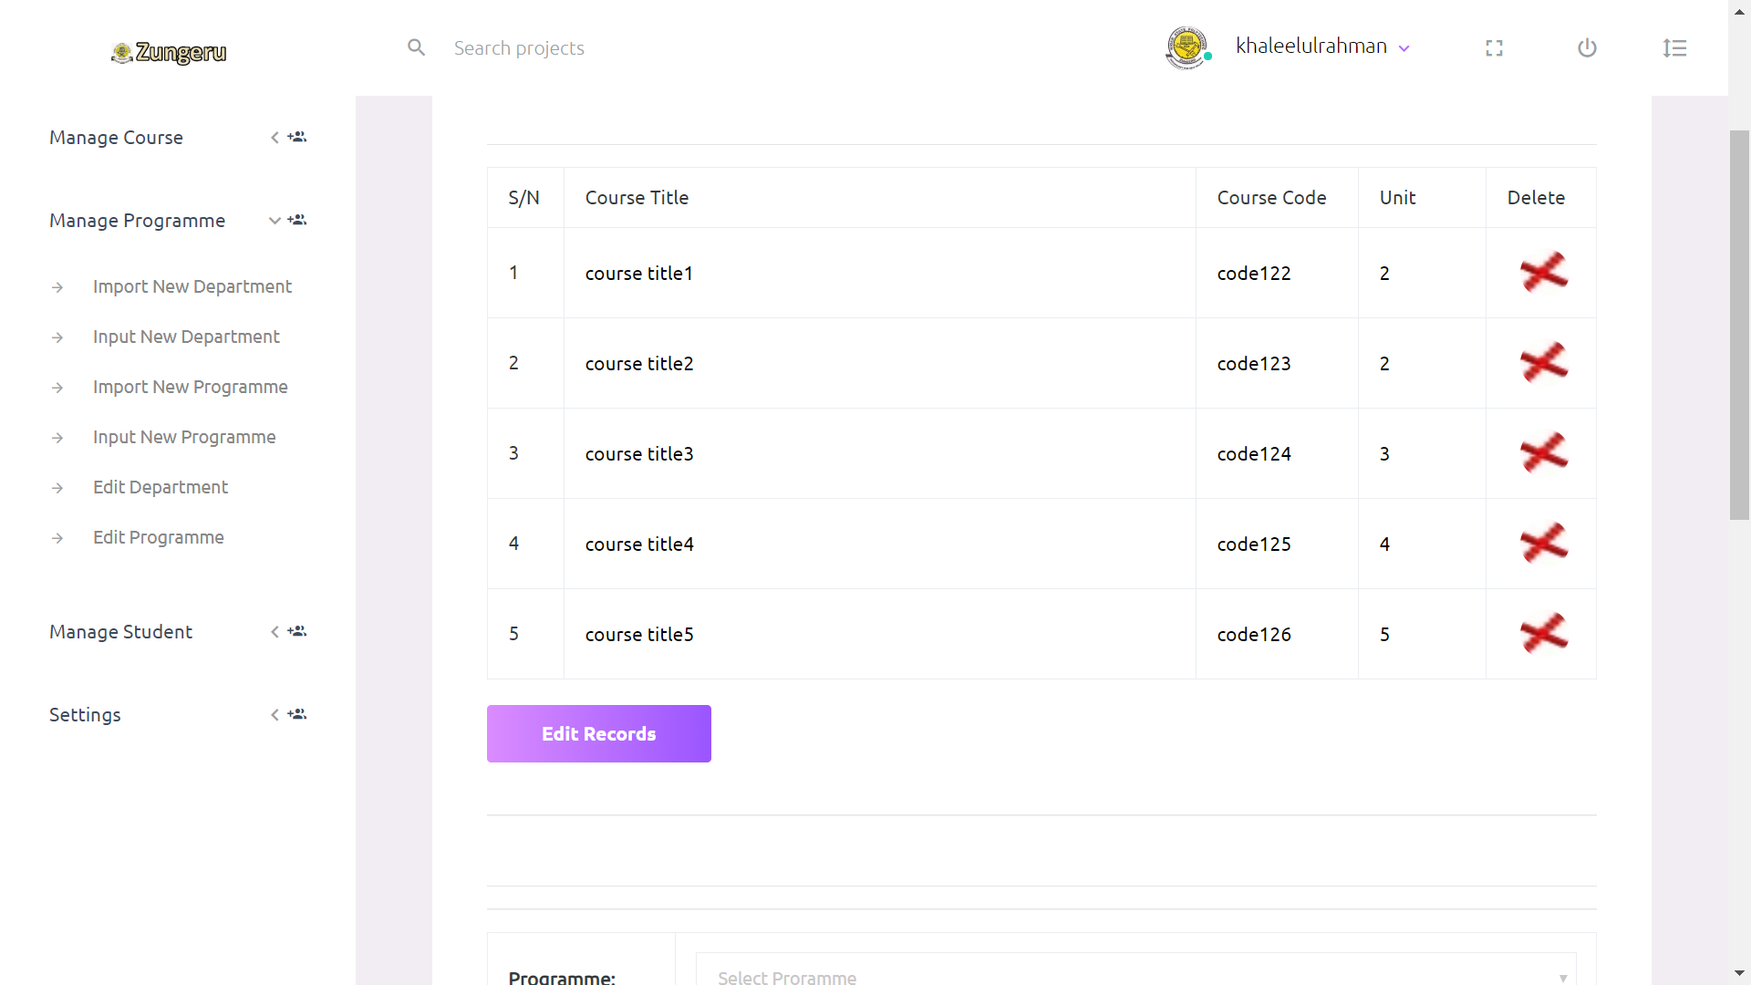

Figure 5. 10: Mange programme Menu and the Submenus

The sub menus are to enable the user add records of college, school, department, and programme via the keyboard or to add by importing file in .csv format through a form. If user is using the input submenu only one record in added at time while the import allows multiple records to be entered into the dataset at once Figure 5.11 & 5.12 shows the import and input forms.

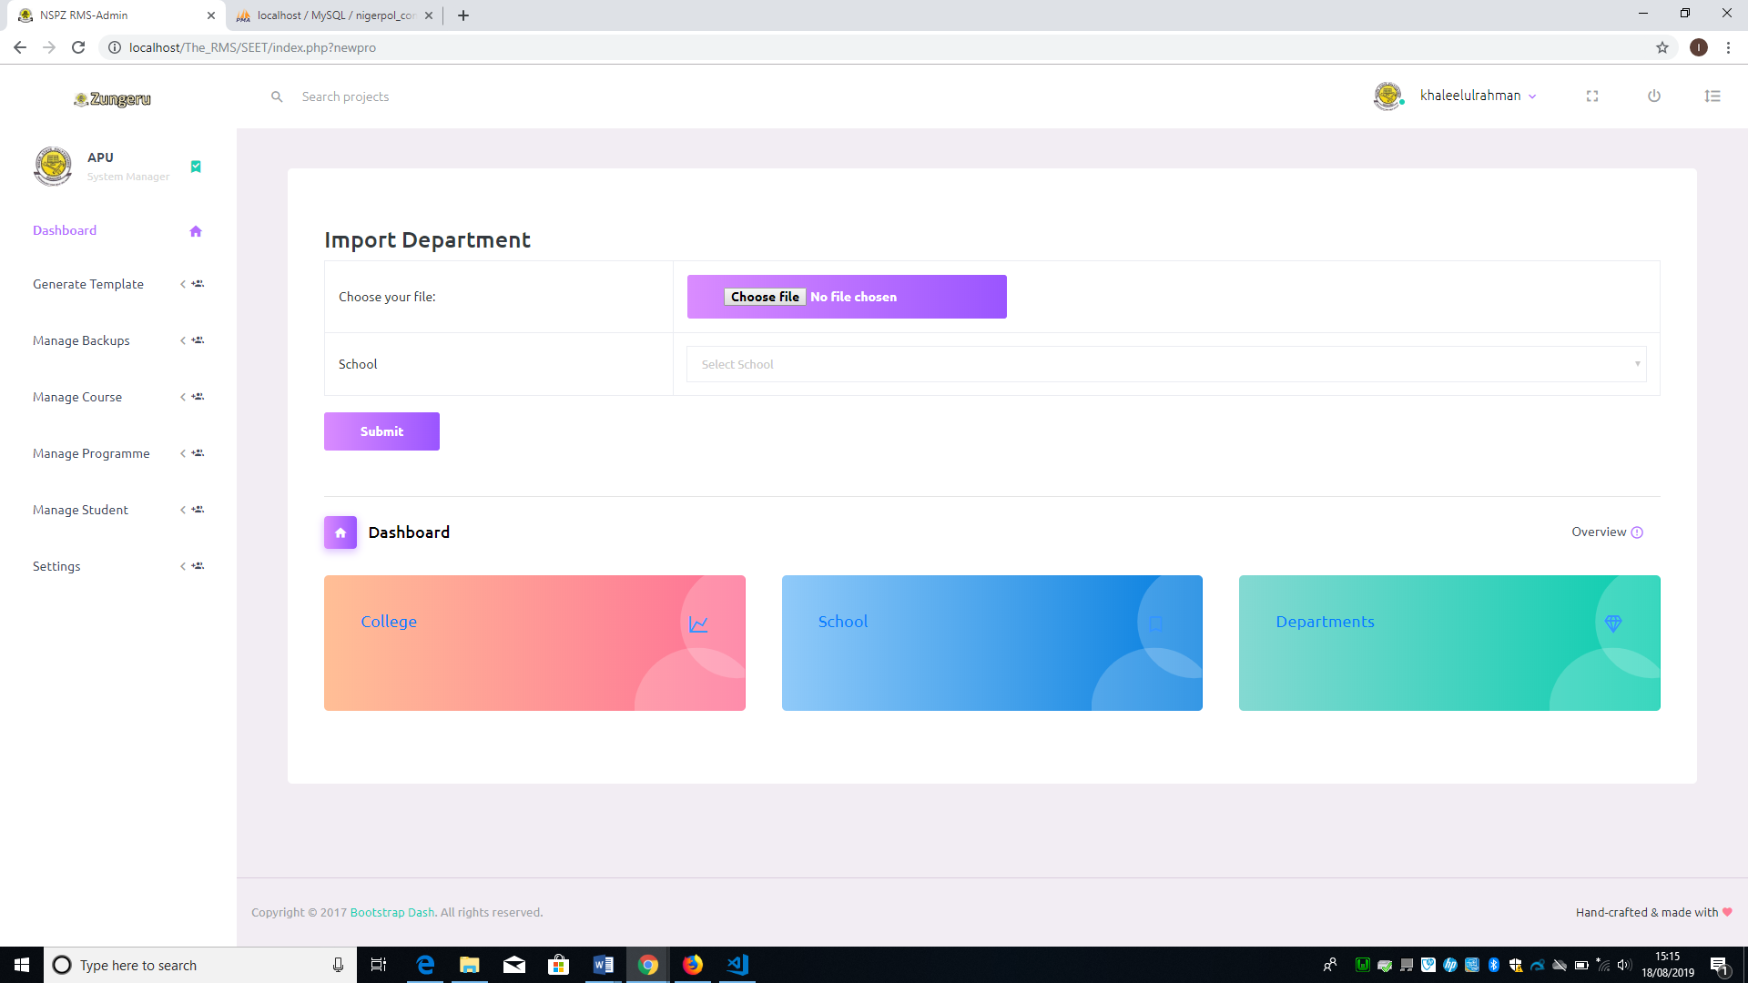

Figure 5. 11: Import Department Form

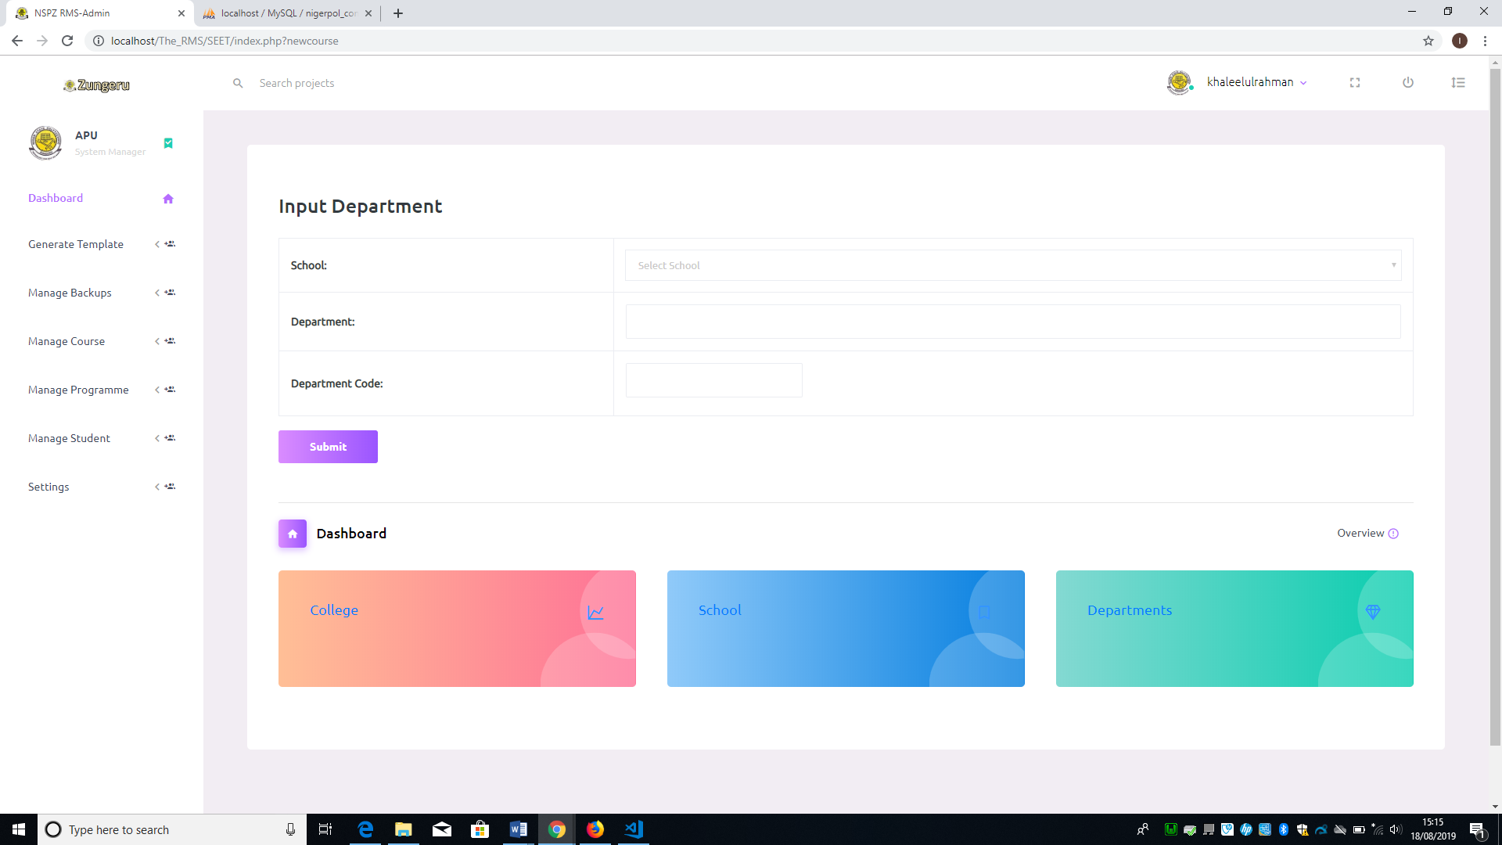

Figure 5. 12: Input Department Form

The user can also view or edit the programme or department, by clicking on edit programme or edit department, it displays the programmes or department with edit and delete links to the left corresponding to each record. See figure 5.13 & 5.14 below

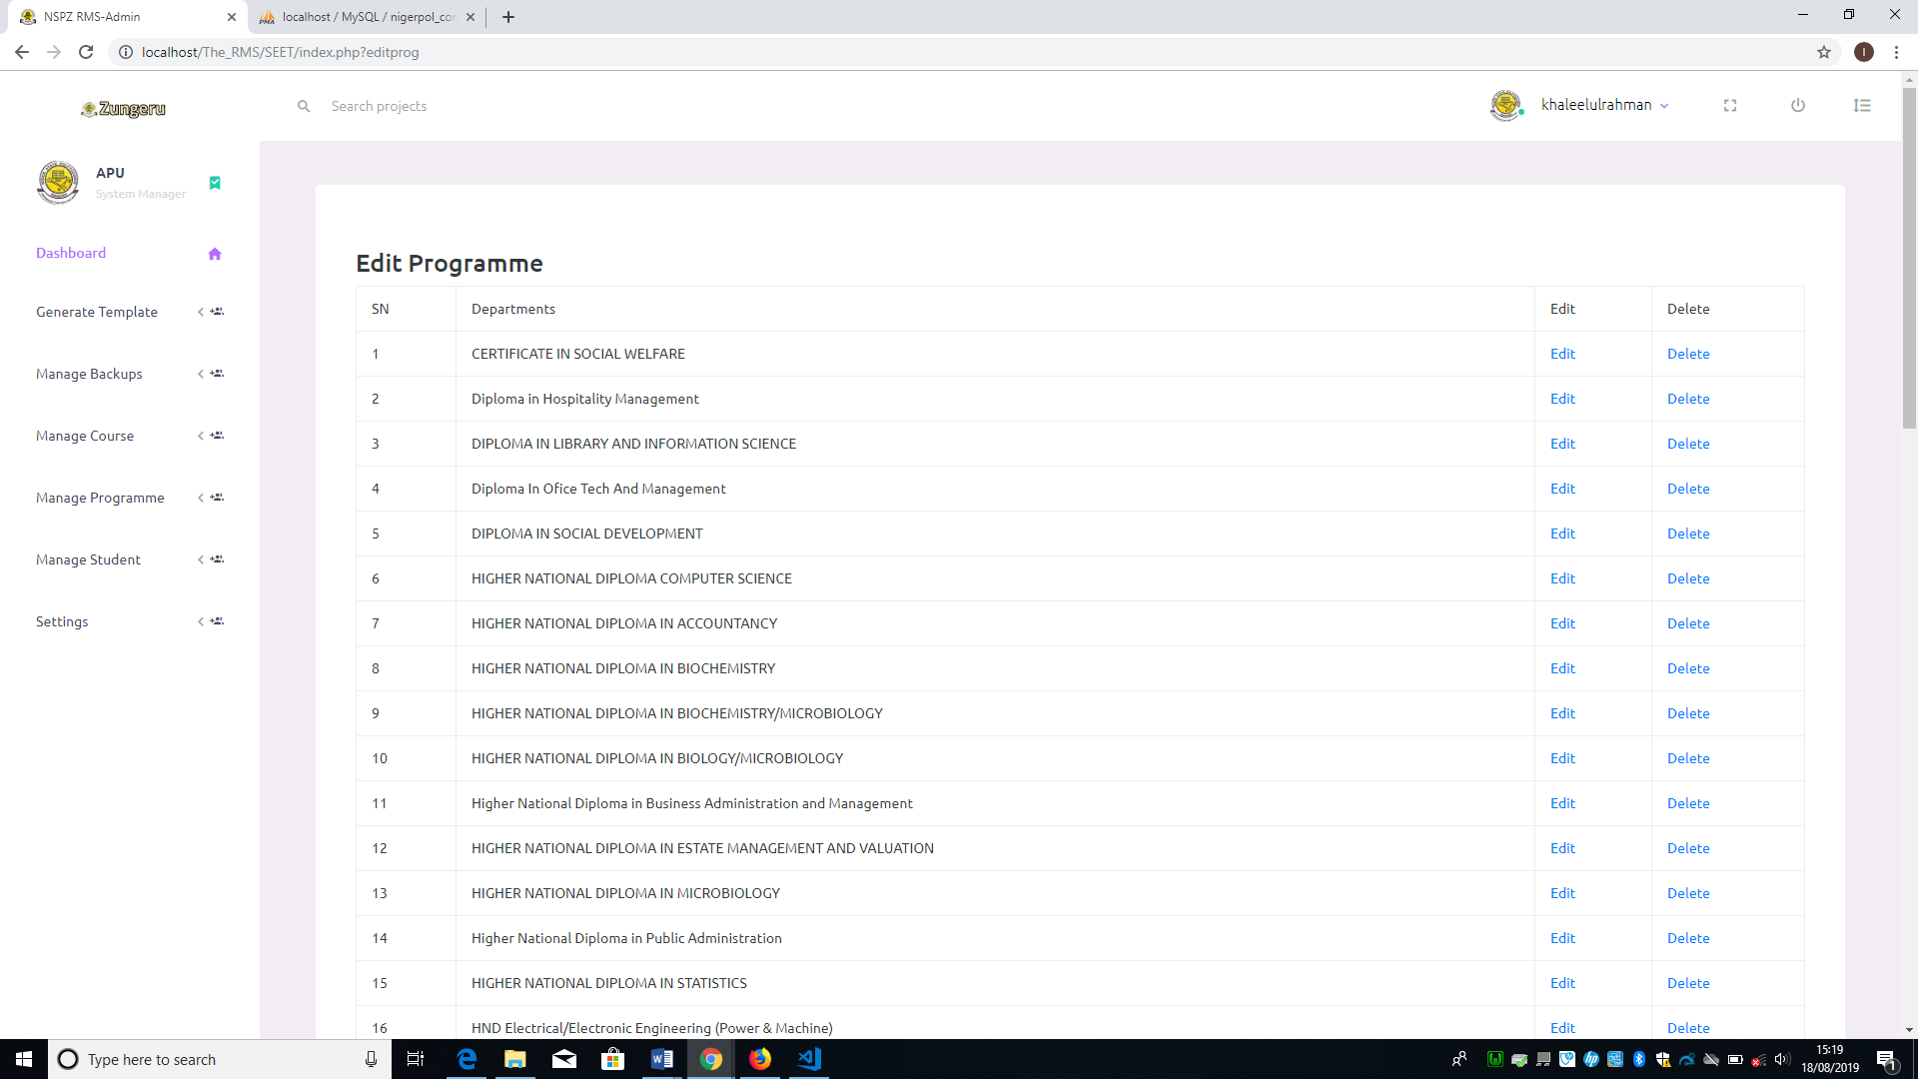

Figure 5. 13: View/Edit Programme

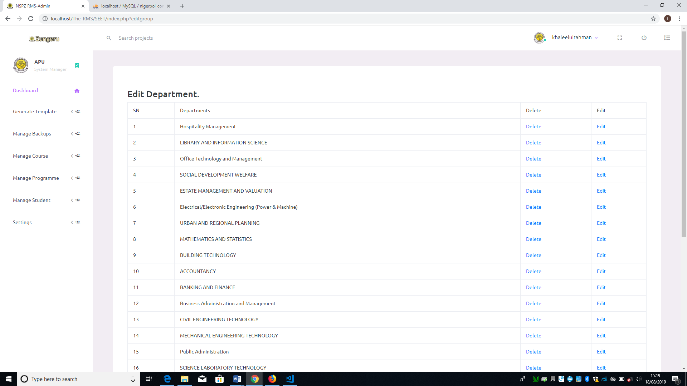

Figure 5. 14: View/ Edit Department

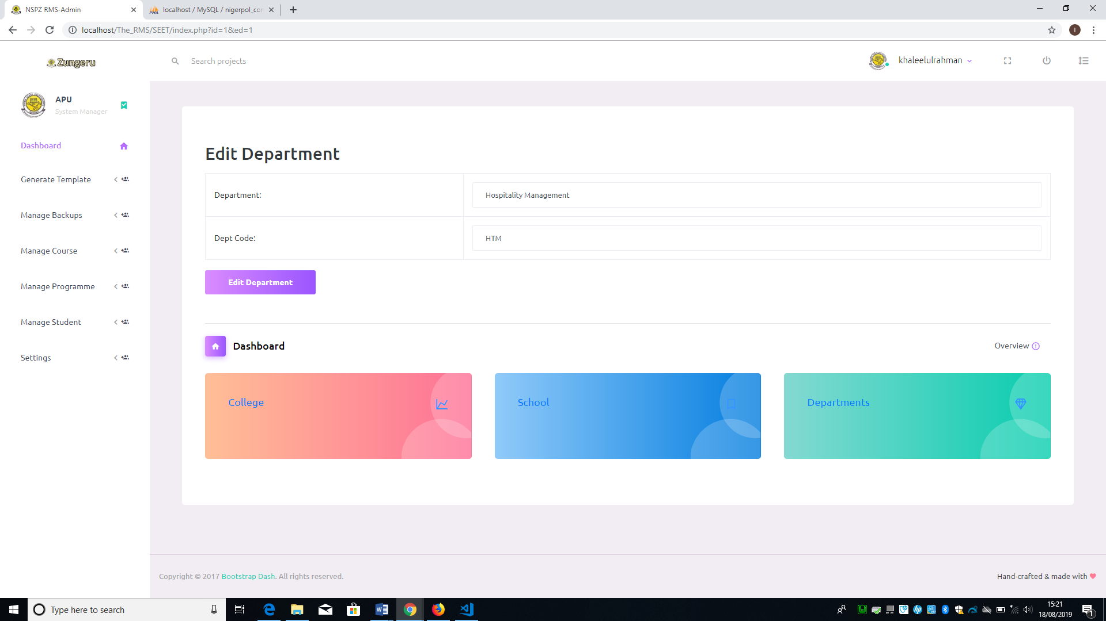

Figure 5. 15: Edit Department Form

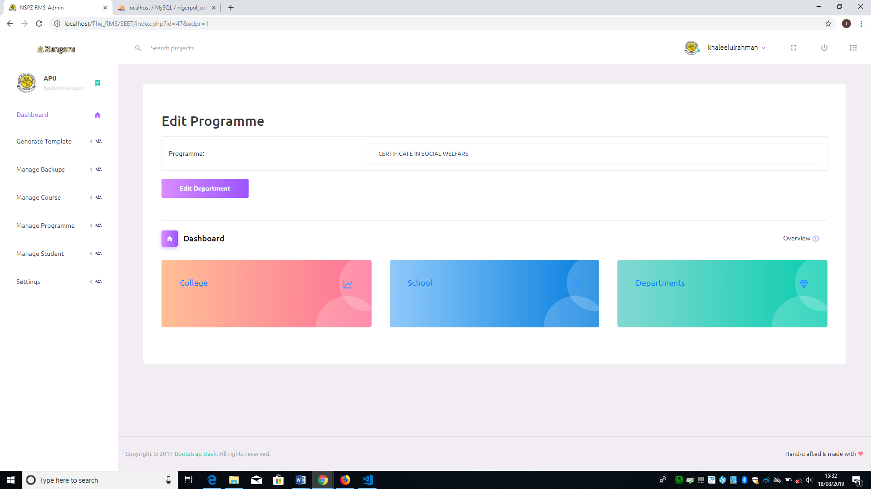

Figure 5. 16:Edit Programme Form

### 5.5 Manage Student

This menu comprises; Import/ Input Student records and View/ Edit Student records sub menus. Figure 5.17 shows the menu and submenu.

The “input Students Record” sub menu enable user enter students data into a form requiring the fields (programme, year, matric number, name, gender and session) through the keyboard to a database one student at a time (see figure 5.19). If any of the fields is not selected or left empty, it prompt the user that “empty fields cannot be submitted”.

The import sub menu enable user to enter student data into the database by importing a file through a form with required fields (programme, year, and session) to be selected then choose the file to import and submit (see figure 5.18). The advantage of the import over input is that it allows multiple records to be added to the dataset at once.

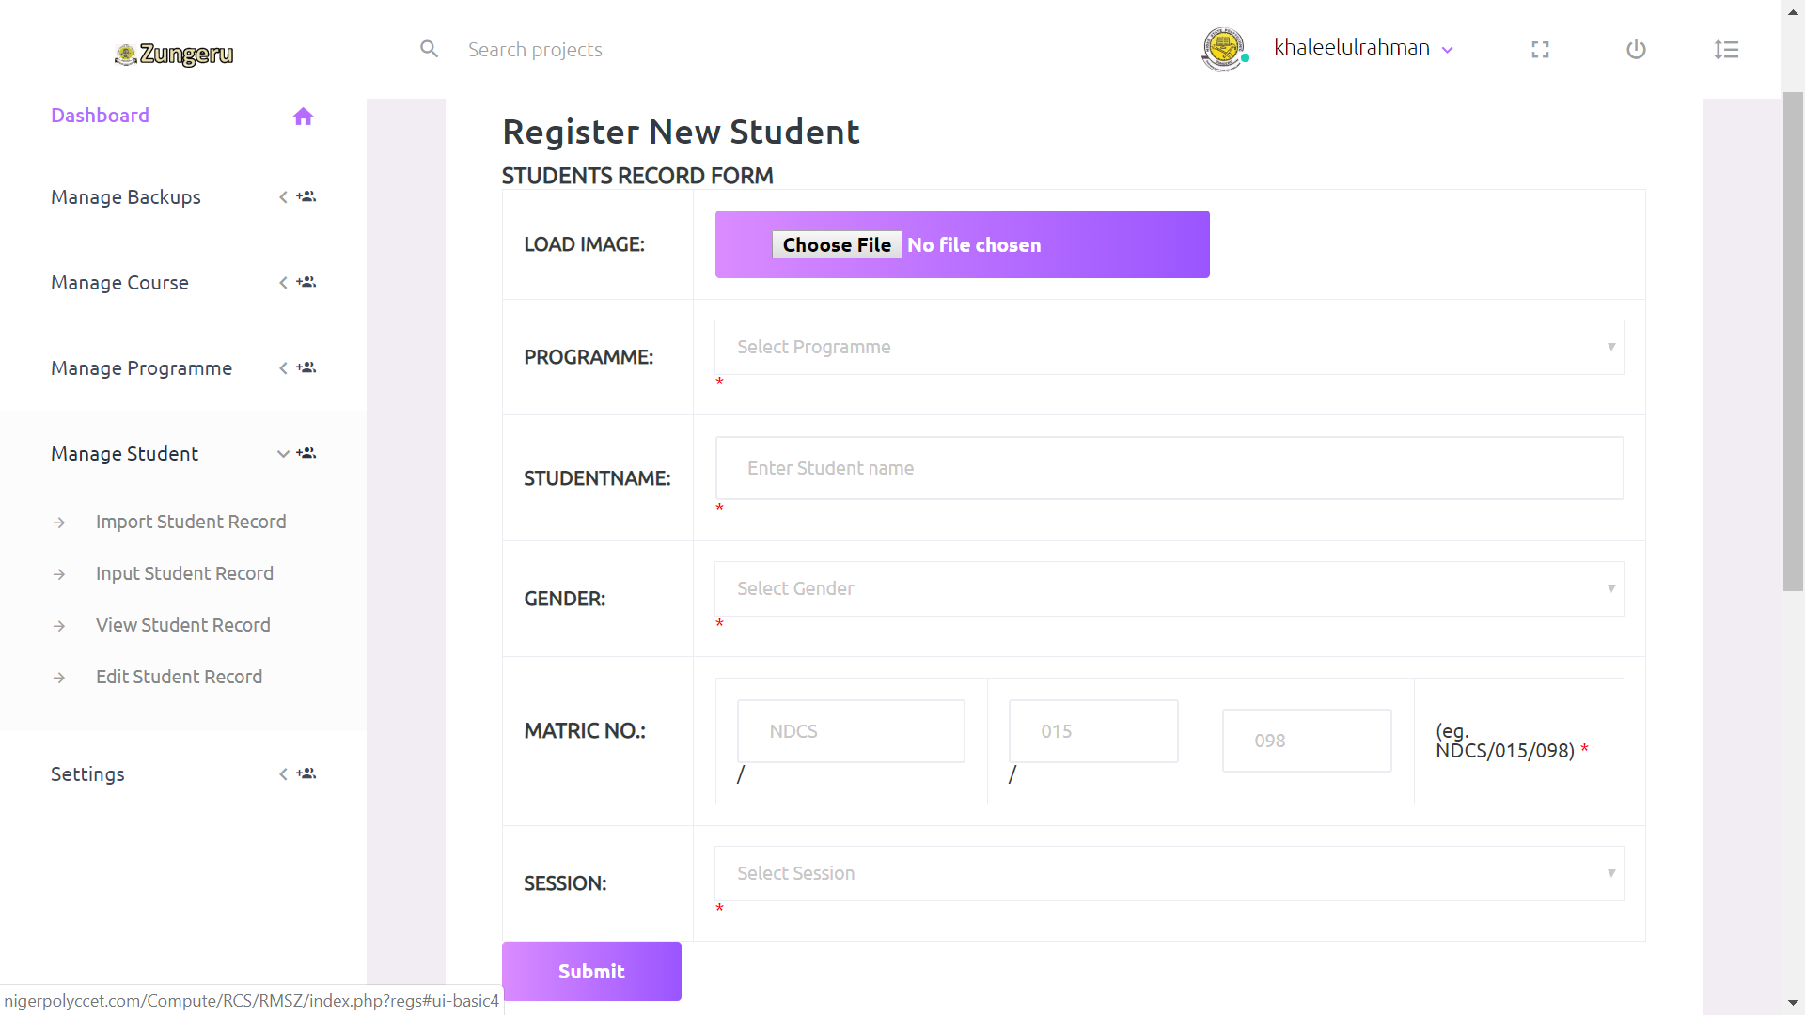

Figure 5. 17: Manage Student Menu and Submenus

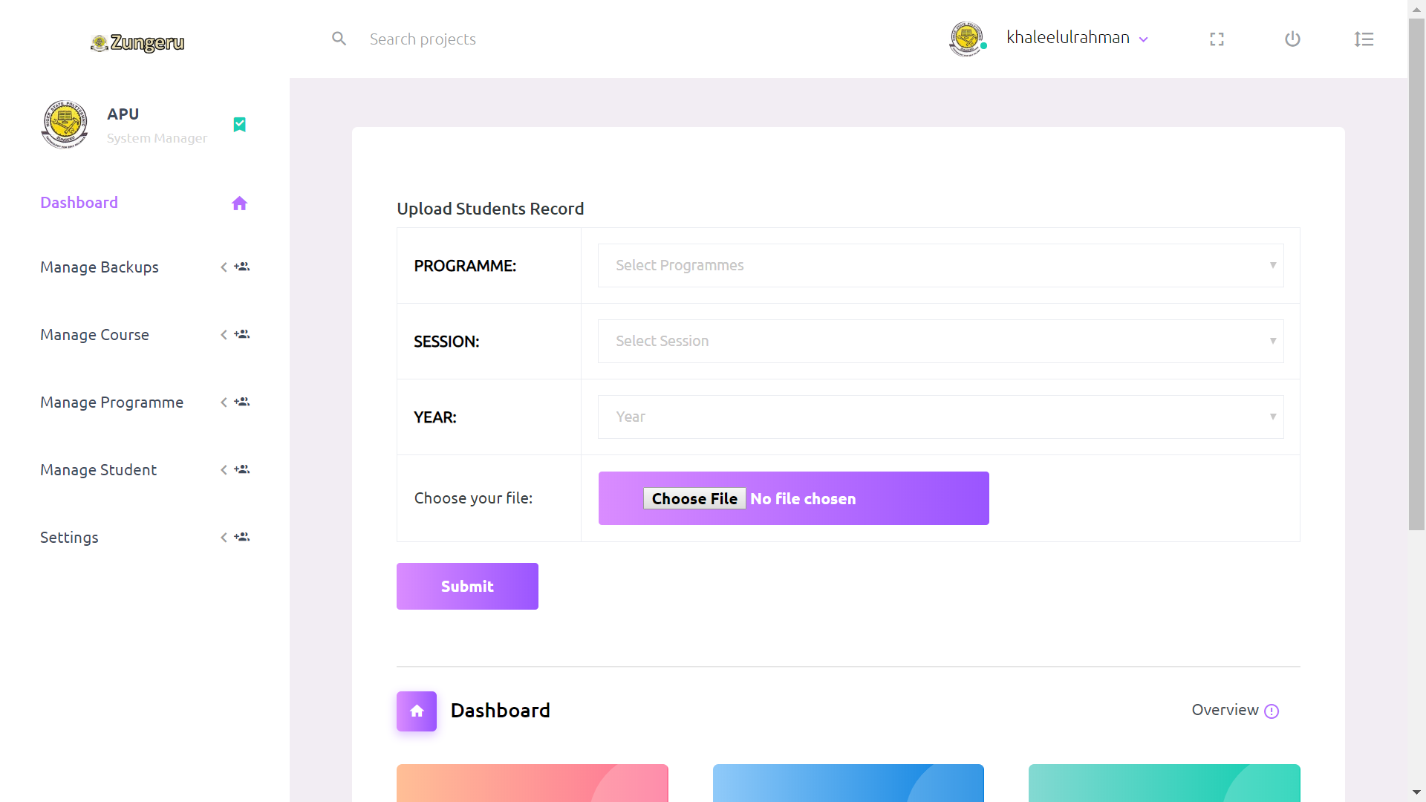

Figure 5. 18: Upload or Import Student Record Form

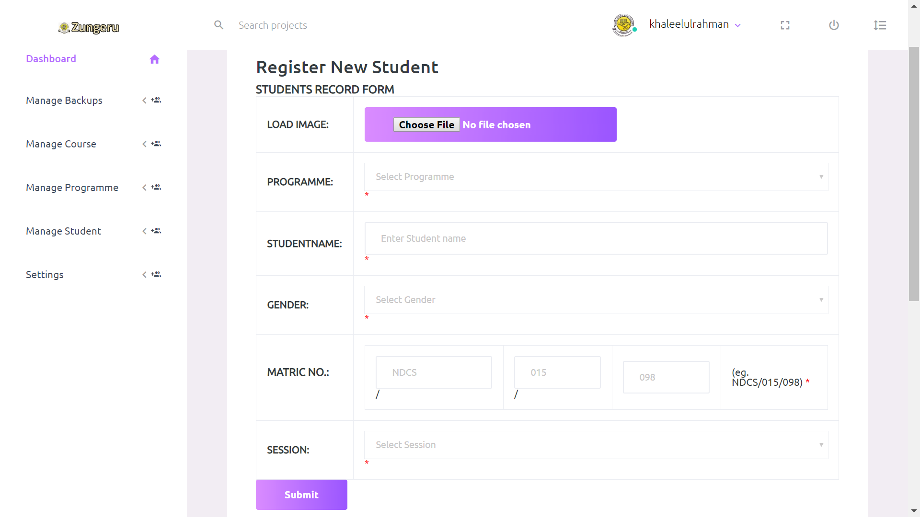

Figure 5. 19: Input or Register Student Form

### 5.6 User access control

This menu comprises; “Create users” and “Edit user” submenus. The create user sub menu enable user (System Manager) to create or add new user who can access the system. This submenu create user with a default password.

If the user created is logging in for the first time, the system prompt the user to change password, and if password is successfully changed, the user is logged out and re-directed to the login page to login again. Figure 5.20 below shows the create user form.

The user name and password of the user (Student) is created, during import or input of student data, the username is set as matric number and password is default for all student.

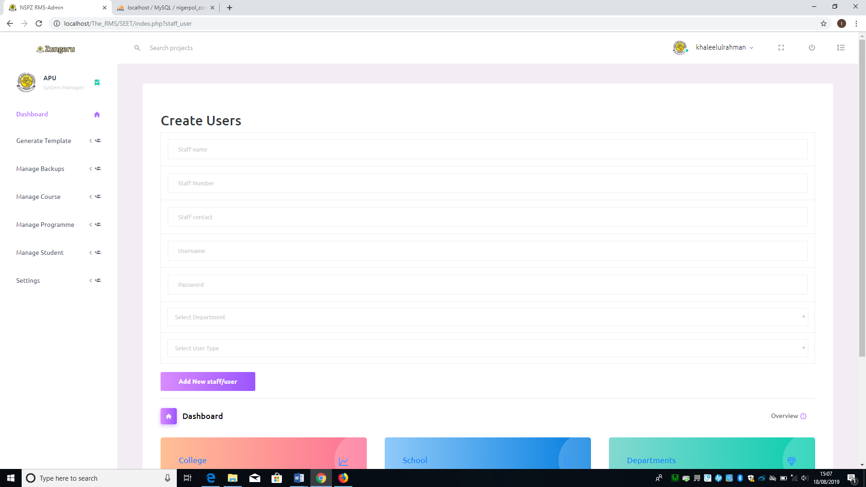

Figure 5. 20: Create User Form.

The “Edit User” submenu would allow user (System Manager) to make changes to user login details and can also use the link “menu control” on the page to control the user navigation menu by enabling or disabling any of the user navigation menu.

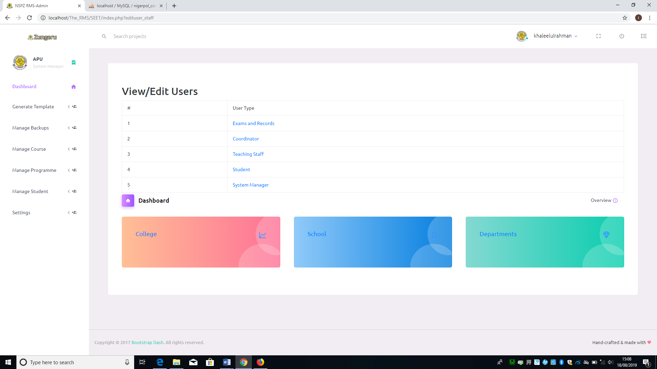

Figure 5. 21: List of User Type

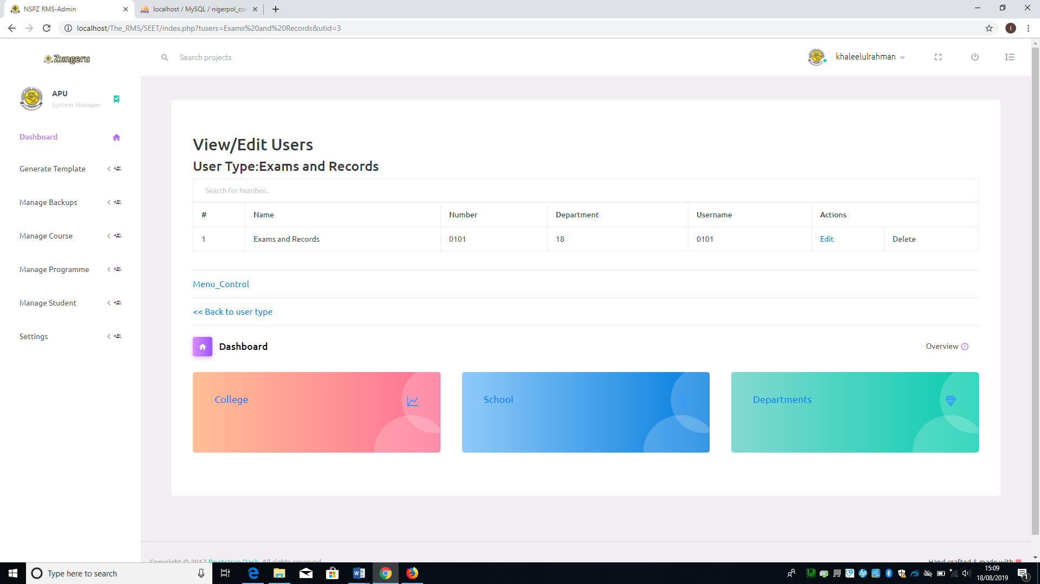

Figure 5. 22: List of Users in a user type category

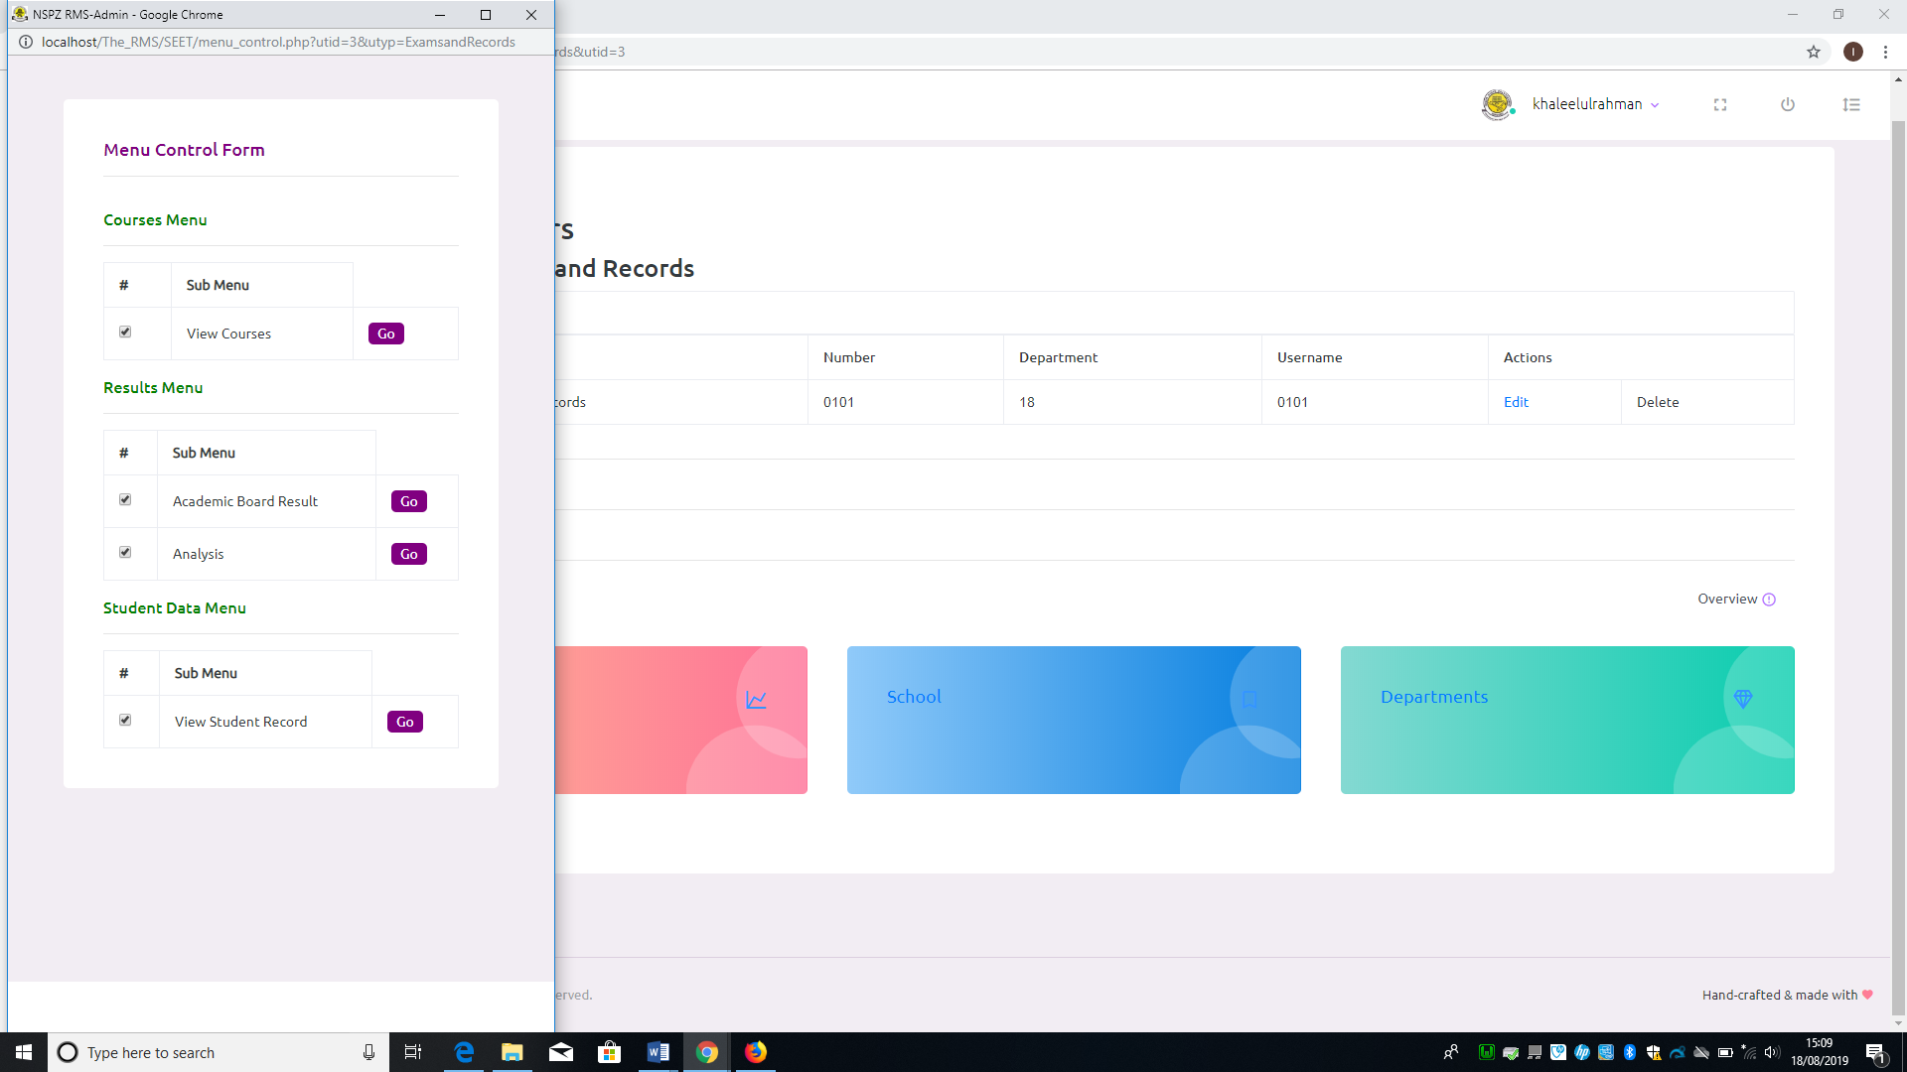

Figure 5. 23: Menu Control Form

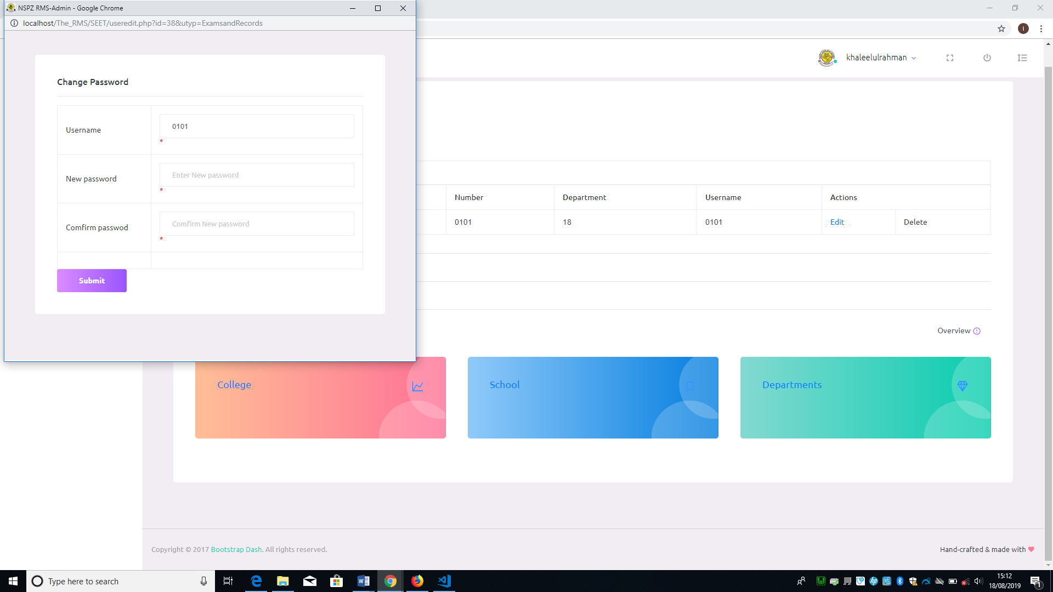

Figure 5. 24: Change Password Popup window

* When user click on the submenu “edit user”, all the user types are displayed as links (see figure 5.21), the user (System Manager) can click on any of the user type to view all the users on that user type category. Below the details of all users is a link (Menu Control). When the link “Menu Control” is clicked it display the menu control form (See figure 5.23), on this form user can enable or disable user type menus. The list of users displayed has a corresponding link (Edit) to the left. See figure 5.22 above. When the “Edit” link is clicked by, it popup a window with form to change user password (see figure 5.24)

# 6.0 Coordinator Role

Haven logged in successfully as user (coordinator), the user is granted access to dashboard and their navigation menus as described below. This user will only have access to only his/her departmental records.

### 6.1 Allocation menu

This menu has a sub menu (Course Allocation). This sub menu enables the user to allocate courses to user (teacher/lecturer) at the beginning of every semester, this is to give the user (teacher/lecturer) access to import exam scores of every student that offer that course. Clicking on the sub menu (Course Allocation), the system displays a form containing all the courses offered in the department and a dropdown list containing the names of the lecturers in that department. To allocate course(s) to a lecturer, the name of the lecturer is selected from a drop-down lists, click on the check boxes at the right corresponding to the course(s) to check or select it, then click on the button “Allocate” to allocate the course(s) to the teacher/ lecturer. Figure 6.1 shows the allocation form.

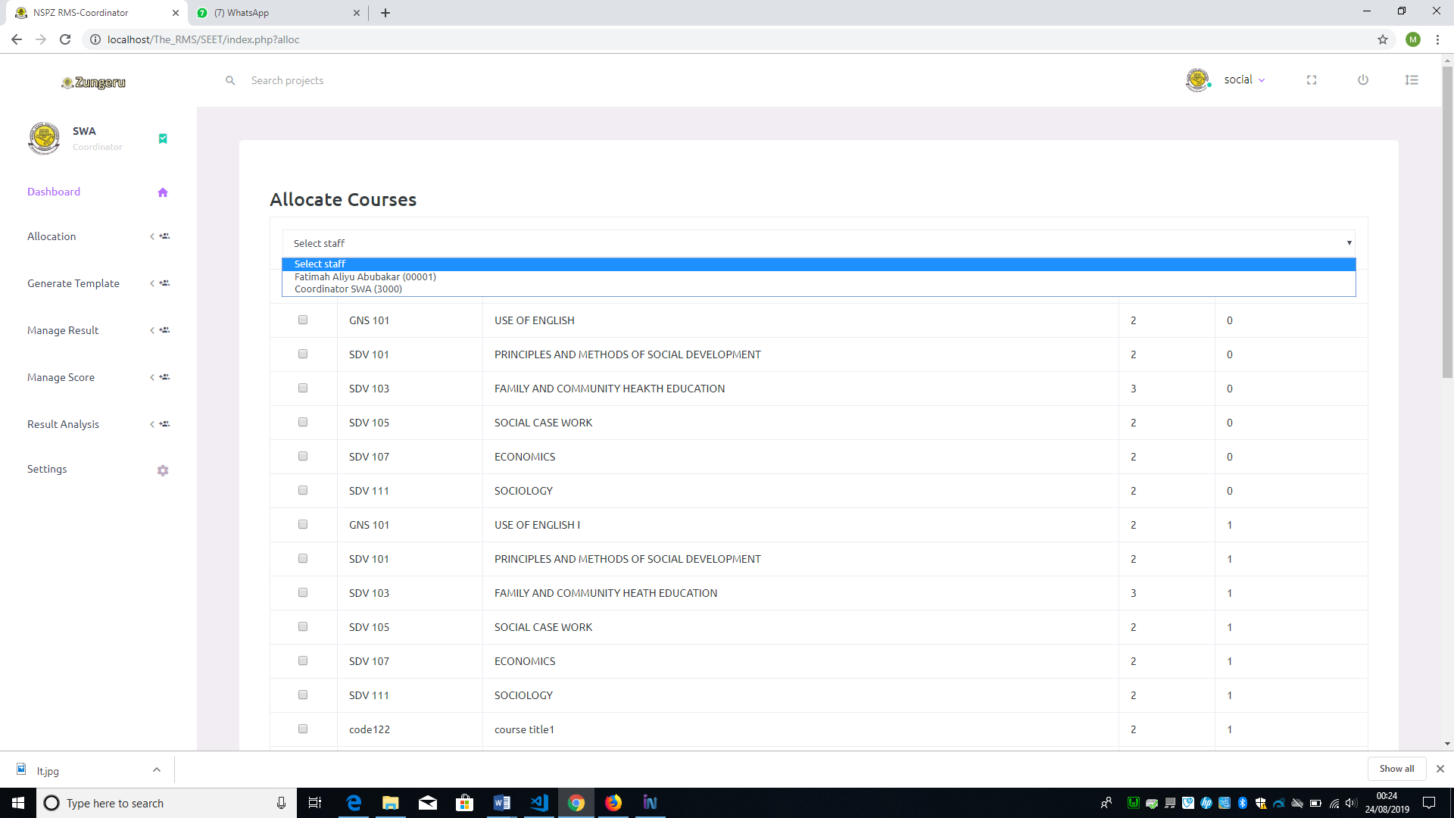

Figure 6. 1: Course Allocation Form

### 6.2 Generate Templet

This menu has “Score entry” as sub menu, it is clicked on when user need to generate a template in “.csv” file format to enter student exam scores. First when user clicked on the sub menu, the system displays a form with two fields requiring user to select programme and year of the student score to generate template for, then click on submit to generate the template, it is named “score_template.csv”, saved in the downloads file of the user PC. Figure 6.2 shows the score template form

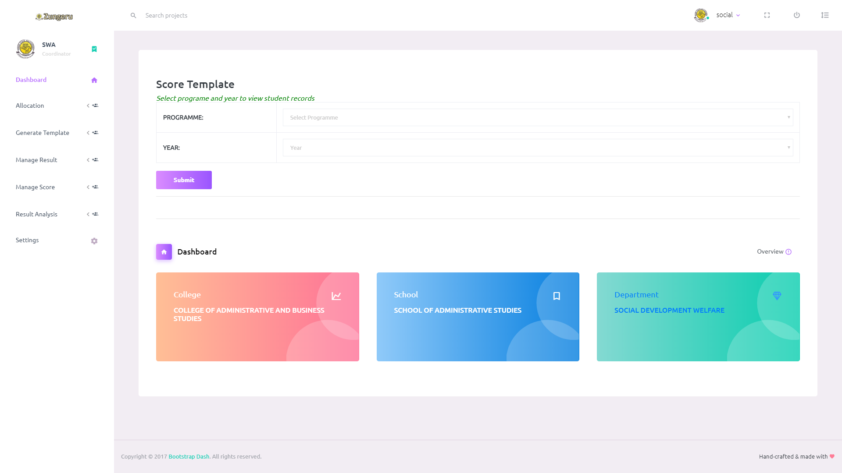

Figure 6. 2: Score Template Form

### 6.3 Manage Result

This menu comprises of; “Academic board result” and “Notice board result” as submenu. Each of the result is in a broadsheet format containing the semester results of students in a class. Academic board result is used in the academic board meeting for decision while notice board result is made to be placed on the notice board for all view. The difference between the two is the name column which is only present in the Academic board result copy.

When a user clicks on the “Academic board result” or “Notice board result” submenu, the system displays a form, where user is required to select programme, semester, session, and year (class) to view the results (See figure 6.3).

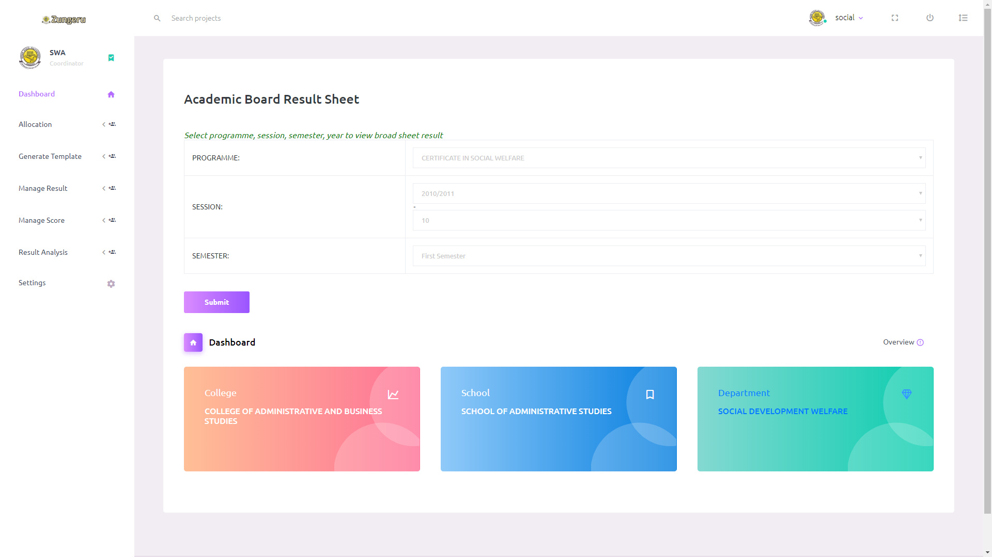Figure 6. 3: View Board Result Form

The user then clicks on the button “Submit” to view academic board or notice board result. No field on the form can be submitted empty. Figure 6.4 & 6.5 shows sample displayed result and visual analysis respectively.

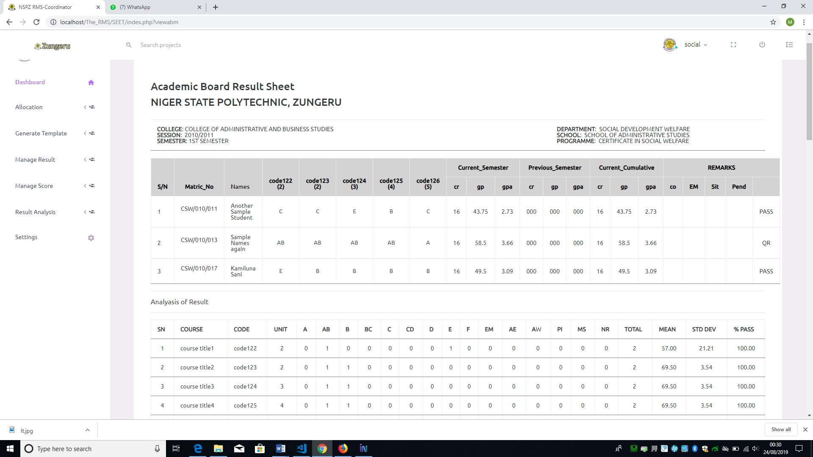

Figure 6. 4: Broadsheet Result

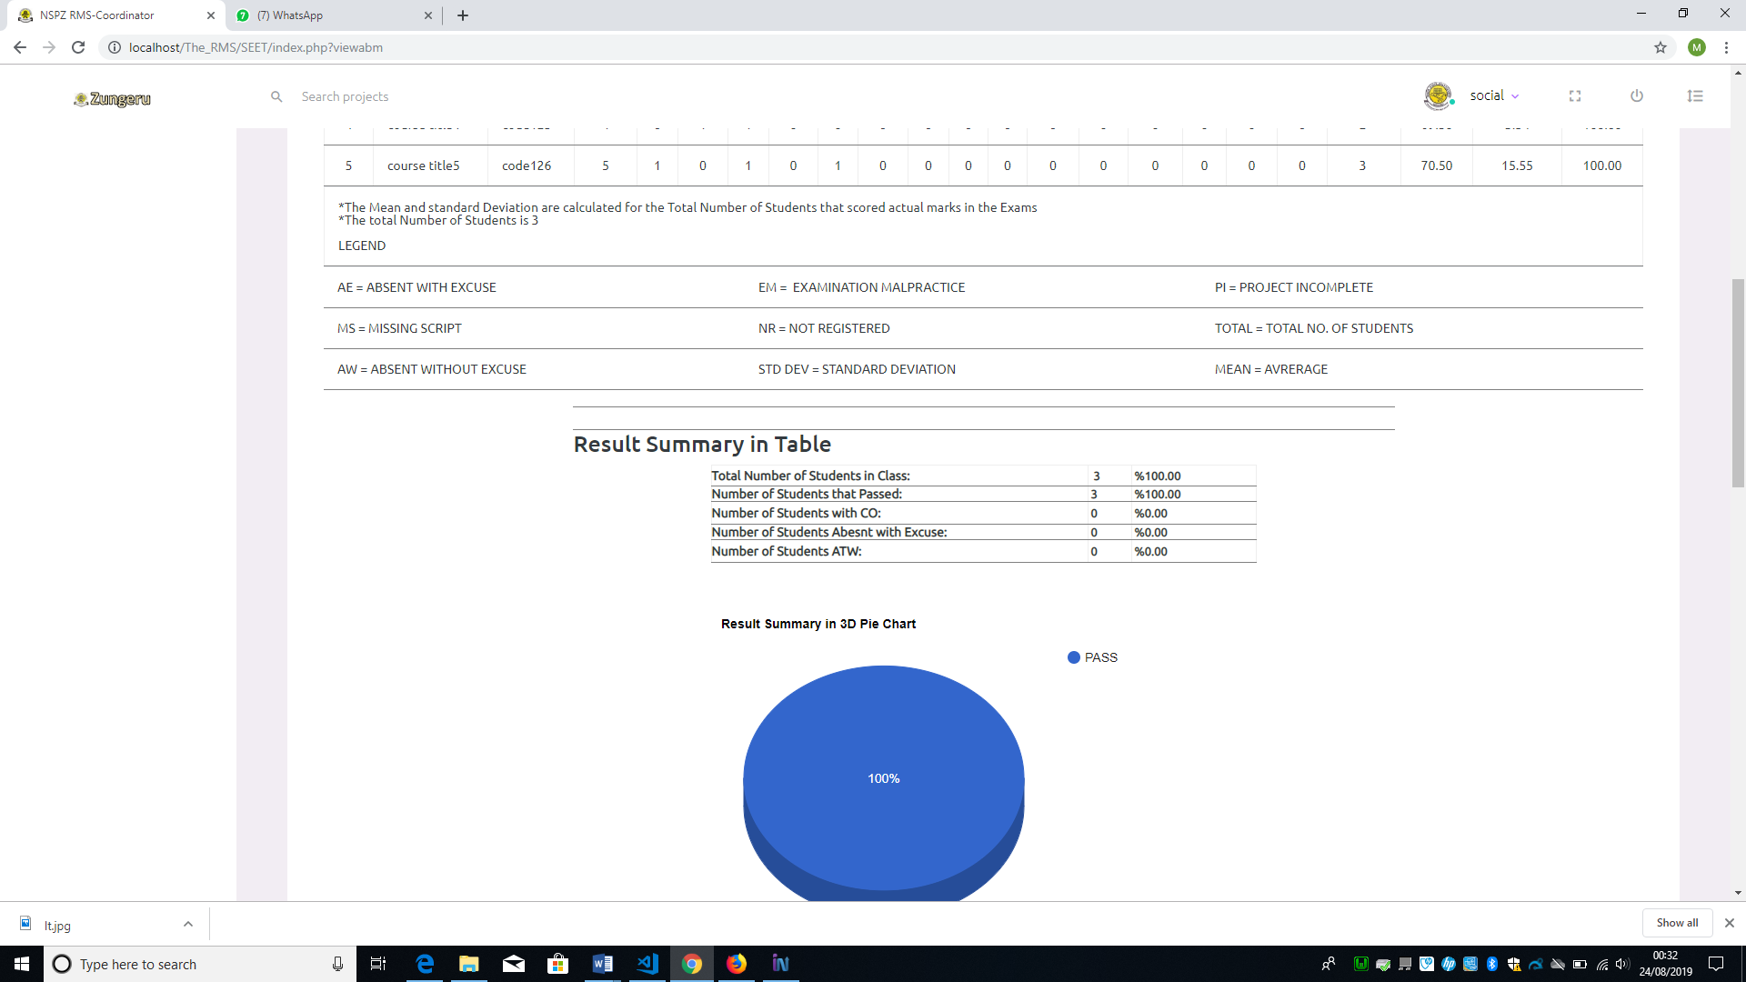

Figure 6. 5: Visual Result Analysis

### 6.4 Manage Score

This menu has; Input/import exam scores, Edit Exam score, Consider Exam score, Input / Import Carry over, Spill over Result, and Delete Result as submenus. See the menu and submenu in figure 6.6

The input and import score submenus are to enable user to enter student exam score into the database through a form. Using the input menu gives the user the chance to enter only one student score at a time while the import will allow multiple students score at a time. The input score requires all results of the courses offered by student to be ready before input and every score is entered through the keyboard by the user. With the Import menu user only import a file in .csv from comprising student exam score of a course.

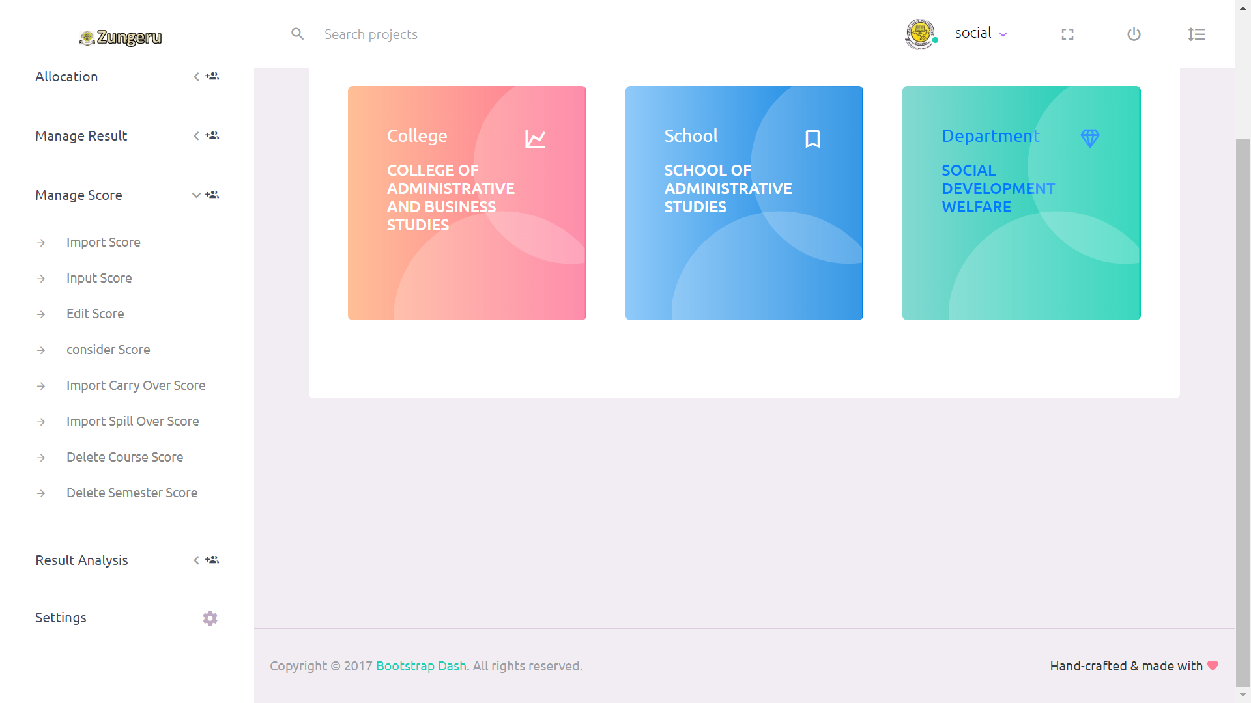

Figure 6. 6: Manage Score Menu and Submenu

When a user clicks on the “Input Score” menu, the system displays the input score form, requiring the user to select the fields; programme, semester, year and session of scores to be entered then click on submit, all the fields are required and must not be empty. The system will then display a form with student name, matric number, and course code of all the courses offered by the student with a field to enter the score of each course (See figure 6.7). As the user finish entering the score for a student and clicks on submit, another form appears with another student information as the previous. This process continues until every student exam scores are entered.

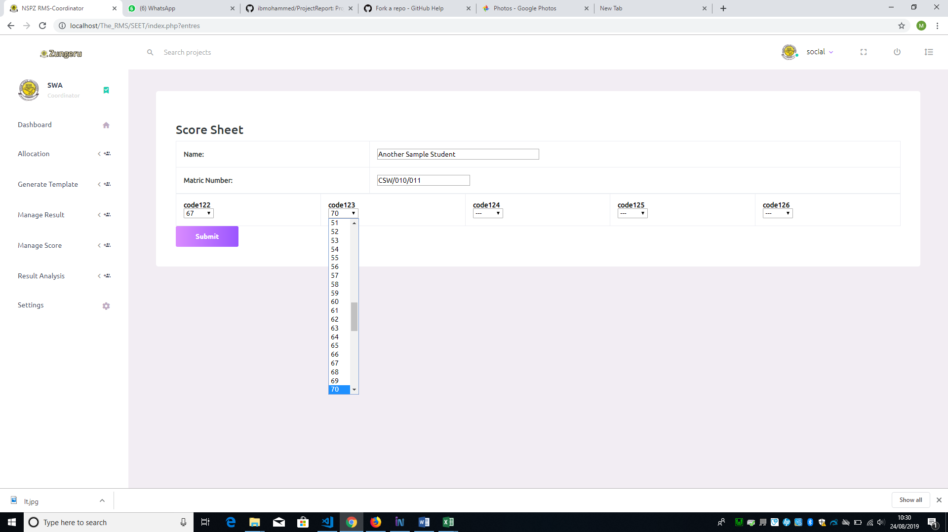Figure 6. 7: Exam Score Sheet Form

When a user clicks on the “Import Score” menu, the system displays the import score form, requiring user to select programme, semester, year and session of the scores to be imported, then click submit (See Figure 6.8). On clicking submit the system displays another form requiring the user to select course code of the score to import, choose a file (.csv file format), then submit (See the form in figure 6.9).

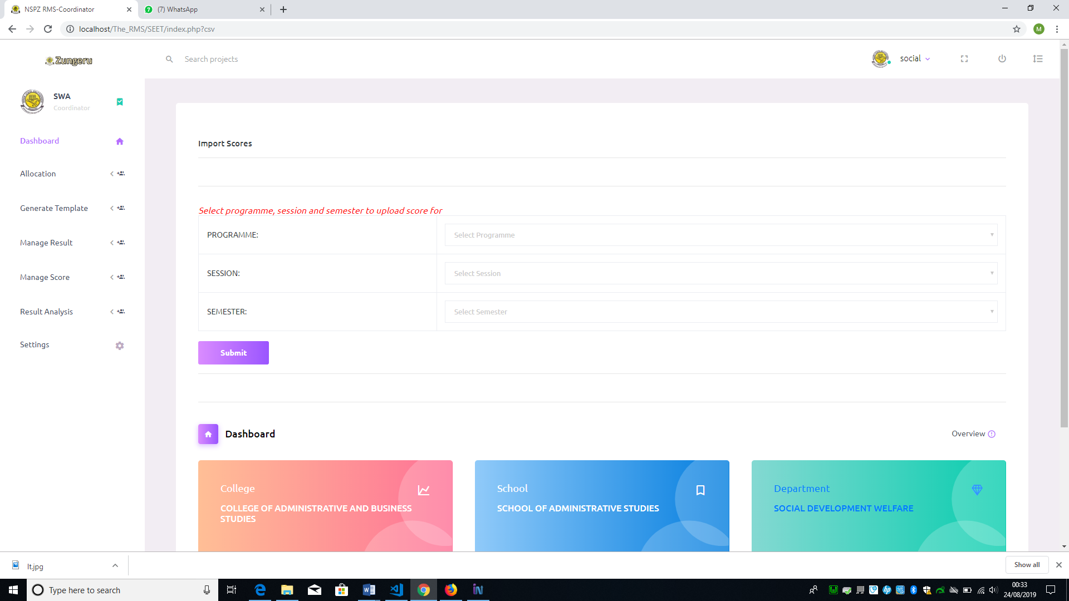Figure 6. 8: Import Score Form

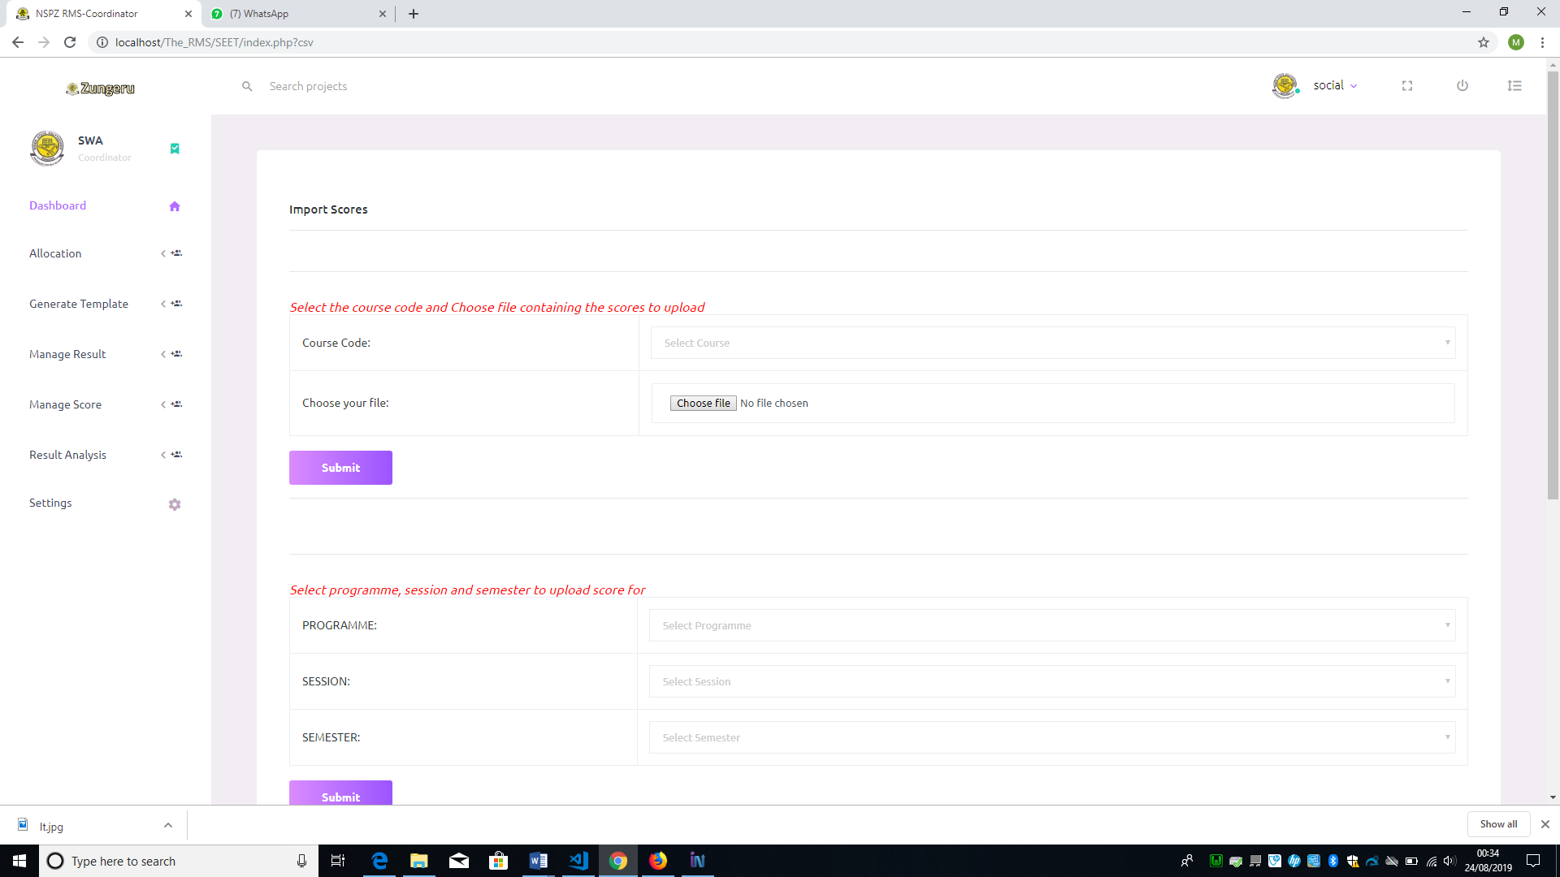Figure 6. 9: File Import Form

The submenu “Edit score” is to enable the user edit student score in case there is need for any correction. When a user clicks on the submenu the system displays a form requiring user to select the programme, semester, and year (class) then submit, on clicking submit the list of student in the class is displayed with an “Edit” link to the left of the list, corresponding to each student in the list (see figure 6.10), clicking on the “Edit” link, the user is presented with a form comprising the student information, courses offered and fields with the scores previously entered (See figure 6.11), the user can make changes to the scores in the fields, then submit, and the previous scores are replaced with the changes made. Alternatively, the user can edit the scores from the file (.csv) and resubmit, it will overwrite the previous scores.

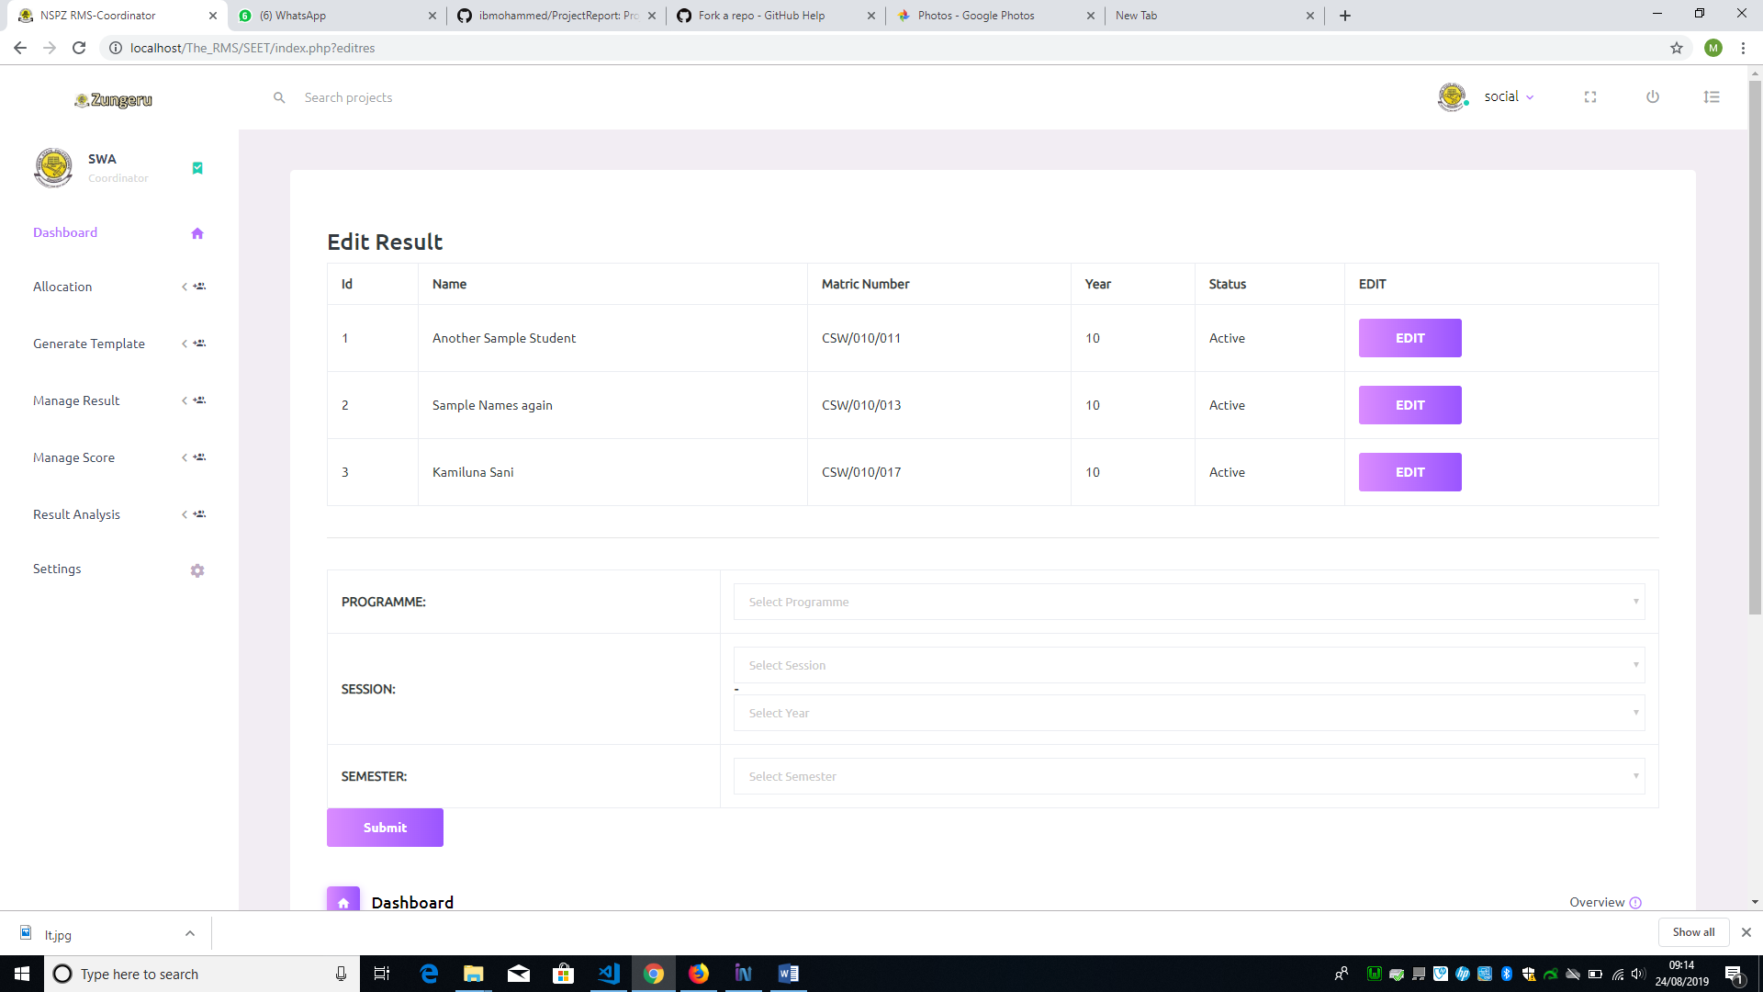

Figure 6. 10: List of Students

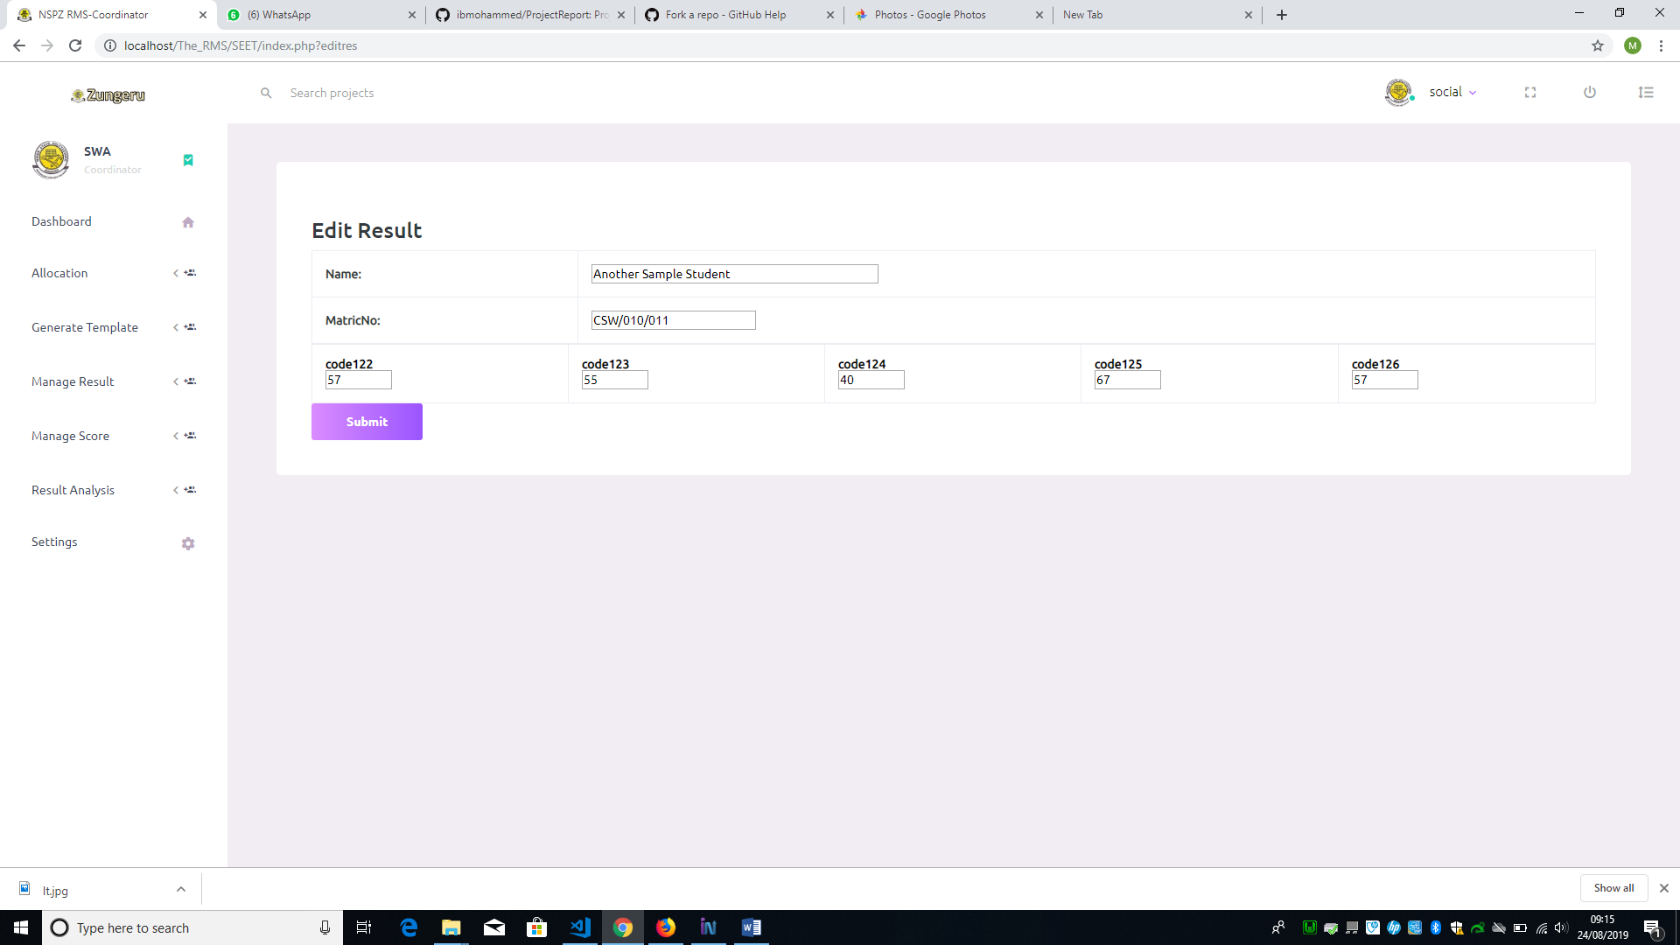

Figure 6. 11: Edit Student Score Form

The “Consider score” submenu is to enable user to enter scores as considered by the academic board during the academic board meeting. For instance, if the academic board decides that all student with score between 38 and 40 should be considered as 40. As the user (coordinator) clicks on the menu “Consider score”, the system displays a form requiring the user to select programme, semester, session and year of the scores to be considered, then click on submit (See figure 6.12). On clicking submit, the system displays a form with all the students that their scores is within the range (38 to 40) and button (consider) (see figure 6.13). When the user clicks on the “consider” button all the score of the students on the list change to 40.

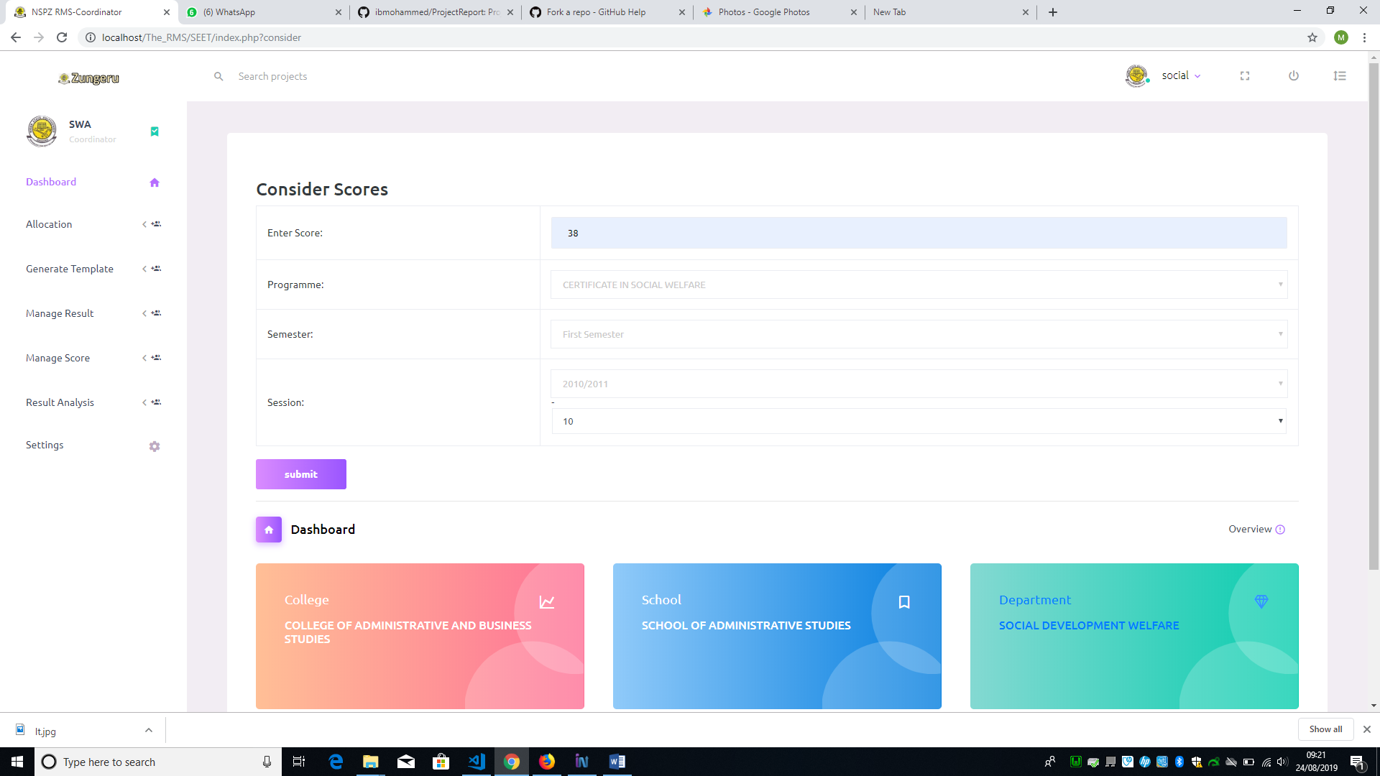Figure 6. 12: Consider Scores Form

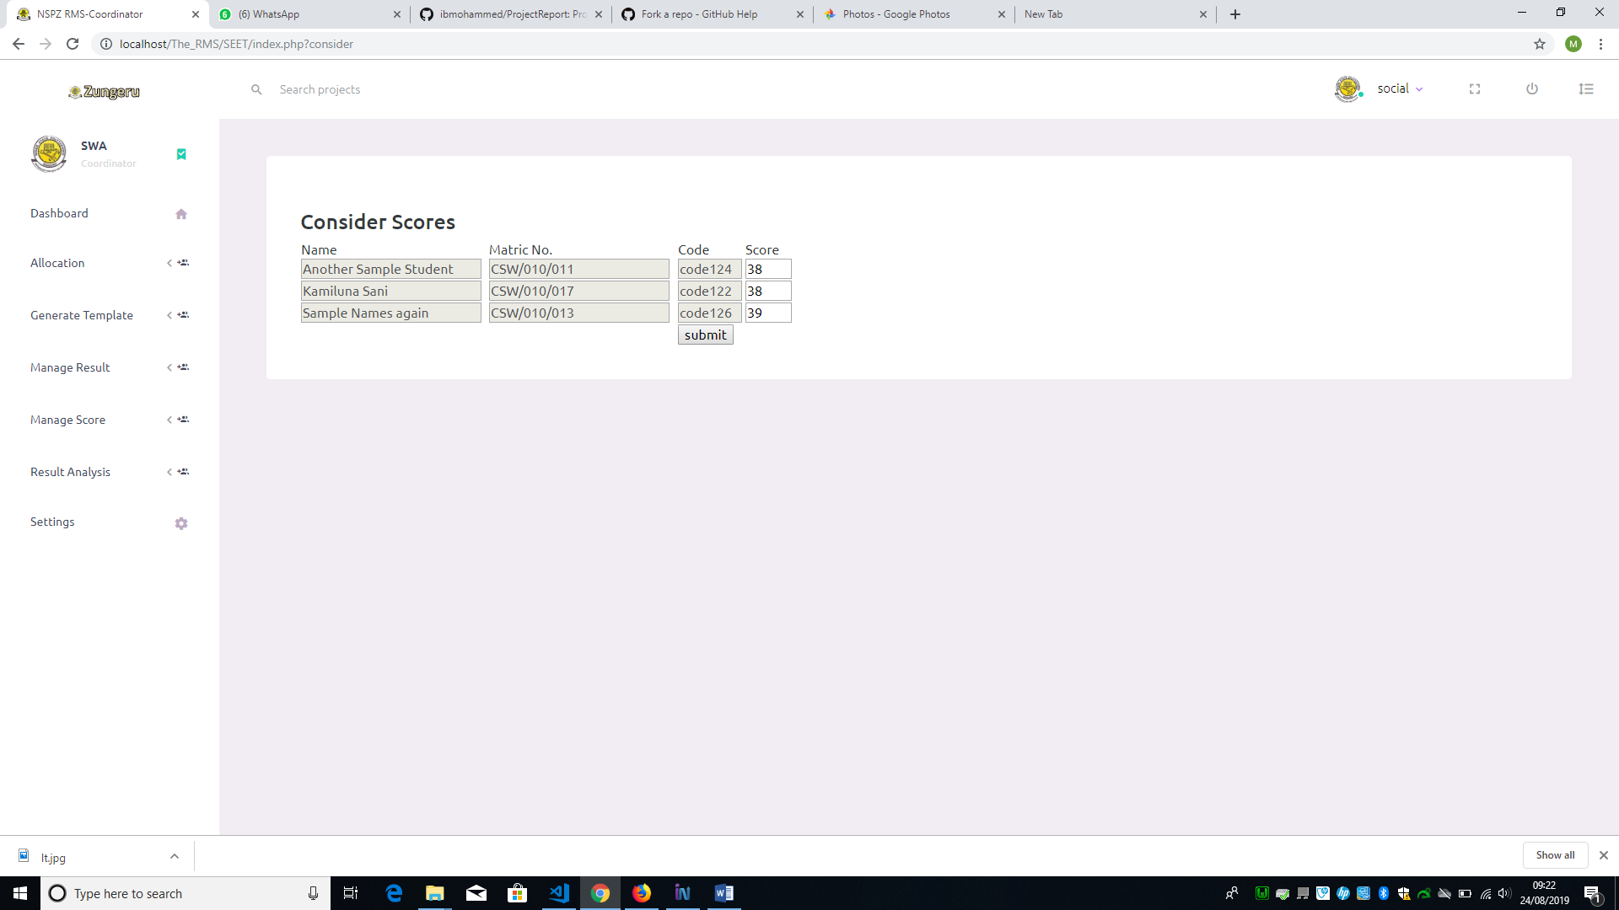

Figure 6. 13: List of Scores within Range to be Considered

The submenu “Import Carryover and Spill over” allows user to import the scores of students that sit for carryover and spill over, this function is similar to Import score above.

The “Delete course Score”/ “Delete semester score” submenus allows user to delete scores entered for entire semester or for a single course. The user clicks on either delete semester score or delete course score respectively. Clicking on the submenu “delete course score”, a form is displayed requiring user to select programme, semester, session and year of the course score, click on submit, and a form is displayed to select the course code of the course to be deleted, then click on the delete button next to it (See figure 6.14).

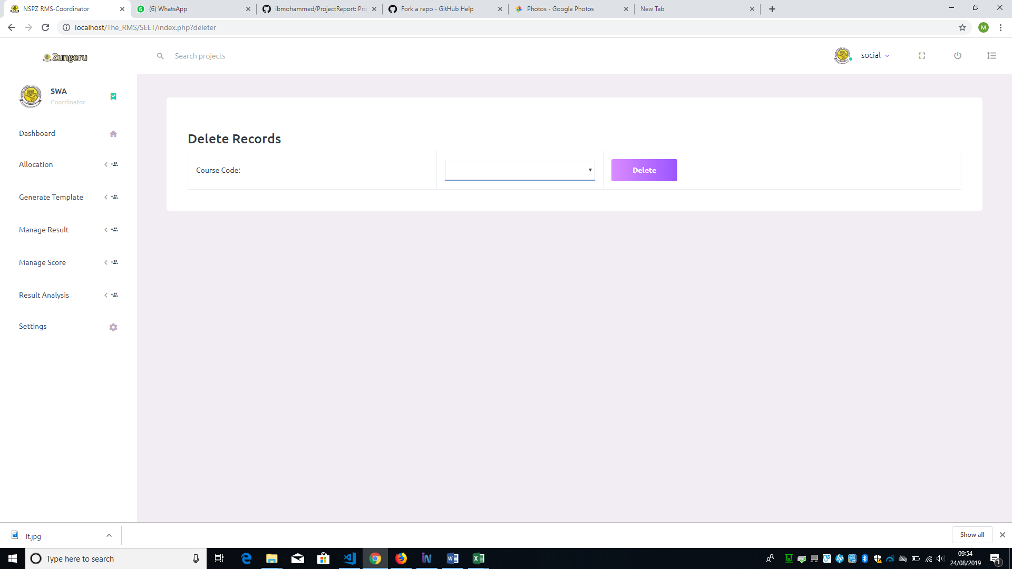Figure 6. 14: Delete Score by Course Form

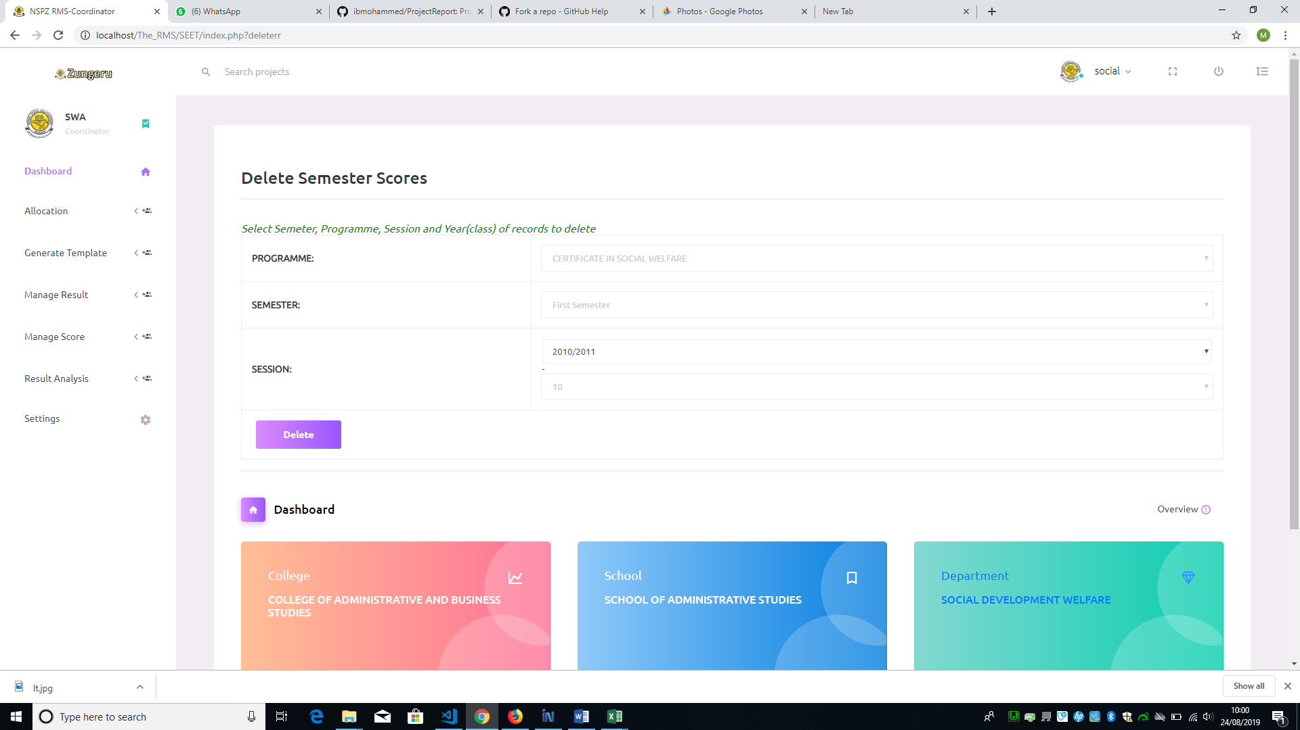

Figure 6. 15: Delete Semester Score Form

As the user clicks the “Delete semester score” submenu, it displays the form in figure 6.15 above requiring the user to select all the fields and click on Delete, all scores for the selected programme, semester and year (class) is completely deleted from the database.

### 6.5 Result Analysis

This menu is a menu accessible by the user (Coordinator), to view analysis of results in a visual form. It has the submenu; “Course Result analysis” and “Complete Result analysis”. When user clicks on the submenu “Course Result Analysis”, the system displays a form requiring user to select programme, semester, and session of the course analysis to be displayed and click on submit, the system then displays another form for user to select the course and click on submit button to view the visual analysis of the course selected. Figure 6.16 shows the form to view complete result analysis of a class and figure 6.17 & 6.18 shows the analysis form and visual analysis of the course.

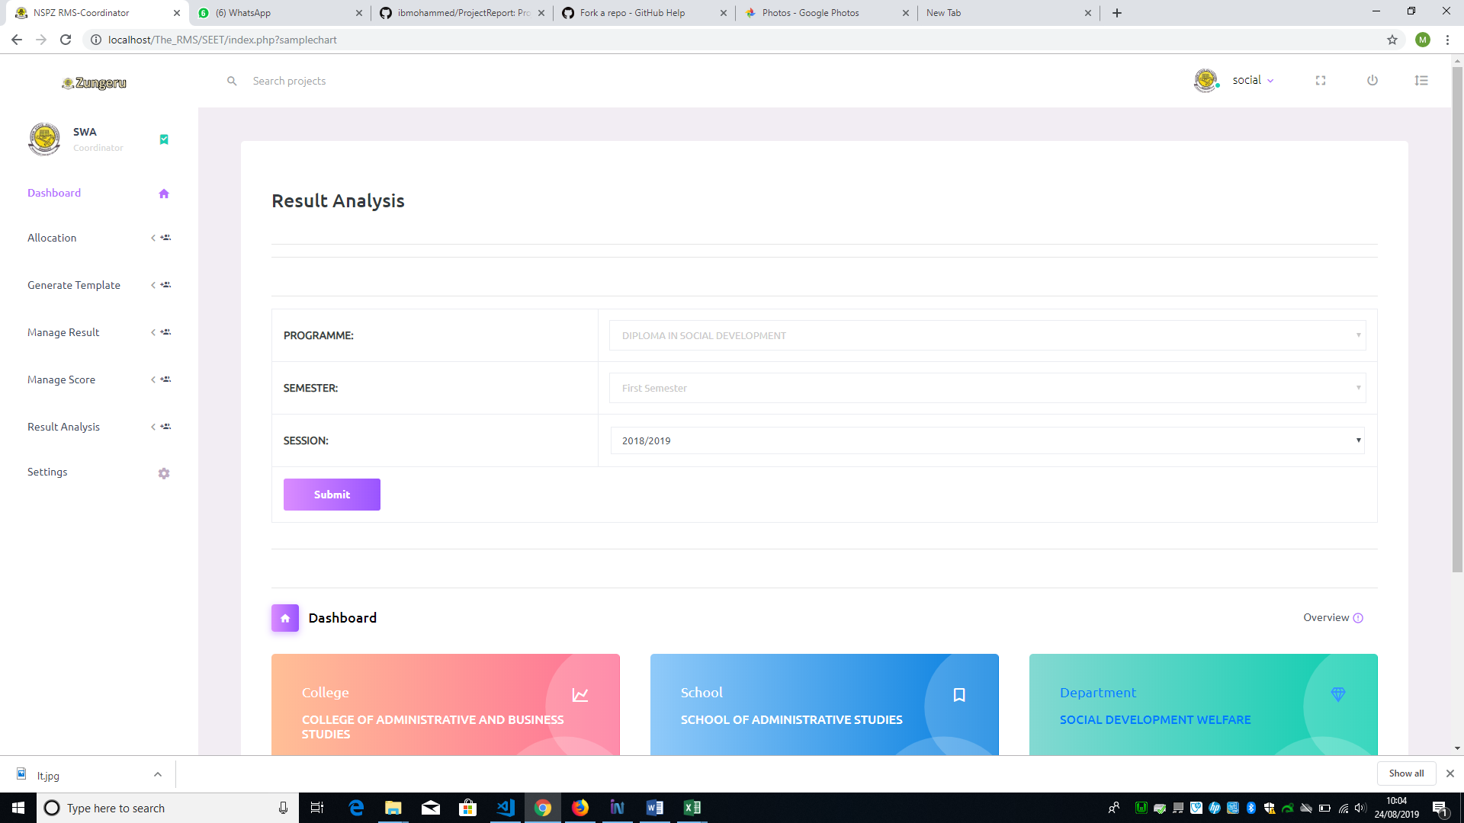Figure 6. 16: View Result Analysis Form

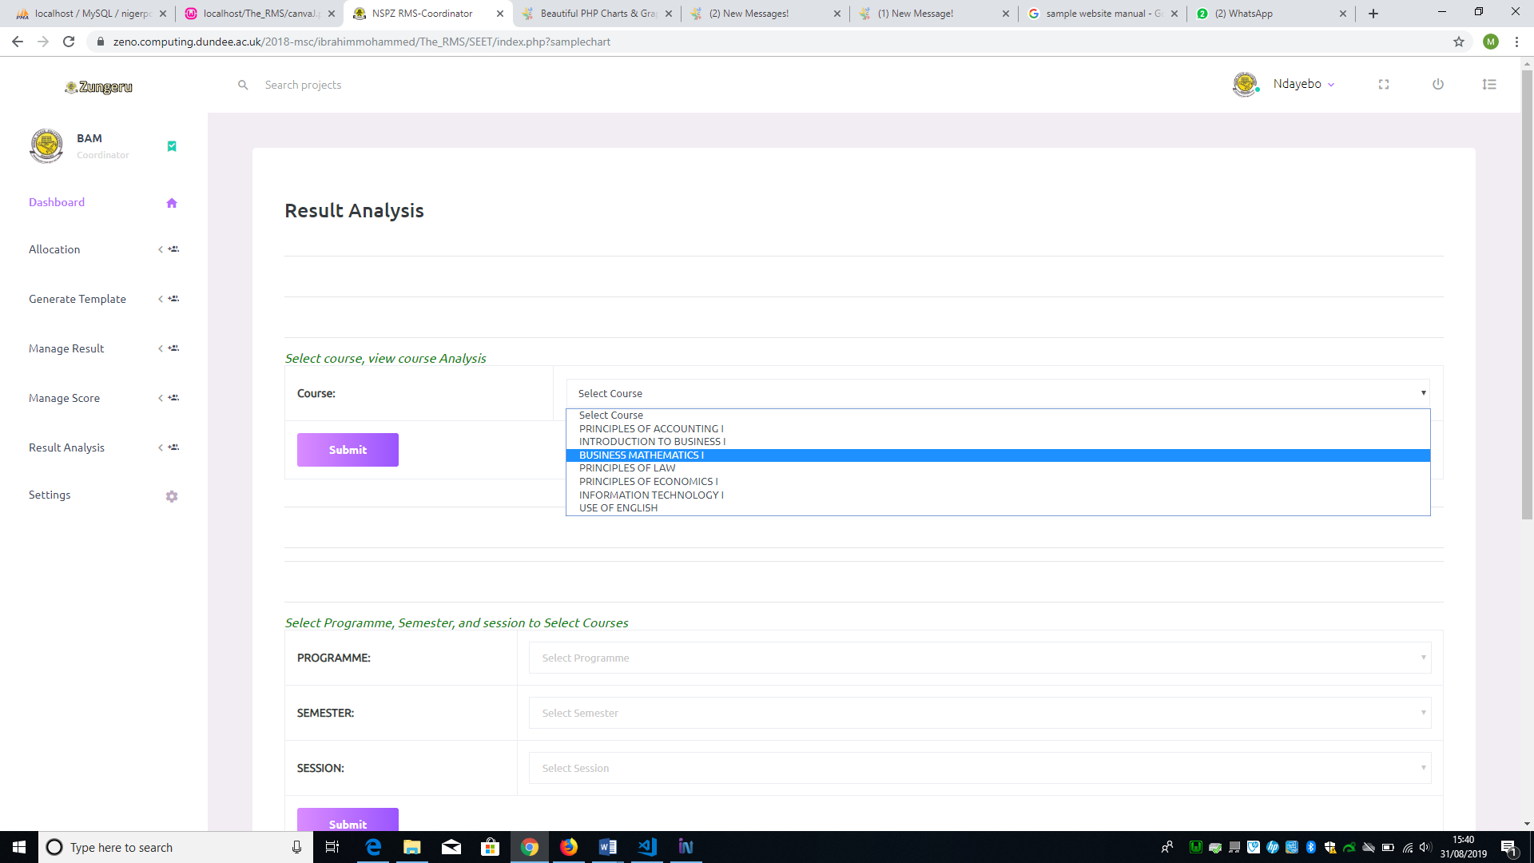

Figure 6. 17: Single Course Analysis Form

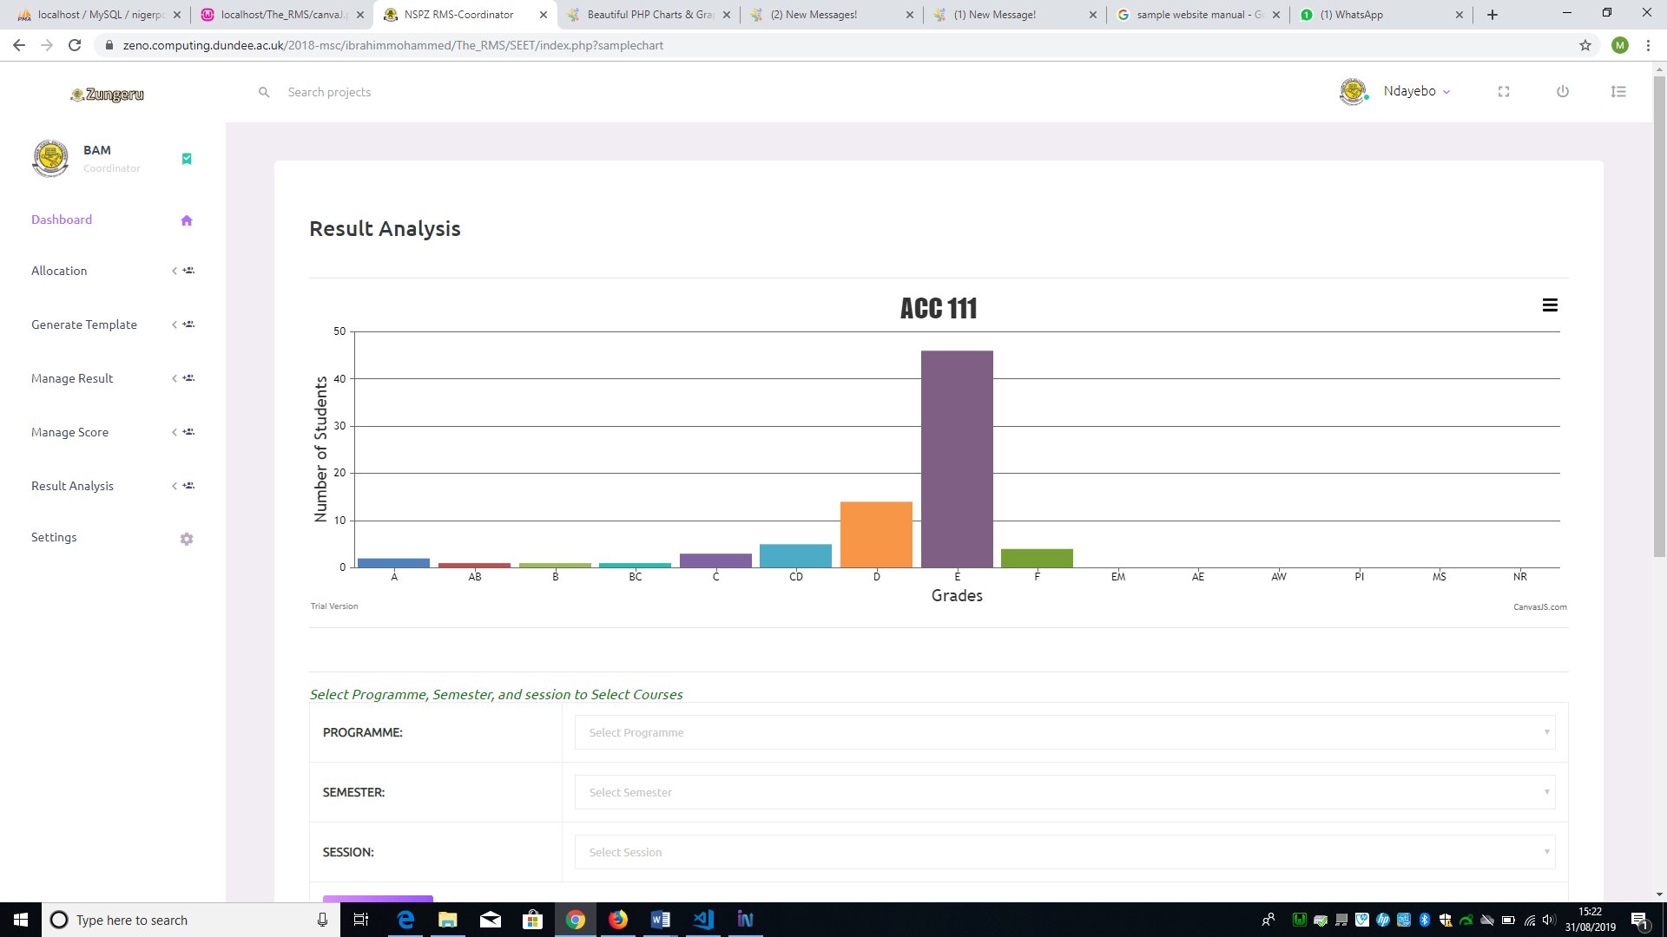

Figure 6. 18: Single Course Visual Analysis

The “Complete Result analysis” submenu is to allow user to view the visual analysis of the entire result of a class when clicked. On clicking the submenu, the system displays a form to select the programme, semester, year of the visual analysis to be displayed. Figure 5.61 shows the visual analysis of single course.

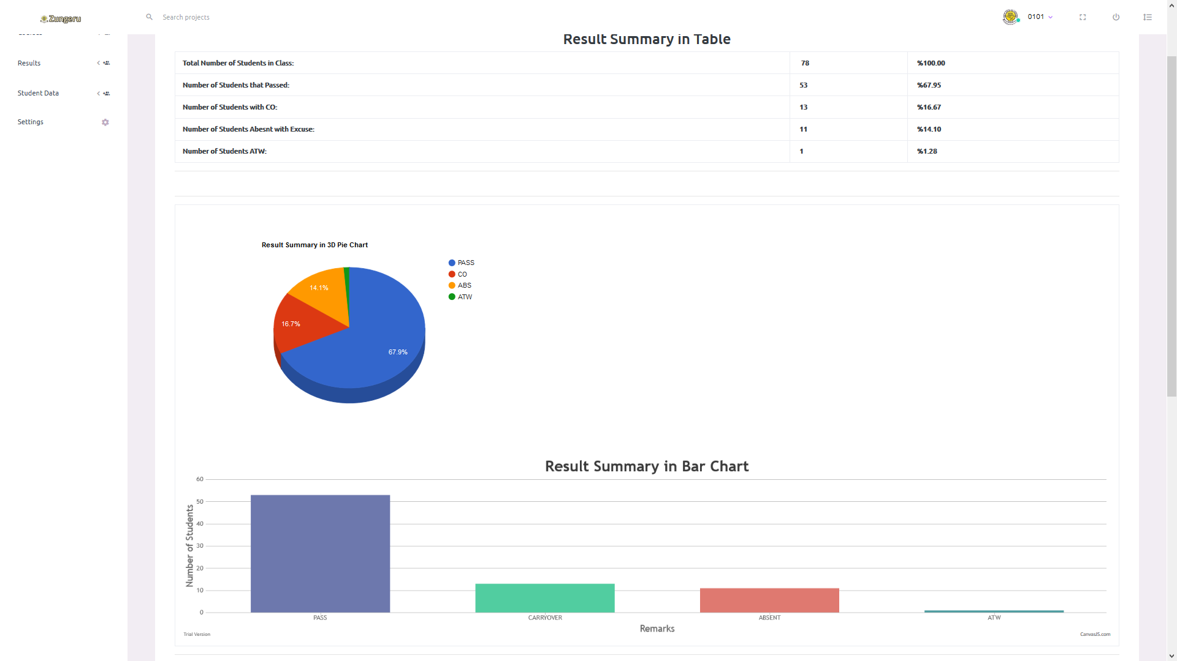

Figure 6. 19**: All courses Visual Result Analysis**

# 7.0 Teacher / Lecture Role

The user (teacher/lecturer), when successfully logged is given access to “Generate Template”, “settings” and “Exam score” menu. The “Exam Score” menu has a submenu “import score”. The “generate template” menu enable the user generate .csv file format for score entry just as mentioned above for user (Coordinator). The import score menu gives the user access to import the scores of students offering course(s) allocated to the user (teacher/lecturer). When the user clicks on the “import score” submenu, it displays the form requiring the user to select a course from the list of allocated courses and then choose a file (.csv file format) containing the scores of the students, then click on submit to import the scores into the database. The user can only import scores for a course once, because the system removes the course from the list of courses to be selected immediately after the user submit scores for that course. Figure 6.8 shows the form for importing student exam scores.

The user can also view the scores they imported by clicking on the course code from the list of courses on their dashboard. See figure 4.13 above showing the user (teachers) dashboard.

# 8.0 Exams and Record Role

The user “Exams and records” have access to menus that allow the view of records only when logged in successfully.

The menus are; courses, result, student data and settings, these menus enable the user view courses, academic board result, and student data respectively. This user has access to view from all programmes in the Polytechnic.

The result menu has the submenus; Academic board result and result analysis, these sub menus will allow the user view academic board result and view the visual result analysis of any programme in the Polytechnic. Figure 8.1, 8.2, & 8.3 shows all the menus and sub menus of the user (Exams and Records).

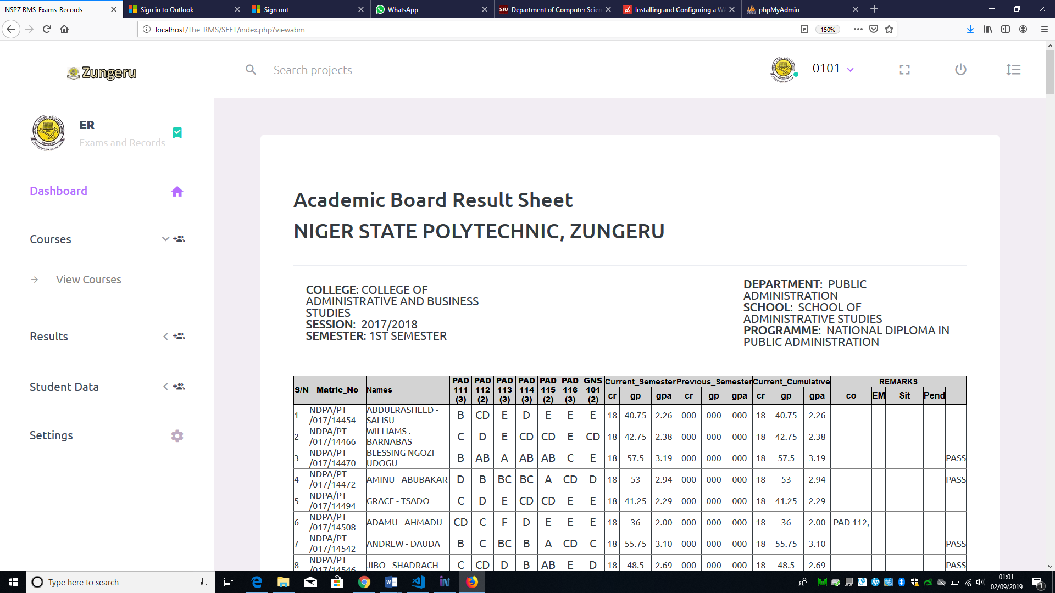 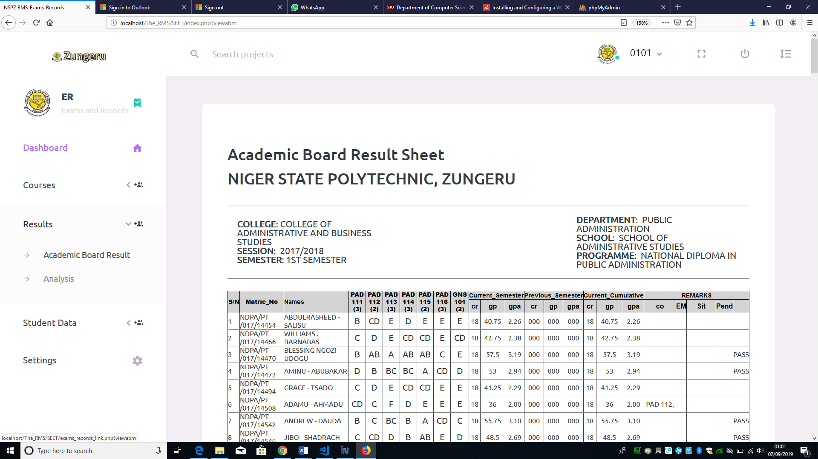 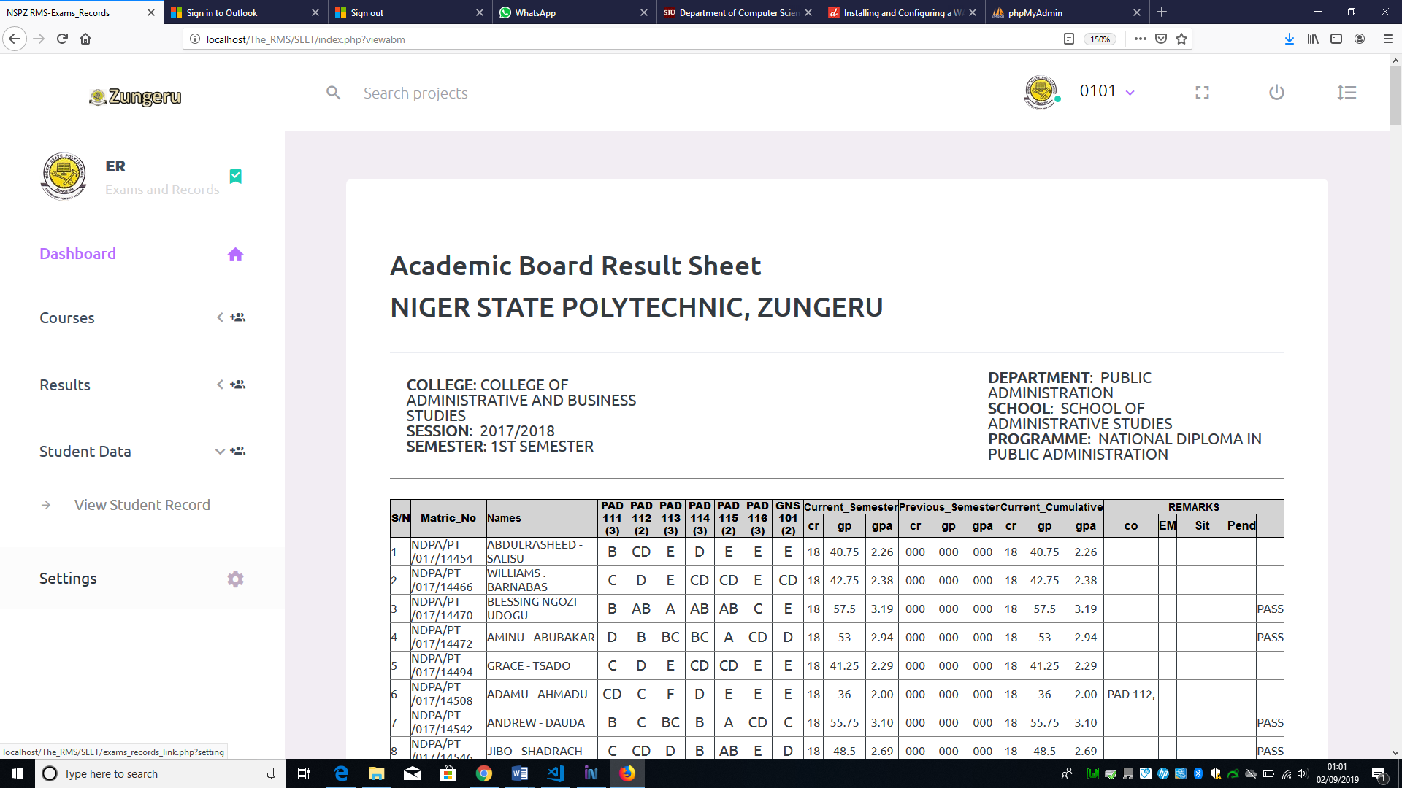

Figure 8.1 1: Course Menu and Sub menu Figure 8.1 2: Result Menu and submenu Figure 8.1 3: Student Data and Submenu

# 9.0 Student Role

The user “student” when logged in, can access the menu “Semester Results”. This menu has submenus that would allow the user to view their result in semesters. Figure 9.1 shows the menu and its submenus.

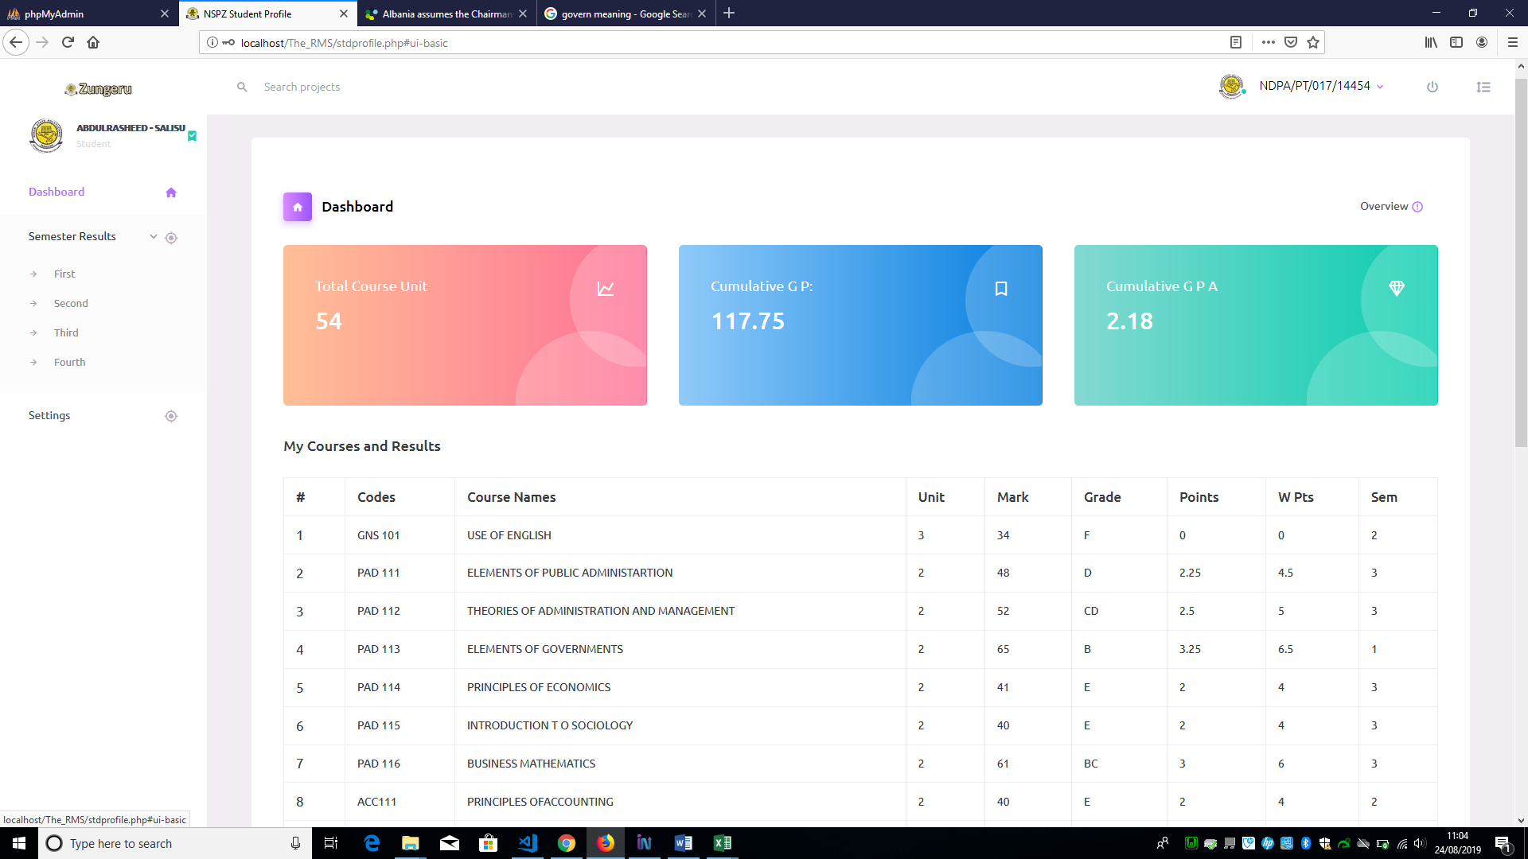

Figure 9. 1: Semester Result Menu and Submenus.

When the user (student) click on any of the submenus (First, Second, Third, or Fourth), the system displays the result for that semester. See figure 9.2 below.

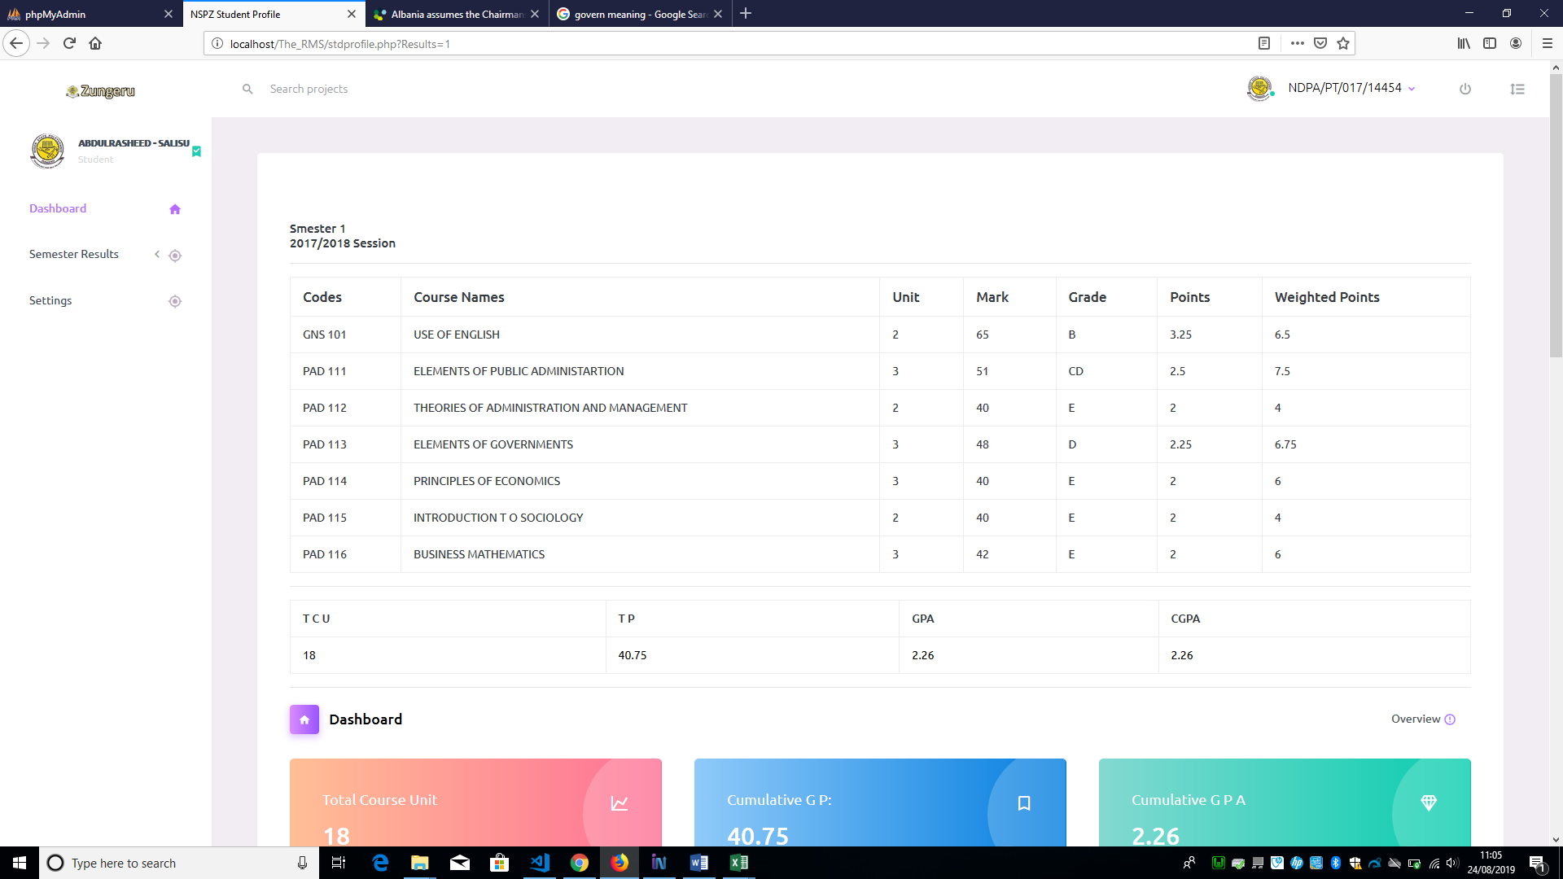

Figure 9. 2: Student Semester 1 Result.